King Street Primary & Pre - School
High Grange Road
Spennymoor
County Durham
DL16 6RA Telephone: (01388) 816078
Email: kingstreet@durhamlearning.net

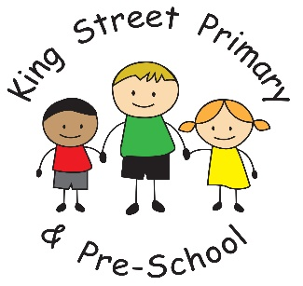

24.3.20
Dear Parent,

We have today received a letter from our Local Authority that they wish us to forward to parents of children in childcare.

After the PM’s announcement last night and in light of new guidance we are asking you to carefully consider whether or not your child needs to be in school.
We appreciate that the central government guidance around what constitutes a key worker is quite broad, however we would like to remind you that the reason schools are remaining open is primarily to ensure that those frontline workers who are key to helping this country get through this situation, can get to work.
Each school will have different levels of demand for these places and may handle this situation differently in order to ensure the welfare of all staff and children. We ask you to respect any restrictions your school may put in place to help them cope during these challenging times.
Finally can we remind you that in line with Public Health England guidance, the best place for your child, wherever possible is at home with you, helping to maintain good social distancing for our wider community.

I appreciate, for most people, childcare is never the option they would choose but as key workers it is the only option. We do ask however, that you only use the service when you are actually at work to reduce the number of children in childcare at any one time. Thus reducing the risk to other children and staff. We will continue to provide this service whist guidance allows us to do so. Please remember that we may need to withdraw the service at very short notice if the situation changes.
If you no longer require a childcare place, please email the school kingstreet@durhamlearning.net

Thank you all for your continued support and we wish you all well.

Kind Regards

Mrs J Bromley

Head Teacher

