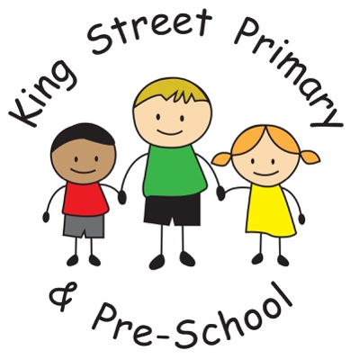
Newsletter
Year 2

Welcome back for the brand new academic year and the start of Year 2.
We have already had a wonderful start to our Autumn Term and it has been so lovely to see how eager and enthusiastic all the children are. I know we are all going to have a super year together.

Our New Class:

This term PE will take place on Monday and Thursday afternoon. Pupils will need black shorts, a plain t- shirt in their house colour, socks, plimsolls and outdoor trainers. Long hair should be tied back and earrings taken out or covered for PE.

Home learning tasks will be set on Wednesday and are due in on the following Monday.
Spellings will be set weekly. Each child will have 10 words to practise at home and spelling sentences to complete. There will be a short quiz of these words on Mondays.
Each week other home learning tasks may include:
- Number facts to learn (such as times tables)
- Handwriting practice
- Topic work
Homework should be completed to a high standard and children should use a pencil, not a pen. A homework folder will be provided for each child.

Your child will receive their new reading record for Year 2. Children should be reading daily and we ask that the reading records are completed by parents at least three times a week.

We have made some changes to our curriculum this year, to ensure that all children are given opportunities to develop their interests and skills, and that their learning is broad, balanced, engaging and fun! Every class will have one whole term of Outdoor Learning. Ours will take place during Spring Term, with a focus on the environment and living things. The topic will be called ‘Saving the Earth.’
English (reading and writing) will be taught through a longer-term topic, using real-life texts to help broaden your child's vocabulary, deepen their understanding, and provide a context for their own work. Science and foundation subjects, such as Geography and History, will also be linked to our topics.
Please see a brief outline of our topics this year below. A more detailed curriculum map will be available on our new school website shortly:
Autumn Term  Here and Far Away: Island Explorers | Spring Term  Saving the Earth | Summer Term  Magic!  The Rhythm of Life

“When I grow up I want to explor the werld.”

Daisy A.
Year 2
A request:

As large backpacks are very bulky and difficult to store in our classroom, we prefer it if the children in KS1 use the flat book bags throughout the week and save the backpacks for school trips or for Fridays, when there might be more letters to take home.
Don’t worry if you don’t have a flat book bag as the homework folders, which school will be providing, can serve this purpose.
Thank you so much for your support in keeping our classroom tidy and pleasant.

WANTED
Donations of:
- Large men’s shirts which can be used as painting aprons
- Old sheets or cloth
- Throws, blankets or cushions for our sofas (which are looking a little tired).

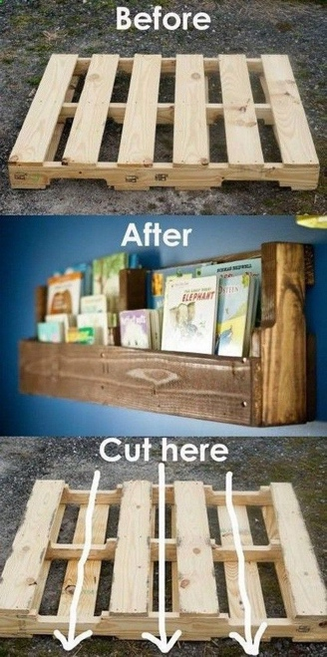
Are any parents particularly crafty, with a little time on their hands (and a sewing machine)? We would love some seat storage sacks or a pallet bookshelf if anyone feels willing and able.

With thanks for your continuing support,
Miss A. Tait
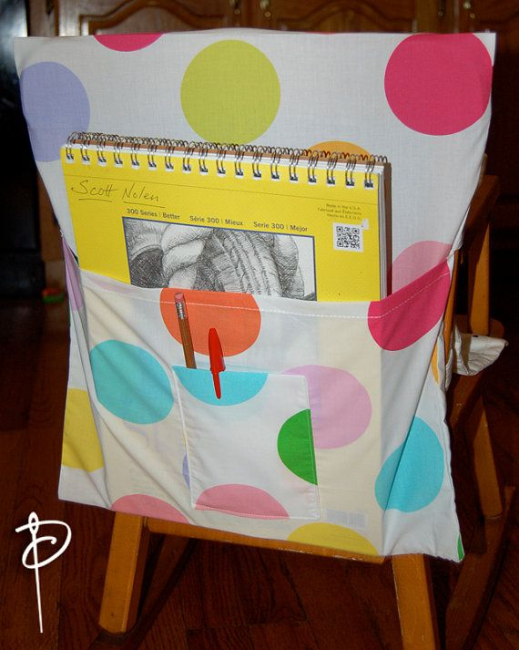
Mrs T. Gamsby

