King Street Primary & Pre - School
High Grange Road
Spennymoor
County Durham
DL16 6RA Telephone: (01388) 816078
Email: kingstreet@durhamlearning.net

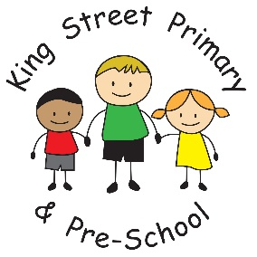

01/03/19

Dear Parent/Carer,

Our children have returned to school really settled and full of enthusiasm. They are very excited about the things the classes have planned and particularly about the Mother’s Day event next week. If you have not yet paid for your Strawberry Tea, please do so using Parent Pay before Monday 4th March to secure your place.

Internet Safety
It will have no doubt come to your attention this week, the potential dangers of social media and unmonitored phone use. It does appear that the Momo situation has been a bit of ‘fake news’ hyped up by social media and the news but it does also heighten our awareness of the need to be very vigilant and that new things are happening all the time. We have spoken to all children in our assembly about being safe on the internet and ensuring they report anything they find frightening or offensive. We know we cannot stop the inevitable that children may come across these things but we are doing all we can to educate children on what to do if they do come across them.

Parent’s evening
Our Parent’s evening will be taking place the week beginning 18th March and the booking system is now open on ‘eschools’. If you are not able to log in, have lost your log in or are unsure of the system please ask your child’s teacher as they will happily give you another login or help introduce you to the system. Parents evenings are a great way to catch up on what your child has been doing as we know that by the time they get home their response to your questions about the day are often ended with “nothing”!

Upcoming events
We have a few other events taking place over the next few weeks with World Book day (7th March), sports tournaments and Comic relief (15th March). Please do not feel you must buy your child a costume for world book day, homemade ones are always a delight to see and the children are always very proud of them. We are also celebrating national Science Week this term and there are so many amazing experiments and events planned for the children to take part in- I am sure you will hear all about them and we will keep you updated with photos through marvellous Me.
Parents of Year 6 please also remember that next week is a busy week with a visit on Monday and a ski lesson on Tuesday. Consent forms must be returned.
As always, if you have any queries or concerns, please contact us in school.
Yours Sincerely
J Bromley
Head teacher

