King Street Primary & Pre - School
High Grange Road
Spennymoor
County Durham
DL16 6RA Telephone: (01388) 8160781
Email: kingstreet@durhamlearning.net

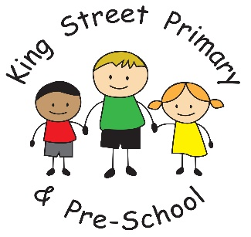

17th December 2020

Dear Parents and Carers

Reporting symptoms after the school closes for Christmas Holidays

Our school will close at the end of the school day on Friday December 18th. If your child develops symptoms of coronavirus you must still book a test.

If your child develops symptoms anytime up to and including 20th December, which result in a positive test result up to the 24th December, you must inform the school at kingstreet@durhamlearning.net and put ‘positive Covid result’ in the subject line of the email.

Please include the name of your child, their year group and the date that their symptoms started, as well as your own contact details.

From Monday 21st December
If your child develops coronavirus symptoms from Monday 21st December onwards, they must be tested and, if positive, follow the advice of Test and Trace. You do not need to inform the school of any symptoms which occur from the 21st December- only if symptoms appeared before the 21st December.

Contact tracing during the Christmas break

Please be aware that the school, following the guidance of the Department for Education and Public Health, will do the following for 6 days after the end of term:

- Collect information from staff and pupils with positive tests and families of symptomatic pupils

- Advise families of close contact with confirmed Covid cases, and inform them of self-isolation requirements

Please do check emails regularly until the 24th December as this will be the method of communication used by school.

We hope to see everyone fit and well and ready for the new term on Tuesday 5th January. School reopens as normal at 7:45am for breakfast club.

Yours Sincerely

Joanne Bromley
Head teacher

