King Street Primary & Pre - School
High Grange Road
Spennymoor
County Durham
DL16 6RA Telephone: (01388) 816078
Email: kingstreet@durhamlearning.net

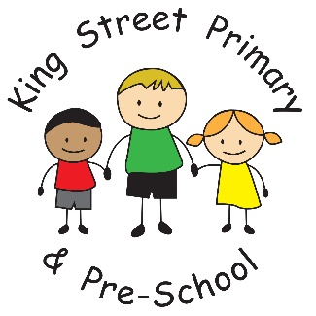

9th November 2018

Dear Parent/Carer,

It has been another busy week in school and the children are continuing to engage in fantastic activities. Year 2 have been undertaking the role of architects and designers, Year 3 and 4 have had a very engaging visitor to enhance their work on The Greeks and The Stone Age, Year 5 have been investigating humans and animals and Year 6 have been investigating the functions of the heart! We would love to enlist your help if anyone has knowledge and skills as architects, designers or midwives who could talk to the children in relation to the topic they are covering– they love having visitors in school. We are particularly interested in raising the children’s understanding of STEM (Science, Technology, Engineering, Mathematics) as we are aware that many of the jobs of the future could lie within these fields. In fact, Year One are visiting Hitachi (thanks to one of our parents) and have the opportunity to look at the engineering behind some of our trains.

Diary Dates
The most recent list of diary dates are attached to this newsletter – please keep your diaries updated so you do not miss out on any events. If we can encourage enough parents to sign up to ‘eschools’, this can become a great form of digital communication for everyone and diary dates could come direct to your phone, as well as letters and reminders. If you are not signed up- please do so as it is also a quick and easy way to sign up for parents evenings.
The upcoming dates to look out for are:
12th November- Year 1 at Hitachi
12th November – Odd Socks Day – We would like to encourage all of our children to wear odd socks in honour of the start of “Anti-bullying” week. This helps demonstrate we respect value and treat everyone with kindness and that everyone is different.
13th November 3.05pm Dr Tom Robson presentation to parents (no tickets required so please come along)
15th November – Year 6 at the safety carousel
16th November – Children in Need.
Miss Tait is our charity organiser in school and will be issuing a separate letter with all of the information regarding the event. The children have chosen some brilliant things to do on the day and I’m hopeful it will raise a huge amount of money for this worthy cause.
19th November – Year 1 visit to Durham castle (letters from Mrs Kane will be sent home tonight)
21st November – Careers day in school
23rd November- whole school STEM workshops
26th November – Year 2 visit to the Botanical gardens
29th November – Year 2 visit to captain Cook Museum (this replaces a pre-planned church visit)

Sports update
We have more sports celebrations this week with our Netball and Athletics teams. Our Netball team won their league games and our budding athletic stars came 5th. It is brilliant to see the team effort from the children and as always they are impeccably behaved and are amazing ambassadors for the school. They make us very proud.

Volunteers
Our knitting club has been a huge success with the children now considering running an enterprise and selling their fantastic items to help pay for more wool. Due to the increasing numbers however, we are looking for another adult who has basic knitting skills who can assist within the club. It runs over lunchtime on a Tuesday so if you are free and interested please do get in touch.

Yours Sincerely
J Bromley
Head teacher

