King Street Primary & Pre - School
High Grange Road
Spennymoor
County Durham
DL16 6RA Telephone: (01388) 8160781
Email: kingstreet@durhamlearning.net

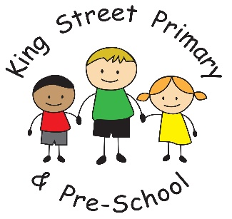

14th September 2018
Dear Parent/Carer,

It has been another busy week this week as children begin to engage in their new curriculum. It has been great to hear so many of them talking about the things they are doing and the plans their teachers have for them for the rest of the year!
It was lovely to see many of you at our ‘Meet The Teacher’ event this week. I hope you came away feeling you had been able to put a face to a name and understood some of the routines and plans for the next term. It is an event we plan to repeat at the beginning of every new school year as we feel it allows families to ask any questions they may have and get to know the staff working with their child. Thank you to all of those families who were able to attend- it was great to see you.

Diary dates
I have attached an outline of future dates with this newsletter and hopefully this will allow families to plan in advance as we know how busy life can get. We will, of course, add further dates to this as they arise. For example: school visits, Friends of the School events and activities for individual classes.

Dr Tom Robson
Some of our families were fortunate enough to be able to attend the event we held after school on Tuesday 4th September where Dr Tom Robson delivered some super ideas of how to help your child become more independent and how to support their learning. He is an inspirational, international speaker who always leaves his audience wanting to hear more. We have been lucky enough to squeeze another session into his diary on Tuesday 13th November 3:15-4:15pm so please put the date in your diary and come along to hear his inspirational and information ideas.

Lunches
Many of the children have now labelled their pack lunch boxes which has been a huge help this week so thank you for taking the time to do this. If you wish to change your child from school dinners to packed lunch or vice versa, please speak directly to the school office and we will make these changes for you. If no notification is received you are at risk of still being charged for school meals that have been ordered.

Lego swap cards
If your child is currently (frantically) collecting the Lego cards from Sainsbury’s – they are not alone! There are a number of children who are trying to collect the full series and so due to popular demand we are holing a ‘swap shop’ on a Tuesday and Thursday break time. These sessions will be monitored by staff and will allow children to exchange cards to help them in their quest. The rule we have had to apply to this is ‘once they have been swapped- you can’t ask for them back!’
As always, if you have any questions, queries or concerns, please speak to us as we are happy to help.
Yours Sincerely
J Bromley
Head Teacher

