King Street Primary & Pre - School
High Grange Road
Spennymoor
County Durham
DL16 6RA Telephone: (01388) 8160781
Email: kingstreet@durhamlearning.net

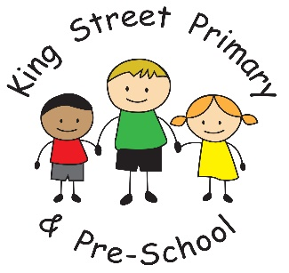

Dear Parents/carers
I hope you all had some lovely time with your children over half term. As news of the second lockdown sinks in, I am sure many of you will have very mixed emotions. At the very time we felt like we were starting to emerge from the pandemic and have some small snippets of normality, we seem to be, instead, heading deeper into it.
As a school, we are pleased to remain open. I do think it is the right thing for our children and I feel as though we owe it to them all to retain our own little wonderful bubble inside our school walls. As I have previously said, when we are in school, it is almost as though nothing is happening in the real world! We are surrounded by laughter, chatter, disagreements, talking and giggling – it is wonderfully normal! However, there is a ‘real world’ out there and as adults, we are all too aware of the dangers that still exist. I would therefore like to reassure you all as best I can that we will continue to implement our risk assessments and safeguard the pupils to the very best of our ability. We desperately want them to be in school rather than learning from home – and I am sure you do too. We will continue to do what we do best – offering your children the routine, security, love and support that is always there. However, we do need your help in order to ensure our school remains open and to achieve this, I ask that you continue to adhere strictly to social distancing and lockdown guidance when bringing children to and from school and now advise that if you wish to speak to a teacher on the yard, you must wear a face mask. Staff have been asked to do the same. If you would like to wear a face mask when dropping off and collecting, we would also welcome this but it is not essential – only if speaking to a staff member.
This way, hopefully, we can help to alleviate any potential risks both at the school gates and on the school premises. Attendance at school continues to be mandatory – our attendance is currently at 96% which says it all! We have robust cleaning procedures in place, robust risk assessments and robust rules in order to keep children and adults as safe as possible. However, we also have robust learning and fun taking place too - it really is win, win for us all at the current point in time! However, it is likely that over the next half term, we will have bubbles needing to self-isolate. We will text parents of the affected bubble in the first instance to send the children home before carrying out a thorough risk assessment to assess which children need to self-isolate. PHE (Public Health England) are constantly changing their guidelines so it does take a little time to liaise with them and receive the most up-to-date guidance at which point we will officially inform you in writing of the self-isolation guidance. Children will then work remotely using Eschools and will be directed by the class teacher. Your child should know their eschools login as this platform is also used in school. If you do not receive a text message, your child is not affected and will continue to attend school. Please ensure that all contact details are up to date.
If we, as a school, are given any further information regarding lockdowns or additional guidance to follow we will forward this on to you. At present we are following the same information that was presented in Saturday’s briefing.
We have managed to get through, what has probably been, the most challenging 6 months of our lives together so far. We will continue to do so with positivity and a smile on our faces. We will get there. We will see better, happier days!

Yours sincerely
J Bromley
Headteacher

