King Street Primary & Pre - School
High Grange Road
Spennymoor
County Durham
DL16 6RA Telephone: (01388) 816078
Email: kingstreet@durhamlearning.net

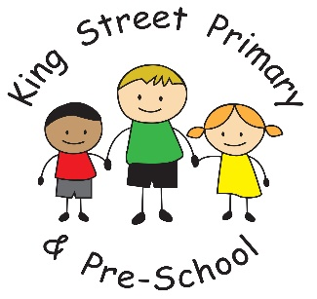

21/11/2019

Dear Parents/Carer

It has been another lovely week in school. Our Year 6 children started our week with a beautiful and thought provoking remembrance assembly, followed by a visit to the cenotaph for another wonderful service and to observe 2 minute silence. We have had children participate in a football tournament and I have even heard children begin to practise for their Christmas Nativity! We have rounded the week off with Children in Need which is such a worthy cause and the children love to participate- we had some very original looking costumes too! Thank you for getting involved.

Baby news
Another wonderful announcement- Miss Bell has had a beautiful baby girl and both are doing very well. I am sure you join us in sending them ‘best wishes’ and I am positive we will see them both very soon.

Coffee morning
Just a reminder we are holding another coffee morning on 20th November 9am-10:30am. This will be in the ‘hub’ building (the detached building as you come down the lane into school). Please do come along and meet other parents, ask questions, share ideas or even pick up a volunteer pack. We aim to make these sessions useful to everyone so if you have any ideas for future coffee mornings please let us know. In the past we have hosted school nurse drop ins, advice and guidance on housing and signposted to community services. Everyone is welcome.

Collections for school
Next Friday (22nd) and the Friday after (29th), we are holding our ‘dress down days’ and are encouraging children to bring a donation for the Christmas fayre. We are asking for a bottle donation on the 22nd and a chocolate donation on 29th. All donations are used to support the tombola and stalls at the Christmas fayre so please give generously!
If you or a member of your family would like a stall at the school fayre, please speak directly to Mr Swift and Miss Starkie who are organising the event. The cost of having a stall is £10 and then all proceeds remain with the seller. All items sold must be suitable for a school environment.

Books for schools
The Sun newspaper is running an event which allows schools to claim £600 worth of books. This is a fantastic opportunity for school as encouraging children to read and develop a love of reading is a huge priority for us this year. The event runs from November 23rd until January 18th 2020 and the newspaper will be issuing tokens for readers to collect. Please spread the word as we would love to be part of this but to apply for the books we need to collect a whopping 3500 tokens- that is one massive feat! If you, family or friends do have any tokens, please send them in to school. Miss Whitfield will keep count of how many we collect.

As always, if you have any questions or queries please do not hesitate to get in touch. We always have staff on the yard or you can call into the school office.

Yours Sincerely

Mrs J Bromley
Head Teacher

