King Street Primary & Pre - School
High Grange Road
Spennymoor
County Durham
DL16 6RA Telephone: (01388) 8160781
Email: kingstreet@durhamlearning.net

16th November 2018

Dear Parent/Carer,

Thank you to everyone who has contributed to our Children In Need day!

I am delighted to share our secret visitor with you- Pudsey Bear!
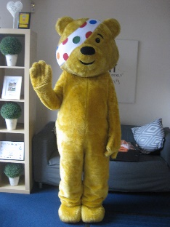

This has been a great way to end another brilliant week! The children have been very creative with costumes and we have been amazed at the creations. The time and effort has been well worth it as we already know we have made over £200 and we are still counting! The children had the pleasure of fun ‘Pudsey’ activities, face painting, a bring and buy sale and plentiful amounts of sweet treats!

The rest of the week has seen equal amounts of fun with Year 1 visiting Hitachi and have learnt so much about engineering. They are out again next week – this time visiting Durham castle. We hope they thoroughly enjoy themselves.
Year 6 have experienced a safety carousel, learning about water, electrical, fire and internet safety and after speaking to a few of them they appear to have learnt a great deal. These events are always very good at raising awareness and we hope to continue them next year.

In our sporting news, our ‘Netballers’ were, once again, victorious in their matches. It is a delight to see them return from the game in high spirits and we always celebrate their achievements in our end of week assembly. Well done to them all.

Next week we are hosting our careers day- thank you to all our volunteers who are coming to talk about the work they do- we know you inspire the next generation. We have also had confirmation from the ‘Polar Explorer’ company that we were chosen to be part of our STEM project which means all our children in school will receive some high quality STEM education over the next few months. Children really seem to engage in these type of activities and hopefully helps them to see the links within the real world.

The NHS have asked us to remind parents our flu vaccination is due to take place soon in school. It is imperative that you sign the online consent form which can be found by typing in the following link: www.hdft.nhs.uk/nasalflu-consent You will be asked for a school code which is 78763 and these must be completed ASAP and by no later than 31.11.18. If you have already completed this form it does not need to be done again.

A final thank you to some additional volunteers who have offered to help out in school. We now have an additional adult to help in our knitting club and a volunteer to help teach art to children across the school. We value these people so much; their skills really do make a difference to our children.

As always, if you have any questions or concerns please do speak to myself or a member of staff. We are here to help the children and our families.

Yours Sincerely
J Bromley
Head teacher

