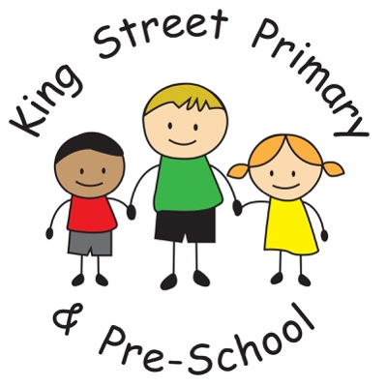
Newsletter
Year 2
It’s the start of the Summer Term- Hooray!
Let’s hope we get some bright, sunshiny days soon.
This term PE will take place on Monday and Tuesday afternoon. Pupils will need black shorts, a plain t- shirt in their house colour, socks, plimsolls and outdoor trainers. Long hair should be tied back and earrings taken out or covered for PE.

Our over- arching topic this term is:
MAGIC!
This is broken down into the following areas:
Writing-
Magical tales.
Looking at alternative versions of traditional tales and magical stories from other cultures, and sharing ‘The Magic Finger’ by Roald Dahl as a class book.

Science-
Materials and their Properties
Looking at the magic of materials and how different materials can be used to make different objects, finding out what makes a material suitable based on its properties and discovering the magic of changing materials- by squashing, squeezing, stretching and twisting them! We are also hopefully going to see some real magic materials and take a trip to the Sunderland Glass Centre to see the magic of glass blowing.

Topic-
Inventors and Explorers
Studying transport through time and the magic of new inventions and how they have changed the world! Perhaps also having a go at designing our own inventions and experimenting with different materials. Lots of STEM challenges ahead.

RE-
Introduction to Buddhism/ How do Buddhists show their beliefs?
Buddhism is all about finding serenity and peacefulness- now wouldn’t that be magical in a class of 30? We will be learning about Buddhist beliefs and comparing the religion to the other major world religions we have learned about this year. I hope you find this topic interesting and thought- provoking too!
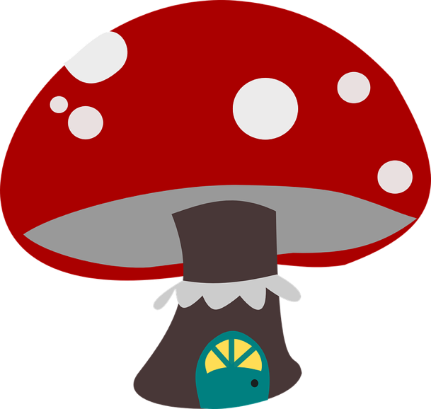

Our Year Two SATs tests will be taking place during the last two weeks of this half term- Summer 1. The children will be sitting their papers in small groups during any time from the 14th- 25th May 2018, so it is really important to be rested and in school on time every day. The children will receive breaks between papers and all we ask of our pupils is that they try their very best.

The best thing you can do to help your child prepare is to keep reading lots of books and discussing what you have read together, and to keep practicing the 2, 3, 4, 5 and 10 times tables, number doubles/halves and number bonds to 10, 20 and 100. I cannot stress enough how important reading is and we are going to continue to have a drive on home- school reading books and celebrating children who are reading lots at home through special awards in class! Try to listen to your child read for at least 10 minutes per night.

As a reminder, the children will be sitting four papers and we will report the results to you at the end of the summer term, in the end of year reports:
- Reading Paper 1 (short paper)
- Reading Paper 2 (long reading booklet)
- Maths Arithmetic Paper
- Maths Reasoning Paper

Please do not worry about these tests, as they only form one small part of the end of year teacher assessment. They do not assess what makes each one of your children special and unique, nor do the SATs reflect their talents, skills or personalities. I promise you that the children will not be stressed by this experience and will take it all in their stride, so parents please do not be worried about these year two SATs either. I know that the children will continue to make progress and achieve their personal goals, whatever the outcome of the SATs is.

If you have any questions or concerns at all, then please do not hesitate to catch me after school.
With thanks for your continuing support,
Miss A. Tait
Mrs T. Gamsby

