King Street Primary & Pre - School
High Grange Road
Spennymoor
County Durham
DL16 6RA Telephone: (01388) 8160781
Email: kingstreet@durhamlearning.net

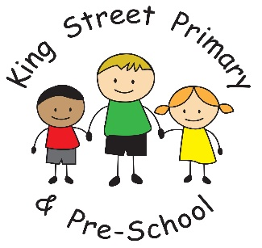

16th October 2020

Dear Parents/Carers

I would like to thank everyone who has brought in Harvest donations for the local food bank. I know these will be gratefully received and will go a long way to supporting families who find themselves struggling. Times have certainly been difficult over the last 7 months and many families have found very sudden changes to their circumstances, and as a school, we take pride in being able to help out.

Y6 secondary school places
If you currently have a child in Year 6 we have been asked by the Local Authority to remind you that you must apply for a secondary school place by October 31st. The form is online but a paper form can be requested by contacting admissions at County Hall. If you do not apply for a secondary place you may not get the place you would like.

One way system
I would just like to remind parents that you must not cut down the back lane as a short cut to collect your child from the Early Years. We have the one-way system in place for safety and whilst it may seem inconvenient due to the additional walk required we must ask that all parents adhere to this. It will prevent the back lane becoming congested with 2-way traffic. We also ask that you do not gather around the school gates. There are currently local restrictions in place that we ask that you adhere to these and that maintain social distance. Thank you to everyone who continues to follow the systems – I’m sure by now everyone’s fitness must have improved!

Halloween meal
The school kitchen have now placed our food order for our Halloween meal and the children appear to be in for a treat! We have some lovely decorations for classrooms and I know teachers plan on making it a fun final day. If your child would like to dress up, we encourage them to do so but this is not compulsory and children can come in ordinary clothes if they prefer.

Flu immunisations
All children with immunisation consent forms had had their immunisation today. We had many come out smiling and telling us that it ‘tickled’. If you wanted your child to be immunised but missed the deadline, please contact your GP for advice.

School photos
Please remember it is school photo day on Tuesday 20th October. Please remember due to current restrictions we cannot mix class bubbles to take sibling photos.

If there is anything you would like to contact us about, including if your family circumstances have changed and you feel you may now be entitled to Free School meals, email the school office at kingstreet@durhamlearning.net

Yours sincerely
J Bromley
Headteacher

