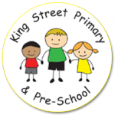
Year 5 Autumn Term Newsletter

Miss Lloyd and Mrs Cummings would like the opportunity to welcome everyone back after the summer holidays! We hope you all had a good rest and are ready for what this year has in store! Below is some information about day to day school routines, expectations and our theme this term.
Homework and Spellings
As per last year, the only homework will be reading books and a set of 10 spellings to learn weekly. However, this year children will be expected to put the spellings into their own sentence. Spellings will be sent out on a Monday and they will be tested on the Friday of the same week. Please do try to listen to your child read each night as this time is vital for embedding and developing reading skills.
Additionally, you can help your child to feel confident and prepared for Year 5 by practising all times tables at home, as well as corresponding division facts, including out of sequence.
Extra home- learning challenges and creative projects, linked to our learning in school, will be sent home, via letter or text message and will be used to extend and broaden learning that has taken place in school.
Also, keep checking our class page on the school website for regular updates on our learning.
Reading
Children should be reading for around 10 minutes per night and we ask that the reading records are completed by parents at least three times a week. In the comment box, please do comment on what you discussed with your child, any questions your child asked about the text, what they enjoyed and any aspects they found more challenging. Children may fill in information such as the name of the book and pages read but an adult signature is required.
We will check reading records daily. If your child regularly does not read 3 times at home during the each week and had it signed by an adult, we will ask them to stay in for 5-10 minutes at break to read to an adult in school.
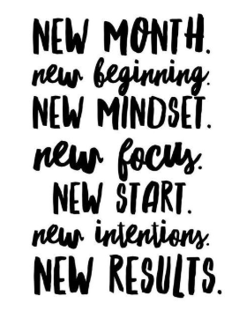

PE
This term PE will take place on a Tuesday afternoon. Miss Lloyd will be taking PE this year. We ask that PE kit comes into school Monday morning in case of timetable changes or other extra-curricular activities.
Pupils will need black shorts, a plain t-shirt in their house colour, socks, plimsolls or trainers. We do lots of PE outside so you may also like to provide jogging bottoms. Long hair should be tied back and earrings taken out or covered for PE.

Outdoor Ed
Outdoor Education will take place each Thursday. Each week, one third of the class will attend Outdoor Education sessions with a member of staff and the Real Adventure team. We will be taking part in a variety of activities including fieldwork and map skills, orienteering and looking at land use.
Please ensure you have checked the letter and know the dates your child will be attending; also, that they have appropriate clothing and shoes.
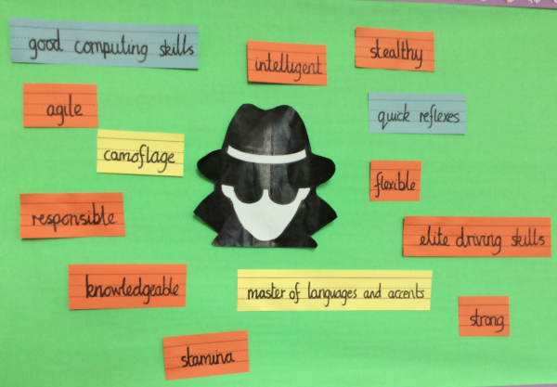
Our topic this term is ‘Spies and Superhumans’. We will be kicking off our topic by exploring the story ‘Skellig’ by David Almond. During our first few days back, we have completed our spy training. We have thought about the skills and qualities a spy needs, come up with our own secret identity and looked at identifying finger and shoe prints. We hope to be able to start our missions soon!
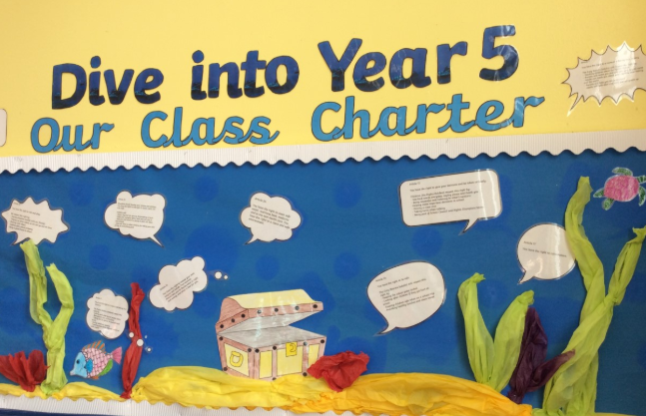

We have also been looking at children’s rights and each created out own deep sea diver for our underwater themed class charter.
In History, we will look at the secrets of the codebreakers during World War II at Bletchley Park. In Geography, we will use Digimaps to improve our mapping skills and participate in some fieldwork activities during Outdoor Ed. Furthermore, our Science will be focussed around properties of materials and we might even design and make our own spy/superhero disguise as part of DT.
A more detailed curriculum map will be attached with this newsletter and will be available on our 0school website shortly.
If you have any questions, please do not hesitate to come and speak to us.

Miss Lloyd and Mrs Cummings

