King Street Primary & Pre - School
High Grange Road
Spennymoor
County Durham
DL16 6RA Telephone: (01388) 8160781
Email: kingstreet@durhamlearning.net

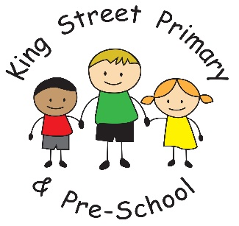

05/01/21
Dear Parents/Carers

I write this with a huge range of emotions, from sadness at not seeing our children back in school to anger and frustration at the way the Government have handled the situation and the mess they have left for schools to pick up.
Today, learning will move to online platforms for all children and teachers will be providing you with a full explanation of how this will be delivered and what to expect. In addition to this online work, we are also providing exercise books and additional school equipment that we feel would be useful over this half term. These are now available to collect from the school office. Please do call into school to collect these as soon as possible as much of the online work will require children to write in these books. If you call to the main office with your child’s name and year group, these will be passed out to you. When you arrive, if there are other families waiting, please remember to socially distance. Collecting packs should only take a few minutes. If you prefer to email us in advance to let us know you are coming, we will have them ready for you.

The next few weeks are going to be tough for everyone and all staff want you to know that they are on hand to help you with any queries or concerns. All you have to do is ask! Please also remember that whilst we want all children to engage with the online learning and remain part of their class, we also recognise that working from home and facilitating learning for children is a real strain. We have chosen not to work on live lessons using platforms such as zoom as, due to safeguarding protocols, an adult must supervise these sessions from the home. We feel that this restricts the work parents can get on with if they are required to monitor zoom calls- especially if you have more than one child. This does not mean your child will miss out. Research from the last lock down has shown that the most important factor in learning was the feedback that teachers gave to individual children rather than online whole class teaching. We feel that the use of eschools and the messaging service allows this feedback to be delivered quickly and effectively and used alongside other platforms such as purple mash, staff will be delivering the whole curriculum to the children.

I hope that you can look positively towards the future and will remain in contact with us throughout. If you are having any problems with accessing online services due to device or WIFI issues, please let us know. We still have a small number of home learning tablets available and also have SIM cards from Vodaphone with 3 months free WIFI on them. We really do want to use these resources so please do ask if you need them. There is no point in them gathering dust in my office!

If you are a key worker and expect your child to access a place in school, we are contacting you today. We will provide more details regarding opening times and expectations as soon as possible today. Please do remember, in order to reduce numbers of children in school we have been advised that children can only access a key worker place if the key worker adult is working in a workplace. Key workers working from home must keep their children at home. This is where the Government feel your child is safest.

Take care and stay positive, we really look forward to the day we welcome them all back.
Yours Sincerely
Joanne Bromley

