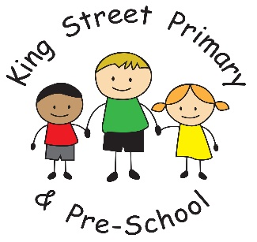
Key Stage 2 result 2017

We are very proud of our recent results. Children make fantastic progress at King Street and we are always keen to celebrate their success. Well done everyone.
The information below is based on the percentage of children reaching the expected level of Attainment at KS2 (Year 6)
Reading: 81%
English Grammar Punctuation and Spelling: 81%
Maths: 84%
% of children reaching required level in 3 Combined subjects: 71%

