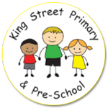
Year 5 Spring Term Newsletter

Miss Lloyd and Mrs Cummings would like the opportunity to welcome everyone back after the Christmas holidays! We hope you all had a good rest and are ready for what this term has in store! Below is a reminder about day to day school routines, expectations and our theme this term.
Homework and Spellings
As per last term, the only homework will be reading books and a set of 10 spellings to learn weekly. Spellings will be sent out at the beginning of the week now be on the following Monday. This will give children the weekend to practise. Please do try to listen to your child read each night as this time is vital for embedding and developing reading skills.
Additionally, you can help your child to feel confident and prepared for Year 5 by practising all times tables at home, as well as corresponding division facts.

Reading
Children should be reading for around 10 minutes per night and we ask that the reading records are completed by parents at least three times a week. In the comment box in the reading diary, please do comment on what you discussed with your child, any questions your child asked about the text, what they enjoyed and any aspects they found more challenging. Children may fill in information such as the name of the book and pages read but an adult signature is required.
We check reading records most mornings. If your child has not read 3 times at home during the previous week and had it signed by an adult, it may be that we ask for them to read for 5-10 minutes at break to ensure they are making progress.
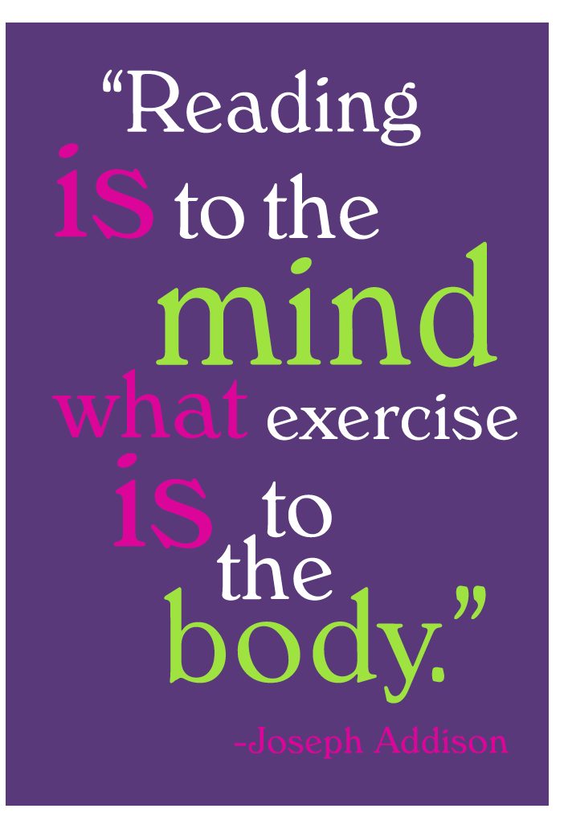

PE
This term PE will take place on a Wednesday afternoon and Thursday morning. Pupils will need black shorts, a plain t-shirt in their house colour, socks, plimsolls or trainers. We do lots of PE outside so you may also like to provide jogging bottoms for colder days. Long hair should be tied back and earrings taken out or covered for PE.

Our topic this term is ‘Gods and Monsters’. We will be exploring, drawing and writing about all kinds of mythical creatures and monsters, reading stories about the Ancient Greek and Egyptian Gods as well as exploring the legend behind Chinese New Year. Furthermore, we will kick off the new year by learning about ‘Earth and Space’ in Science and we hopefully have a trip in the pipeline!
A more detailed curriculum map will be attached with this newsletter and will be available on our new school website shortly.
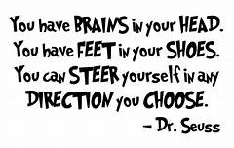
Parent and carer volunteers
If you would like to volunteer and read with Year 5, we’d love to hear from you.

Thank you so far for your support this year. If you have any questions, please do not hesitate to come and speak to us.

Miss Lloyd and Mrs Cummings

