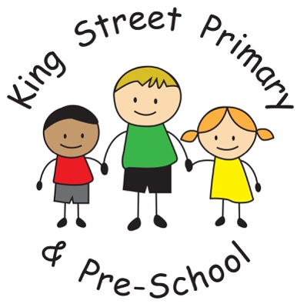
Newsletter
Year 2

Welcome back for the start of our Spring Term and a very happy new year to you all. I hope you have all had a lovely Christmas break and are now refreshed and ready to go! We have another exciting term ahead.

Our Outdoor Education sessions with Real Adventure through
Sport have already begun and Group 1 had a thoroughly exciting
time at their first session. They climbed to the top of a tower
(99 steps!) and surveyed Newcastle from the top of the turret.
Then they learned fencing and archery skills and can now
confidently defend our shores (and perhaps the shores of
our secret island too!). I know that all the other children are looking forward to having their turn after they heard all about group 1’s adventures. It’s lovely to see the children so
enthusiastic and inspired by their outdoor curriculum, which really helps to develop body, mind and soul.

As a reminder, when it is your child’s day for Outdoor Adventures they must bring warm clothing, a waterproof, trainers, a packed lunch, a snack and a drink (and possibly a change of socks in case of wet days!).

Here is a reminder of the groups and dates:

Group 1 | Group 2 | Group 3
Tuesday 9th January- Archery and Fencing  Tuesday 30th January-  Forest Schools Survival Skills  Tuesday 27th February- Catapults and rope swings | Tuesday 16th January- Archery and Fencing  Tuesday 6th February-  Forest Schools Survival Skills  Tuesday 13th March- Catapults and rope swings | Tuesday 23rd January- Archery and Fencing  Tuesday 20th February-  Forest Schools Survival Skills  Tuesday 20th March- Catapults and rope swings
Daisy, Charlie B, Ruby, Bobby, Louis, Abbey, Katie, Kaiden R, Evie, Noah | Louisa, Oliver B, Jacob, Max, Layla, Shay, Isaac, Lexi RW, Corey, Kaden T. | Mia, George, Ollie, Faye, James, Esther, Charlie R, Lexie S, Kara, Sonny

Please be aware that children will only have one session of PE a week this term. This will be on a Monday and the topic for this term is Dance.

Homework will continue to be given out on a Wednesday and should be returned the following Monday.

Our topics:

This term our topic is Saving the Earth! (which links nicely to our Island topic) as we will be thinking about protecting and preserving our environment and learning about endangered animals. We will be discussing whether remote and undisturbed areas, such as our secret island, should become tourist spots or how we could preserve such areas for the wildlife and for the future. Look out for our persuasive writing on this!

Our science topics will be Habitats and Animals, Including Humans. Look out for our pet butterflies in class which we will be growing from caterpillars and then releasing when the weather gets warmer. We will get first-hand experience of life stages, growth and life- cycles and it’s always fun to hold the butterflies at the very end before they migrate to warmer climes.

Our RE topic is ‘What does it mean to belong in Christianity?’

READING

Please try to listen to your child read for at least 10 minutes per night and return reading records so that home reading books can be changed. As we move towards the Year 2 SATs, children will need to improve their reading fluency and pace to be able to cope with the exam texts in the allotted time. There are two reading papers and the second one is a longer text of around 1200 words. This can be quite challenging so please try to read as much as possible and discuss what you are reading together. We do aim to keep the SAT time stress- free for the children and in fact most children in Year Two seem to enjoy the activities but it doesn’t hurt to be prepared!

With thanks for your continuing support,
Miss A. Tait
Mrs T. Gamsby

