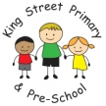

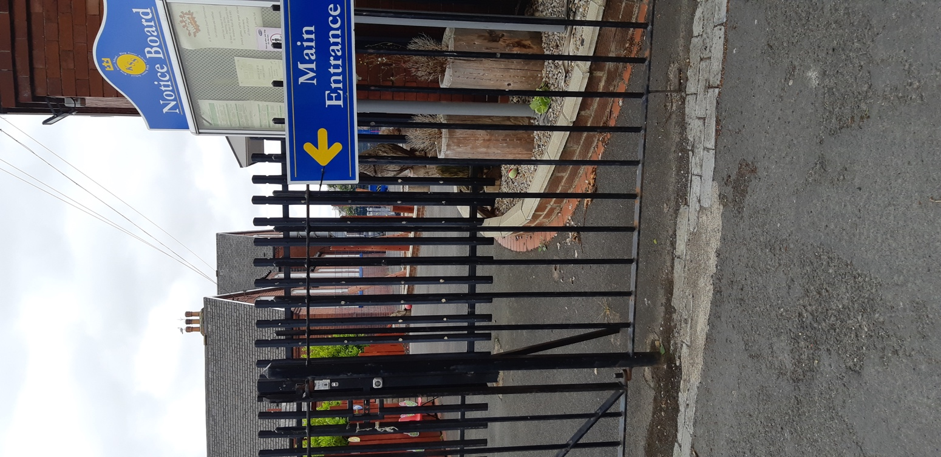

# Returning to School

# Social Situation

This is a social story to help aid the transition back into school for your child.

Please also see our website for further information as well as a video walk-through for each group or ‘bubble’.

[kingtsreet@eschools.co.uk](mailto:kingtsreet@eschools.co.uk)

If you need any further information, please do not hesitate to contact school.

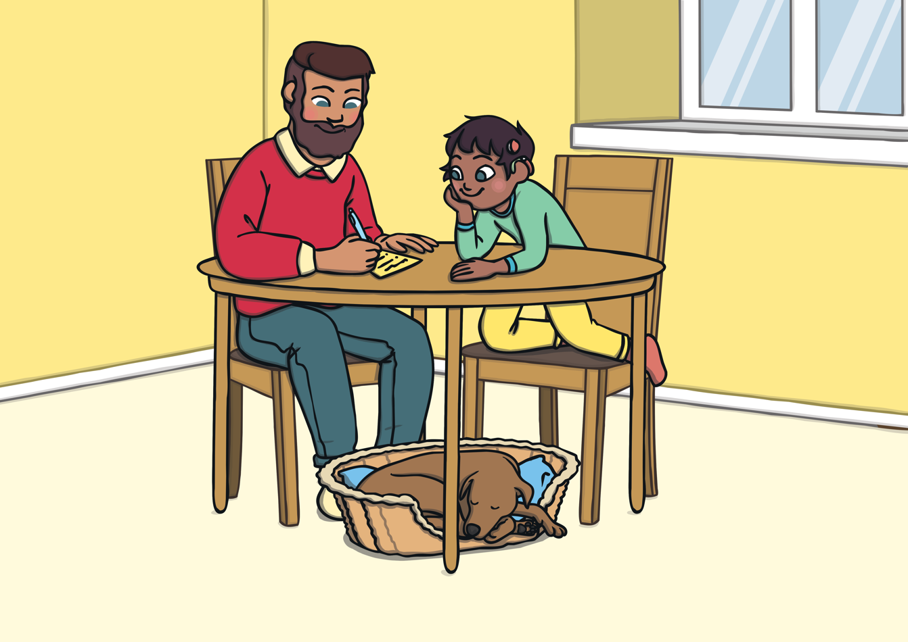

Over the past few months, I have not been at school. I have been staying at home because of coronavirus. During this time, I have been doing my schoolwork with my parents/carers. All of my friends from school have also been staying at home. Schools have been shut to keep me and my friends safe from coronavirus.

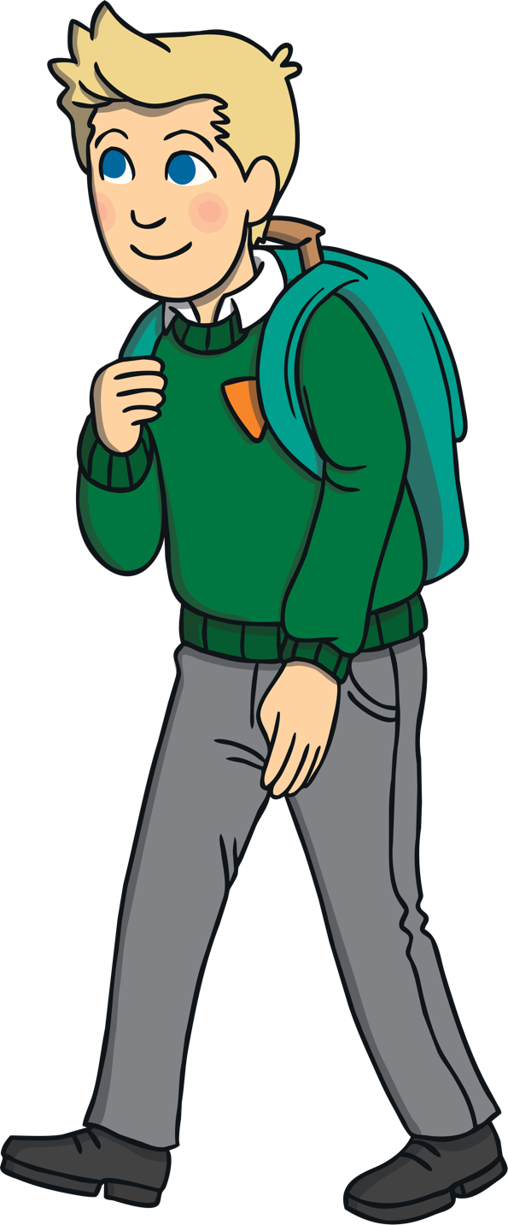

Doing my schoolwork at home has been fun but now it is time for me to go back to school, see some of my friends and do my schoolwork with teachers. To begin with, only certain classes will be going back. This is OK.

My teachers and friends will be happy to see me back at school. When I go back, some things will be different. This is to keep me safe. I might find the changes difficult at first but my teacher will be there to help me. Everyone finds change hard. This is OK.

* Breaktimes and lunchtimes might be at different times. I might not be able to sit and eat with my friends but I will be able to wave to them from a distance.
* I will be taught in a smaller class, which may be in a different classroom and with a different teacher.

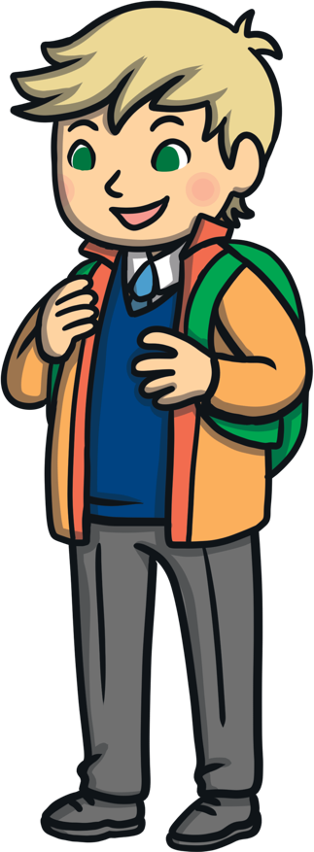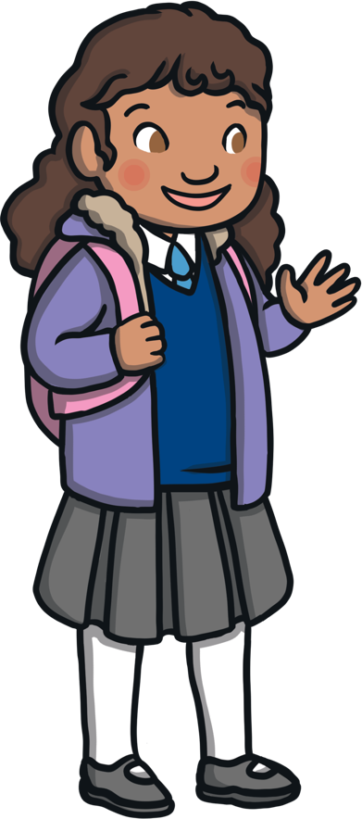

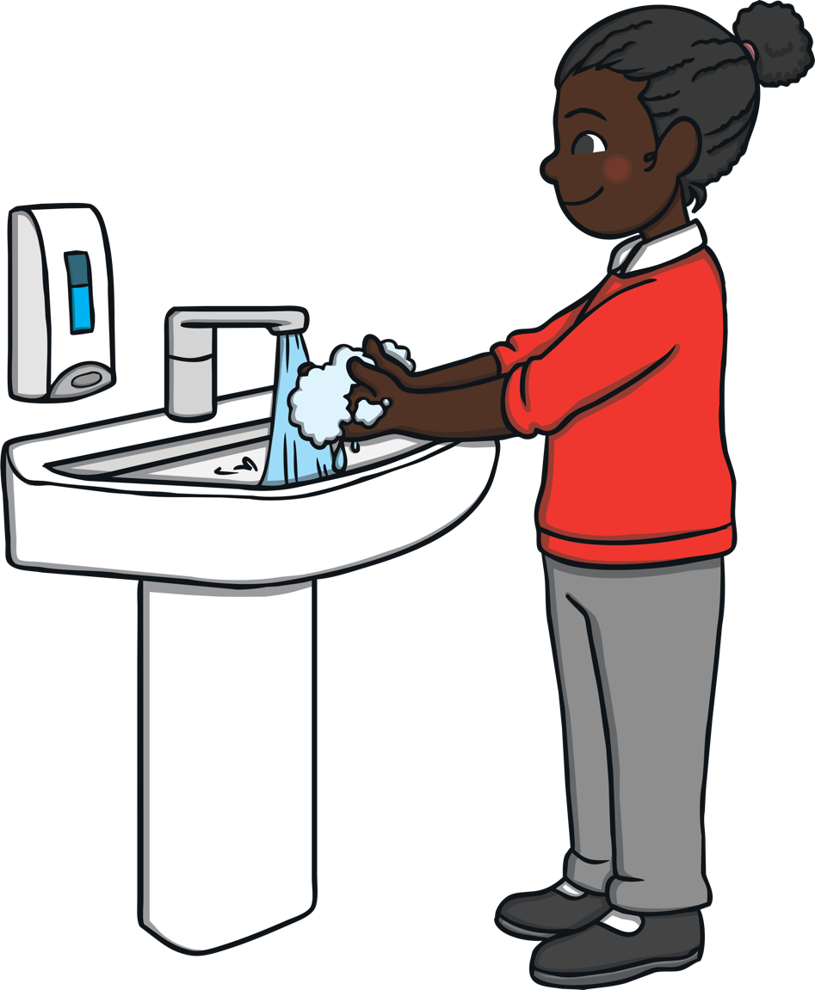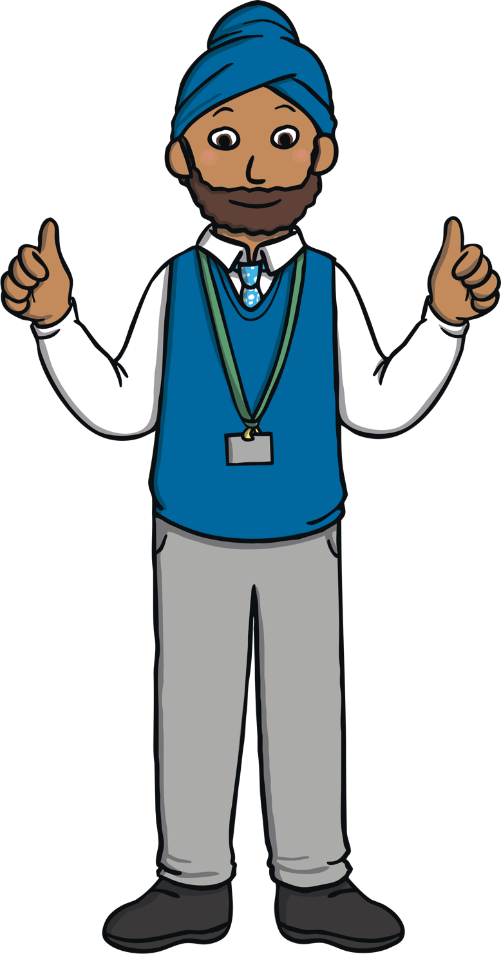

* I must keep washing my hands for at least 20 seconds.
* If I am going to sneeze or cough, I must do this into a tissue then put the tissue in the bin and wash my hands.
* I must try not to get too close to my friends and teachers. I cannot hold hands or hug my friends yet!

Going back to school will be fun. I must try to remember that the changes are to keep me safe. My teachers will be proud of me for trying to remember what I need to do to keep safe at school.