The school will:
- Provide a caring and safe environment for your child
- Teach all children in line with the National Curriculum, according to their individual needs.
- Maintain high standards of behaviour according to the school’s behaviour policy.
- Be welcoming at all times and offer you opportunities to become involved in the daily life of the school.
- Keep you informed about general school matters and in particular about your child’s progress.
- Set, mark and monitor homework and/or other home based learning according to the school’s homework policy.
- Contact parents if there are concerns regarding attendance or punctuality.
- Respond to your concerns and questions as promptly as possible.
- Provide opportunities for extracurricular learning.

Signed: ____________________ Head Teacher

Date: _________

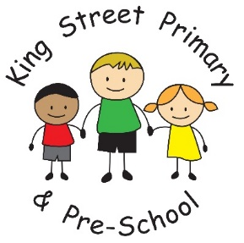

HOME SCHOOL AGREEMENT
2017 - 2018

This home/school agreement is a statement explaining:
- The school’s aims and values
- The school’s responsibilities towards its pupils
- The responsibility of each pupil’s parents
- What the school expects of its pupils

The Governors and staff of King Street Primary School ask parents/carers and pupils to sign the agreement to indicate that they understand and accept the contents.

As a parent/carer, I will set a positive example by:
- Ensuring that my child attends school on time and is properly equipped.
- Keeping the school informed of any changes in circumstances which might affect my child’s behaviour, attendance or learning.
- Supporting the school policies, rules and code of conduct on behaviour.
- Supporting the schools use of modern technologies and social media.
- Supporting my child’s completion of any homework or reading tasks.
- Attending parents’ meetings and discussions about my child’s progress.
- Avoiding holidays in term time.
- Being involved in my child’s learning and progress through discussions with my child, the staff, reading letters and the school’s website.
- Encouraging my child to take part in extracurricular activities.
Signed: ________________________
Relationship to child: ____________________
Date: _________________
As a pupil I will
- Be ready for learning
  - Always try my best
  - Listen carefully and follow instructions
  - Always have the correct equipment

- Be respectful
  - Allow others to learn
  - Be polite
  - Respect myself and differences in others
  - Care for other people’s property as well as my own.

- Around the school and community
  - Wear my uniform correctly and with pride
  - Move around school sensibly and keep myself safe at all times
  - Look after our school

Signed: _________________________
Print Name: _________________________
Date: ________________

Policy Review Date: November 2018

