King Street Primary & Pre - School
High Grange Road
Spennymoor
County Durham
DL16 6RA Telephone: (01388) 816078
Email: kingstreet@durhamlearning.net

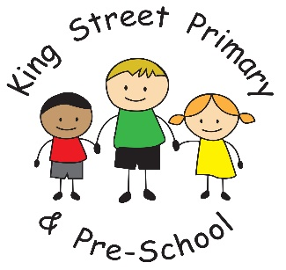

19th October 2018

Dear Parent/Carer,

This last week of term has come and gone so quickly I cannot believe we are nearly at the end of October. The children have had a delightful term with so many lovely activities, visitors, days out and things to make. This week alone we have had an owl in EYFS, Y6 have made electrical fairgrounds and Year 3 have made chocolate rocks! Next term looks to be just as busy with the first week starting us off with the ‘Friends of the School’ Halloween disco. Tickets for this are on sale now from class teachers or the school office, priced at £2.50 and will be available on Monday and Tuesday when we return.
Fundraising
We have been fortunate enough to secure a place at the local pantomime again this year for our Reception, Year 1 and Year 2 children. This will take place on Thursday 6th December during the school day. There is no cost for this as it is paid for through school fundraising. We are however, looking at ways of increasing our fundraising opportunities across the school year so we can continue to offer such lovely opportunities. We do try and balance these events out as we appreciate that having lots of non-uniform days, cake bakes and other events can end up costing families a lot of money- especially where there is more than one child. The positive from the fundraising is that all money is always spent on giving the children thoughtful and engaging experiences. Please do look out for our school in our local ASDA over the next few weeks. We have been selected to be one their ‘champions’ and have the opportunity to win some funding to develop our playground into a well-equipped learning environment. Please encourage your friends, family, neighbours and anyone else you know to vote for us by dropping their green token in the box when they are in store.
Learning attitudes and personal development.
If your child has been lucky enough to win our ‘Student of the week’ award, you may have noticed that our end of week celebration certificates have had a makeover! We are now linking the achievements to our ‘Gem Learning Powers’ which we introduced at the beginning of the term. The learning powers are all linked to essential life skills and when learnt and utilised, they help to create well rounded individuals who can collaborate, self-regulate their emotions and deal with all that life throws at us. I have included with this newsletter a list of the gems and what each one means. All staff refer to them during teaching and learning and we have already seen a huge improvement in children’s personal development- especially in rising to a challenge and being resilient. The gems are not specific to school and therefore you are welcome to use them at home to encourage independence, helping around the house and even being kind to siblings!
Finally, please remember if you have a child who will require a place in Reception or will be transferring to secondary school (Year 7) in September, you must apply for a place online through the Local Authority admissions portal. There are no places that are automatic- even if your child attends our Nursery. The portal is already open and instructions are given on how to use it.
I hope you all have a lovely half term- the weather at this point looks to be kind so hopefully that means you can utilise the outdoors before the snow starts!
Yours Sincerely
J Bromley
Head teacher

