King Street Primary & Pre - School
High Grange Road
Spennymoor
County Durham
DL16 6RA Telephone: (01388) 816078
Email: kingstreet@durhamlearning.net

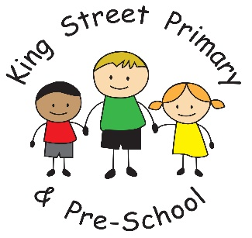

13.12.19

Dear Parents/Carers

It is hard to believe that we are nearly at the end of the Autumn term. Our children have had another lovely week and are still buzzing with excitement about their nativity performances. It makes us really proud to see how much our children develop in confidence over the relatively short number of weeks that they practise and we know you are equally proud of them too. The raffle was drawn after the final performance on Thursday and although a number of prizes were claimed on the day we still have the following prizes:

Thornton’s box of chocolates - blue/white ticket 173
Thornton’s box of chocolates- blue/white ticket 359
Bottle of Wine – blue/white ticket 80
Bottle of Prosecco- blue/white ticket 123
Bottle of Prosecco- peach ticket 867
Chocolate Santa- blue/white ticket 192
Chocolate Santa- peach ticket 443
Chocolate Santa- peach ticket 567
Chocolate polar bear- all blue ticket 984
Mulled wine- white/blue ticket 49

Please call into the school office with any winning tickets from Monday 16th.

Looking forward to next week, we have another busy time. Please note the following dates in your diary:
Monday 16th December – EYFS and KS1 (Year1/2) party- PM
Tuesday 17th December – Y3/4 party – PM
Wednesday 18th December – St Andrew’s church service 1:30pm (Parents are welcome to join us at the church)
Thursday 19th December – Y5/6 party PM
Individual class teachers will send out information regarding party clothes and food so please look out for these in school bags.

On Friday 20th December we will be having a dress down day. This is an opportunity for those children who would like to wear Christmas jumpers, headbands or even tinsel in their hair. Please do not go out and buy a Christmas jumper for the occasion as children are welcome to wear any other ‘dress down’ clothes. There is no donation required for this event, it is simply a celebration of the Christmas season and the last day of the school term. Please note that the school reopens on Tuesday 7th January. Breakfast club will open at 7:45am.

As always, if you have any questions or queries please do not hesitate to get in touch. We always have staff on the yard or you can call into the school office.

Yours Sincerely
Mrs J Bromley
Head Teacher

