King Street Primary & Pre - School
High Grange Road
Spennymoor
County Durham
DL16 6RA Telephone: (01388) 816078
Email: kingstreet@durhamlearning.net

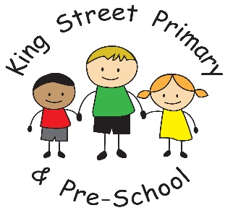

8th February 2019

Dear Parent/Carer,

As the end of this half term draws near I would like to thank the community members who are helping to make our school a success. We have at least one volunteer in school every day and the children are really enjoying working with them. The range of skills they bring are fantastic and we now couldn’t be without them.

Active Ted
We are currently trialling a new health and wellbeing scheme called Active 30. As part of this scheme we have a new healthy school mascot called Active Ted. Children in Year 6 are currently taking him home to participate in activities outside of school and they are sharing this on a closed Facebook group. If you would like to join the Facebook group to watch what Active Ted gets up to, search for ‘King Street’s Active Ted’ in the group search facility. We will be rolling this out across the school very soon so please watch out for him coming home and help him to get active. The children are loving it.

Sporting achievements
The basketball team have again won their latest tournament within the cluster of Durham schools and will now be going through to the County finals in June. This is an amazing achievement against some very strong teams but King Street’s team effort and competitive spirit shone through and we are all very proud. Well done to them all.

Other news
Apologies if your child did not bring any homework back this week – we had a paper shortage due to the delivery being delayed by a week. We are now fully stocked and it will resume as normal next week. It is amazing how much we’ve realised we rely on paper and does certainly highlight our need to cut down in the future to help save the planet!

You will notice our ‘very substantial’ fence is now near completion and I would welcome all parents to still come through the new gate and onto the yard itself to drop off and collect. We do not want it to be a barrier to you being able to speak to staff and wave your child goodbye.

Upcoming events:

Dress down day-Friday 15th February
Dress down day for our Rights Respecting Mascot. A letter explaining the day is being sent home with the children tonight.

World Book Day- Thursday 7th March
The costumes are beginning to appear in shops and our participation pack has arrived in the post which means that we are drawing closer to this annual event. We always celebrate this event to promote a love of books and to allow children to share their stories of books they have read. Please do not feel you must buy an outfit for the day- we often find the most creative ones are the ones that have been homemade from old T-shirts and blankets! More information on this event will be sent in due course.

Mother’s Day event- Friday 8th March
We are, again, hosting our Mother’s Day event in school this year and hope it will be as enjoyable as last year. This year we are offering cream scones, strawberries and a shortbread biscuit. Please look out for the letter coming home to book yourself a place. All requests must be made by Friday 15th February.

Please remember that school finishes for the half term next Friday (15th February) and re opens on Monday 25th February. Due to the very limited interest in holiday clubs this time, we are unable to offer any provision over half term but are hoping to restart it in the Easter holidays.

As always, if you have any queries or concerns, please contact us in school.
Yours Sincerely
J Bromley
Head teacher

