King Street Primary & Pre - School
High Grange Road
Spennymoor
County Durham
DL16 6RA Telephone: (01388) 816078
Email: kingstreet@durhamlearning.net

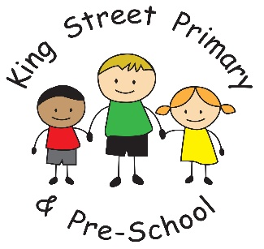

12th October

Dear Parent/Carer,

It really feels like we’ve had some Autumn weather now and our leaf and conker competition was very tough to judge! There has clearly been a lot of walking and foraging going on and many Autumn tales to tell. The children have thoroughly enjoyed this and I am pleased to announce that the winners of the conker competition were Dillan (Year 5) Kellan (Year 2), Missy-Jo (Reception), Evan and Kara Stanton (Year 5 & 3), Max (Year 3). The leaf competition winners were Seb (Reception), Lacey (Year 1), Oscar (Year 1), Katie (Year 2) and Carson (Year 6) .Well done to them all! We are now busy thinking of possible winter competitions but don’t want to encourage the snow to come too early!
In light of the weather today and the likelihood of further rain and winds, please ensure that your child brings a coat to school as some of our children have asked to stay in during playtime as they feel too cold to go outside. If anyone has lost a coat we have a number in school with no names on and you are welcome to come in and seek one out.

World mental health day
Some of you may have been aware that it was “World Mental Health Day” this week, we have been raising the profile of mental health in school this term and encouraged children to talk openly about their thoughts and feelings. Whilst there is a National Day to celebrate this, we will be continuing our work with children for much longer and integrating mental health into the school curriculum as well as training staff in more specific aspects of mental health. We do now have a Positives Future Worker in school who is working alongside children to support friendships, develop social skills and to better understand their emotions. If you have any concerns about your child’s emotional wellbeing please speak to a member of staff.

Football league
Well done to our undefeated footballers who have continued their winning streak and have now taken the title of League Champions. They have been rewarded with a fantastic medal and certificate which I am sure will take pride of place at home.

Parents’ Evenings
Thank you for taking the time to attend parents’ evenings this week, our staff enjoy the opportunity to talk to you 1:1 about your child and the progress they are making. It was lovely to hear the positive comments from parents and to hear children are enjoying their curriculum and are happy coming to school. If you have not yet been able to speak to your child’s class teacher, please do get in touch as we are still happy to make appointments.

Careers event
I asked last week if any parents or family members were willing to come into school and chat with groups of children about their chosen career. We hope to inspire the next generation of hairdressers, artists, scientists, pilots, sports stars and much more. Every job is worth discussing and we’d love more of you to help raise the aspirations of our children. We have 2 volunteers so far so if you would like to be involved please do contact school and we will give you more details of the event. Our children are our future and we need them to know what job possibilities are out there!

As always, please get in touch if you have questions or queries as we are here to help children and families.
Yours Sincerely
J Bromley
Head Teacher

