King Street Primary & Pre - School
High Grange Road
Spennymoor
County Durham
DL16 6RA Telephone: (01388) 8160781
Email: kingstreet@durhamlearning.net

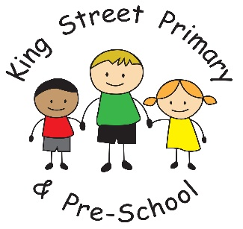

10.1.20
Dear Parent/Carer
A very happy new year to you all, from everyone here at King Street. We hope that this year is healthy and peaceful. We certainly have begun with lots of enthusiasm and excitement and Year 6 have already had the pleasure of a visitor from the DLI, Year 2 and 4 are starting Outdoor Education sessions and Early years and Year 1 will have weekly Forest school sessions. On top of this we have many sports festivals and visits planned. Listen out for your child talking about ‘Now press play’. This is a new resource in school trialled by our Year 3 children and it seems like it is going to be very well used! Our classrooms are always buzzing. If anyone would like to volunteer in our classrooms, as a reader or to help on visits, we always welcome your support.

Funeral of John Toas
Today is the funeral of our much-loved crossing patrol. We have paid our respects in school today and I will be passing on the contributions from the children and staff. Thank you for your continued efforts to ensure he continues to be remembered.

Applications for school places.
Please remember that the deadline for a place in Reception class for September is looming (15th January) and ensuring your application is in on time is the best way of securing your first choice place. Applications are made directly through Durham county council admissions- they have an online portal.
Secondary school place applications have already closed but you can still make a late application by contacting admission at County hall.

New starters
We have a number of new families starting the school this term both in Early years and also across the school. We would like to welcome everyone and know that you will become part of the community very quickly- the children have certainly settled in well.

Contact details
We would just like to remind people to keep us up to date with new contact details, both phone numbers and emails. We appreciate that at this time of year many people may have upgraded phones and just need to keep our records up to date.

Uniform bank
Thank you for all of the recent donations of uniforms and coats- it is amazing that after only a term children can grow out of them so quickly. Due to the high quality of clothing donated, we would like to take the opportunity to offer these items to other families. If your child has grown out of anything and you need replacements, please do try us before purchasing new things- this way we can reduce costs for everyone and help save the planet!

If there is anything at all that you would like to speak to us about, please speak to a member of staff on the yard or make an appointment through the school office. We are here to help you and your child.

Yours Sincerely
Joanne Bromley
Head teacher

