 | Multi-Agency Meetings |  | Page
  Strategy | ●Referral taken up by First contact Service: ‘reasonable cause to suspect child is suffering or likely to suffer significant harm’. ●To agree whether to start s47 enquiries and to begin/complete a core assessment under Child Act 1989. ●Professionals meeting only ●Held at short notice (some professionals may be available by phone).Police Sergeant and investigating officer (VU); Assessment and Intervention Team manager and SW, Health, referrer (if professional) and other relevant colleagues. ●Usually held in A&I Team office, hospital. ●To PLAN how to look into the concern: share information, consider criminal investigation, medicals, interviews etc. |  | 25
Initial Child Protection Conference   | ●15 DAYS after last strategy meeting ●Accessible public building: A&I offices ●Parents/carers (supporter/legal adviser) and all relevant professionals who work with family members and children attend ●  Conference is to decide whether the child(ren) are at continuing risk of significant harm and whether CP Plan needs to be put in place. ●Tasks: prepare a report for the conference on all children in family you work with ●Share report with parents and carers at least two working days before the conference (open/transparent procedure so parents can know and question all information in advance).●Ensure that child’s views are given ●Produce single-agency chronology. ●If children not put on list then consideration of services needed, now passes to relevant Child Protection Team. |  | 32
Core Group  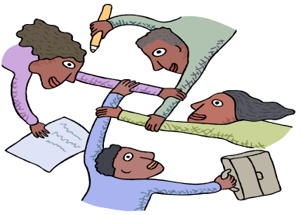 | ●10 DAYS later. Date for this meeting and first Review Conference is set at the Initial Conference ●This ‘core’ of essential professionals will work with the family and the young person to try and achieve change and improvement so that the child is not still at continuing risk of harm (these safety issues are dealt with before other ‘welfare’ matters) ● Key worker is the social worker ●The group complete the Child Protection Plan and complete work on the core assessment as part of this ●The chronologies are merged and continuously updated as working documents ●Initially meetings quite frequent but generally held about every 4-6 weeks |  | 36
  Review CP Conference | ●10 WEEKS (3 months) before first Review conference.● Evaluate effectiveness of Core Group in effecting change and better care of the children ● ‘..to review the safety, health and development of the child against the planned outcomes set out in the child protection plan’ ●to see whether CP plan should continue to be in place or should be changed ●Child’s wishes and feelings must be sought and taken into account ●if the child is not still at risk of significant harm then they should not require a CP plan ●Tasks: report needed and shared with parents/carers 7 days prior to conference: evaluation what has changed, the impact on child’s welfare against objectives set out in the plan |  | 40

