King Street Primary & Pre - School
High Grange Road
Spennymoor
County Durham
DL16 6RA Telephone: (01388) 816078
Email: kingstreet@durhamlearning.net

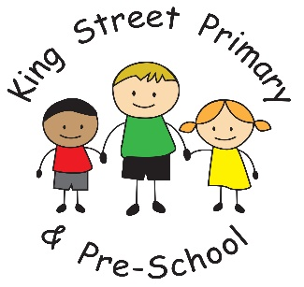

28th September 2018
Dear Parent/Carer,

What a wonderful, busy week we have had. The term already feels like it is flying by and conversations are turning to Christmas performances and parties! Next Friday (5th October) is our Harvest service at St Andrews Church. We ask that if you would like to attend you are at church for a 1:30pm start. If you have any donations of food for the Harvest Festival please take these to church with you where they will be collected and distributed at a later date.

After School Club
Our After School Clubs are continuing to be popular with children. They are benefiting from highly experienced coaches who are teaching them some fantastic skills- the karate club is particularly impressive to watch! If you have any further ideas for clubs we could run or contacts for coaches or organisations, we are always looking to improve what we can offer.

Year 1 trip
This week our Year 1 class visited Shildon Train Museum and had an amazing time. The children were very excited to be adventuring on a big bus and learnt so much about early transport. I must also commend their behaviour, which was fantastic throughout and was praised by the staff at the museum. Well done Year 1.

Early morning behaviour
We have had reports of a small number of our pupils who are pushing and shoving before coming into school on a morning. This appears to be happening at the gated entrance from the side road and is just before the gates open at 8:40am. We have spoken to pupils about managing their behaviour, not throwing school bags around and being courteous to those around them. There have been instances of young children and parents with pushchairs being knocked and this is not fair. Children who are arriving at school without adult supervision should be old enough and responsible enough to regulate their behaviour and behave appropriately. Please ensure if your child arrives at school alone that you are confident they are well behaved.

Leaf and conker competition
It is Autumn time again and that means our leaf competition is back! Children have been encouraged to hunt for the ‘darkest red leaf’ and ‘the darkest yellow leaf’ that they can find and bring them into school. Staff will judge who the winner will be and prizes will be awarded! This year we have added another element – The biggest conker! We would love children to get out and about (safely) and hunt for conkers. They can bring in the biggest one they find and again, there will be a prize for the winner. Happy hunting- it is a lovely time of year to get out and about.
As always if you would like to discuss anything or help as a volunteer, please get in touch.

Yours Sincerely
J Bromley
Head Teacher

