King Street Primary & Pre - School
High Grange Road
Spennymoor
County Durham
DL16 6RA Telephone: (01388) 816078
Email: kingstreet@durhamlearning.net

18/05/18

Dear Parent/Carer,

This week seems to be full of celebrations. I would like to say a huge well done to our Year 6 children who have now completed their SAT’s. As always, they are a challenging few days but the children have risen to this challenge and made the whole week look easy! We are incredibly proud of the progress they have made since they started with us and appreciate that the SATs do not represent the ‘whole child’ and all their individual talents and we know they will continue to flourish through the rest of their time with us and beyond. I would also like to thank staff and parents for all the extra hard work that has gone into booster sessions and moral support as it has all contributed to their success.

On the theme of celebrations; Mrs Kay Johnson (our Teaching Assistant in Year 1) surprised us all by getting married and is now known as Mrs Wilson. The photographs of the day were delightful and they were lucky enough to have beautiful weather for the whole day. Congratulations to both Mr and Mrs Wilson from all of us.

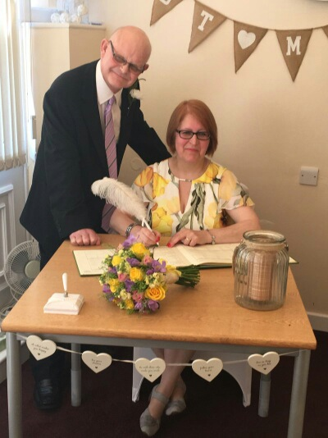

Our Year 2 children will take their turn with SATs over the next 2 weeks. Whilst this is informal, it is important that children attend at all times to ensure that they are present to undertake them. The children should not feel any pressure for these and we are not expecting that parents need to do additional boosters at home or worry about them. Staff in school know the children really well and already know how well the children are doing- the SAT’s are simply a Government way of tracking and comparing schools. Eventually, the Government do have plans to phase these tests out; as we all know that testing isn’t the best way to see what a child can do!

The subject of children using digital media and games has arisen in school again this week with an incident which we found repulsive but is representative of the dangers of children using online games where other people can access the games as another player. These players are often unknown and have the potential to pose a significant threat to children and expose them to highly explicit and inappropriate content. I would like to advise parents who may not know much about the games the children are playing that, despite parental controls, there are still opportunities for children to be listening to inappropriate content. Please talk to your children about the importance of staying safe online.

As always, if you have any questions, queries or concerns please speak to us at school. We urge you not to use social media to raise any questions or concerns as this does not always generate accurate information.

Joanne Bromley
Head teacher
Date | Time | Event
Friday 25th May | 5.45 | School Closes for Half Term Holiday
HALF TERM HOLIDAY
Monday 4th June | ALL DAY | CPD Day – School Closed
Tuesday 5th June | 7.45 | Schools Re-Opens
Friday 15th June | 1.00 | Fathers’ Day Event
Wednesday 27th June | 1.00 – 3.00 | EYFS & KS1 Sports Day
Thursday 28th June 2017 | 1.00 – 3.00 | KS2 Sports Day
Monday 2nd – Wed 4th July | 3.00 – 6.00 | Parents Evening (Pre-School to Year 5)
Tuesday 10th – Thursday 12th July | 3.00 – 6.00 | Parents Evening (Year 6)
Wednesday 18th July | 1.45 | Year 6 Leavers’ Assembly
Thursday 19th July | 6.00 | Year 6 Sleepover
Friday 20th July | 5.45 | School Closes for Summer Holiday

