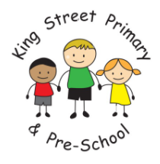

Dear Parent / Carer,
Due to the government announcement last night about school closures and tighter lockdown measures, I am writing to you to explain about the remote learning that we are providing for the children.
The children made fantastic progress last term and I know that this will continue if the work that is set is completed. The children will be set 3 – 4 hours of work a day, in line with the amount of time that would be spent learning on a normal day. The children should still have break times and a lunch time to keep with the school routine. However, I know that due to work and home commitments and other siblings, the exact timings of home schooling may differ to those that we follow in school.
I will continue to use eSchools as our way to communicate. I will message you and the children through this and you can contact me during working hours. Each day, I will send a message outlining the learning for the day. I will try to keep some of the routines that we do at school already as the children are comfortable and happy with these. Please help your child log-on to and check eSchools regularly to make sure that they are keeping up with the work set.
Additionally, we have some extra learning platforms that will help with your child’s teaching and learning. I will be using these to set work that matches the Year 2 curriculum and the learning that I had planned for the half term.
These are…
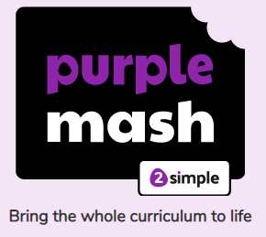
Purple Mash – this is an online learning platform that has learning activities in Maths, English and our topic subjects.
Each child has a log-in for this which have been put into their home learning folder. The activities are completed online and I am able to monitor progress.

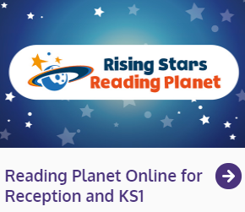
Rising Stars Reading Planet is an online reading scheme. This is going to be brilliant as we will not be sending books home. Your child will be assigned books that match the colour book band that they read in school. They can open the book and read it online and then there are questions to answer, which is fantastic for comprehension.

Sumdog is another online learning platform that we will be mainly using for Maths. There are lots of exciting and fun games and you can compete against other people!

A number of children are using Lexia as a reading program. This can continue to be used at home as normal.

In addition, I will be using websites such as YouTube, Top Marks, Phonics Play and BBC Bitesize to provide learning opportunities. I will provide the links to these on the days that we are using them.
Please make sure that when using any of these websites you are completing activities for Year 1 or Year 2, or Key Stage 1, or in phonics, Phase 2, 3, 4 or 5.

Activities on the online platforms will not require paper and pencils as I will see the progress as it is completed online. If there are activities that are to be done on paper, you can take a photograph of it and send it to me through eSchools messages.

Last term, we spent a lot of time thinking about wellbeing and keeping our minds and our bodies healthy. We know that we need to drink water, eat lots of fruit and vegetables, get enough sleep and be active to help our brains learn. We had started running for 5 minutes everyday and also did regular yoga and stretching. This fits with our learning about Team Up and the Brainy Bunch, which the children are very knowledgeable about! Please support your child in encouraging this at home and message me if you have any questions.

I hope that this makes sense and I look forward to hearing from you and your child and seeing all the fantastic work that they produce this term.

Take care and I look forward to seeing you soon.
Kind regards
Mrs Cornley

