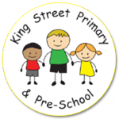
Year 5 Summer Term Newsletter

Miss Lloyd and Miss Lowery would like the opportunity to welcome everyone back after the Easter holidays! We hope you all had a good rest and are ready for what this term has in store! Below is a reminder about day to day school routines, expectations and our theme this term.
Homework and Spellings
As per the last two terms, the only homework will be reading books and a set of 10 spellings to learn weekly. Spellings will be sent out at the beginning of the week and the test will be on Friday of the same week. Please do try to listen to your child read each night as this time is vital for embedding and developing reading skills.
Additionally, you can help your child to feel confident and prepared for Year 5 by practising all times tables at home, as well as corresponding division facts.
Extra home- learning challenges and creative projects, linked to our learning in school, will be sent home, via letter or text message and will be used to extend and broaden learning that has taken place in school. We loved the monsters that the children made in the February half-term! We’ll have our thinking hats on for a May half-term project!
Also, keep checking our class page on the school website for regular updates on our learning.

Reading
Children should be reading for around 10 minutes per night and we ask that the reading records are completed by parents at least three times a week. In the comment box in the reading diary, please do comment on what you discussed with your child, any questions your child asked about the text, what they enjoyed and any aspects they found more challenging. Children may fill in information such as the name of the book and pages read but an adult signature is required.
We will check reading records each Monday morning. If your child has not read 3 times at home during the previous week and had it signed by an adult, we will ask them to stay in for 5-10 minutes at break to read to an adult in school.
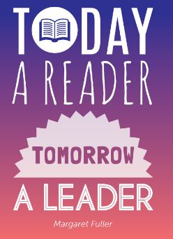

Outdoor Ed
Outdoor Education will take place each Thursday. Each week, one third of the class will attend Outdoor Education sessions with a member of staff and the Real Adventure team. We will be taking part in a variety of activities including: canoeing, kayaking and climbing wall activities. It sounds like lots of fun! Please ensure you have checked the letter from last term and know the dates your child will be attending; also, that they have appropriate clothing and shoes.
PE
This term PE will take place on a Wednesday morning and afternoon. Swimming lessons will take place Wednesday morning and PE will be with Mr Swift in the afternoon. Therefore, I ask that PE kit comes into school Monday morning to avoid children having to remember too much on Wednesday.
Pupils will need black shorts, a plain t-shirt in their house colour, socks, plimsolls or trainers. We do lots of PE outside so you may also like to provide jogging bottoms. Long hair should be tied back and earrings taken out or covered for PE.

Our topic this term is ‘Spies and Superhumans’. We will be kicking off our topic by exploring the story ‘Skellig’ by David Almond. Our first few days will begin with some artwork linked to the book. In History, we will look at the secrets of the codebreakers during World War II at Bletchley Park. In Geography, we will continue to use Digimaps to improve our mapping skills and participate in some fieldwork activities. Furthermore, our Science will be focussed around properties of materials. This will link to our STEM activity, which will involve building a simple machine using levers, gears and pulleys.
A more detailed curriculum map will be attached with this newsletter and will be available on our new school website shortly.
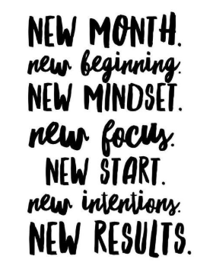
Thank you so far for your support this year. If you have any questions, please do not hesitate to come and speak to us.
Miss Lloyd and Miss Lowery

