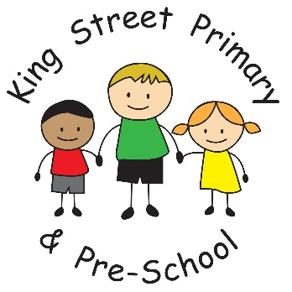

Teaching Children to Manage Strong Emotions

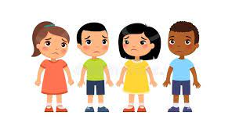

Sometimes our children can struggle at home to contain their strong emotions, we have put together some ideas and techniques that might help you to support children in managing these feelings.
How about putting together a list of household rules? Here’s an example, although it might be an idea to sit down together and think about what you would put on yours. Perhaps your child could write out and decorate your very own one!

Household Rules.

- Treat each other with respect
- No hitting allowed
- Bedtime is at 8.00 p.m.
- One hour on devices a day
- If you make a mess – tidy up
- Be honest

A list of rules shouldn’t be too long or no one will remember them all. It is useful to have this as a visible reminder.
Remember that household rules apply to everyone!


Hand Breathing.

Children are taught how to calm down by breathing in this way:
- Stretch your hand out like a star
- Get the pointer finger of the other hand ready to trace your fingers up and down.
- Slide up each finger slowly, breathe in through your nose
- Pause at the top
- Slide down the other side, breathe out through your mouth
- Keep going until you have traced all of your hand.

This technique is useful when you notice your child getting stressed or anxious. It is also helpful when a child has had an outburst to help them to calm back down.

Bedtime Routine.
Often children struggle with bedtimes and a routine is helpful; it lets everyone know what to expect and is clear that the end point is the child going to sleep!
Here is an example, again it can help to plan this alongside your child and make it more personal to them.

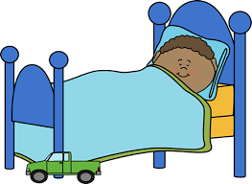
- Non-screen time
- Put on Pjs
- Snack
- Brush teeth
- Story
- Bedtime
- Lights off at 8 p.m.

If it is useful, you might want to look at this alongside a reward chart – giving out stickers or points when your child manages to stay in bed. As the number of points or stickers increases rewards can be given.

Flow Chart

Using a flow chart can be a great way to help children see the consequences of their behaviour.
It’s a good idea to discuss what are positive and negative behaviours with your child, the more they are involved in the discussion, the more it will help them to feel that this is about helping them to make the right choices.

Make the reward something that the child will like and want to work towards. However, it’s not a good idea to make the reward too big!

It can take a while for the children to follow the flow chart and adjust their behaviour – be patient!

Positive behaviours Negative behaviours
Being helpful
Following household rules
Being kind
Completing homework tasks
Being positive about family and school
Using a ‘quiet’ voice inside
Showing respect -please and thank you
Following bedtime rules
Shouting at others
Being unkind
Not following instructions
Being negative about family and school
Not using manners
Ignoring bedtime rules
Breaking household rules
Hitting, kicking, breaking things
Hurting people

Praise
Time playing family games
Stickers
Treats
Some time on devices
Film night – your pick!

Told off -warning
Miss some time on devices
Miss out on treats
Miss out on playing family games
Toys/games removed for a period of time

Gratitude Jars

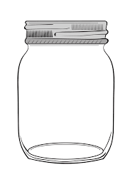
Sometimes it is easy to focus on the negative areas of children’s behaviour, however, studies have shown that looking out for those things that make life good can be helpful.

The idea of a gratitude jar is that the whole family writes down one thing each day that they are grateful/ thankful for and pop it in the jar. At the end of the week all of the notes are read out and enjoyed. The children can have fun decorating a jar to make it look exciting.

The points that are written down can be anything for example; I am grateful that the sun was out today, I am thankful for my family, I am thankful that we had my favourite tea, I am grateful that I can spend time with my friends.

