King Street Primary and Pre-School
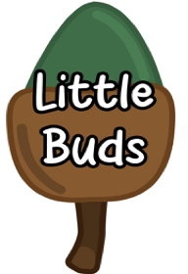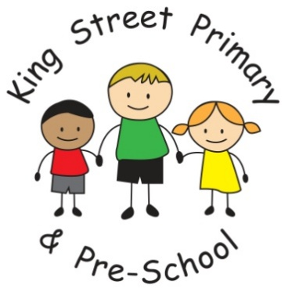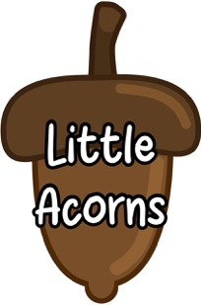
Early Years Foundation Stage
(EYFS) Policy
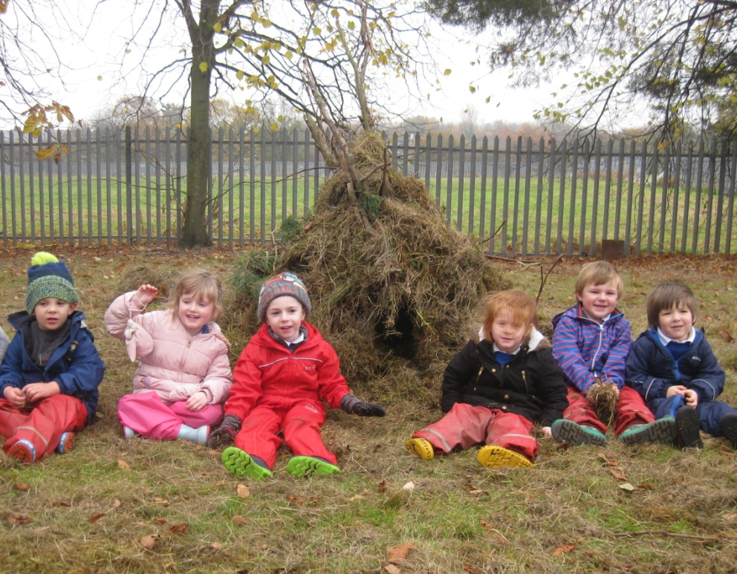

Policy last reviewed: September 2025
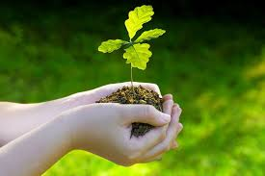
“1. All children deserve the care and support they need to have the best start in life. Children learn and develop at a faster rate from birth to five years old than at any other time in their lives, so their experiences in early years have a major impact on their future life chances. A secure, safe, and happy childhood is important in its own right. Good parenting and high-quality early learning provide the foundation children need to fulfil their potential.
2. The EYFS sets the standards that all early years providers must meet to ensure that children learn and develop well and are kept healthy and safe. It promotes teaching and learning to ensure children’s ‘school readiness’ and gives children the right foundation for good future progress through school and life.
3. The EYFS is about what children learn, as well as how they learn. Effective practice is a mix of different approaches. Children learn through play, by adults modelling, by observing each other and through adult-guided learning.
4. The EYFS seeks to provide: • Quality and consistency in all early years settings, so that every child makes good progress, and no child gets left behind. • A secure foundation through planning for the learning and development of each individual child and assessing and reviewing what they have learned regularly. • Partnership working between practitioners and with parents and/or carers. • Equality of opportunity and anti-discriminatory practice, ensuring that every child is included and supported.” - Statutory Framework for the Early Years Foundation Stage”, Department for Education 2025.
Our Intent and Aims
Within Early years at King Street Primary and Pre-School we aim to:
- offer each child the best possible learning opportunities in a caring, challenging, attractive environment so that they can develop academically and personally to their full potential.
- ensure each child has a happy, positive and enjoyable start to their school life within a safe and secure environment
- establish solid foundations and foster a deep love of learning
- enable each child, through encouragement and high expectations, to develop socially, emotionally, physically and intellectually in order to thrive in a diverse and ever changing world
- offer a rich curriculum that has a range of starting points and unlimited opportunity for development
- encourage children to develop independence within a nurturing and supportive atmosphere
- support children to build relationships through the development of social skills such as kindness, good manners, cooperation and sharing
- help each child to recognise their own strengths and achievements by experiencing success and developing their determination and self-confidence and to show resilience when working towards personal goals
Legislation
This policy is based on requirements set out in the 2025 statutory framework for the Early Years Foundation Stage (EYFS)
Implementation
Structure of the EYFS
The Early Years Foundation Stage (EYFS) applies to children from birth to the end of Reception year.
This Early Years Foundation Stage Policy at King Street Primary and Pre-School applies to all children joining us in our Pre-School Nursery provision and throughout their Reception year.
At King Street Primary and Pre-School, we welcome children into our Little Buds Nursery (Pre-School) the term after their second birthday (or the day of their second birthday if they are in receipt of a Durham County Council Golden Ticket), into our Little Acorns Nursery the term after their third birthday (or the day of their third birthday if they are in receipt of a Durham County Council Golden Ticket), or into our Reception class children join us at the beginning of the school year in which they turn five.
In EYFS, we follow the Early Years Foundation Stage Framework. The Prime areas of learning (Communication and Language, Personal, social and emotional development and Physical Development) are at the heart of our early years curriculum alongside the Specific areas (literacy, mathematics, expressive arts and design, understanding of the world). We provide a varied and engaging programme of teaching and learning and our continuous and enhanced provision enables the children to demonstrate the characteristics of effective learning.
Our curriculum is skills based and our approach focuses on key skills rather than concepts, which are revisited throughout the year in line with the children’s needs. Input may be through whole class teaching, group work, work with individuals, through adults supporting within the continuous provision or enhancements made to continuous provision. Our curriculum ensures that children are ready for the next stage of their learning journey as they move through school.
Our Learning Environment
Our Early Years Foundation Stage consists of two Pre-School Nursery classes and one Reception class. There are large, neutral separate classroom spaces, a shared focused-teaching space and a large shared outdoor ‘learning landscape’. In our Pre-School, staffing includes a teacher and two teaching assistants. In Reception staffing includes a teacher and teaching assistant. We also employ teaching assistants that support children with significant needs 1-1.
The EYFS Unit is organised to allow children to explore and learn securely and safely. There are areas where the children can be active, be quiet and rest. The classrooms are set up in learning areas, where children are able to find and access equipment and resources independently.

Although areas of the classroom change throughout the year due to the needs of the children, we always have a reading nook, construction area, home corner, maths area, message centre (so that children can access paper and writing tools which can be taken to any area) and we have access to a space for baking when needed.

Children have free access to our recently developed and extended enclosed outdoor area. This has a positive effect on the children’s development: being outdoors offers opportunities for doing things in different ways and on different scales than when indoors. It offers the children the opportunity to explore, use all of their senses and be physically active and exuberant.

We plan activities and resources for the children to access outdoors that help the children to develop in all 7 areas of learning.

Learning and Development – Our broad and ambitious EYFS Curriculum
In Reception we follow the curriculum outlined in the Early Years Foundation stage (EYFS) document. The framework defines what we teach and we use the Development Matters guidance and Birth to Five to support our curriculum. The EYFS framework includes seven areas of learning and development. All areas of learning and development are important and inter-connected. Three areas are particularly crucial for igniting children’s curiosity and enthusiasm for learning, and for building their capacity to learn, form relationships and thrive. These three areas, the prime areas, are:
Communication and Language | - Listening, Attention and Understanding  - Speaking
Physical Development | - Gross Motor Skills  - Fine Motor Skills
Personal. Social and Emotional Development | - Self-regulation  - Managing Self  - Building Relationships
In addition to the above there are a further four specific areas through which the three prime areas are strengthened and applied. These are:
Literacy | - Comprehension  - Word Reading  - Writing
Mathematics | - Numbers  - Numerical Patterns
Understanding the World | - Past and present  - People, culture and communities  - The Natural World
Expressive Arts and Design | - Creating with materials  - Being Imaginative and expressive

None of these areas can be delivered in isolation from the others. They are equally important and depend on each other. All areas are delivered through a balance of adult led and child-initiated activities.
We enrich the Early Years framework with our ‘King Street Primary and Pre-School’ curriculum to enhance the experience and opportunities available to the children. This includes special events and celebrations, memorable experiences and themes selected to drive the curriculum.
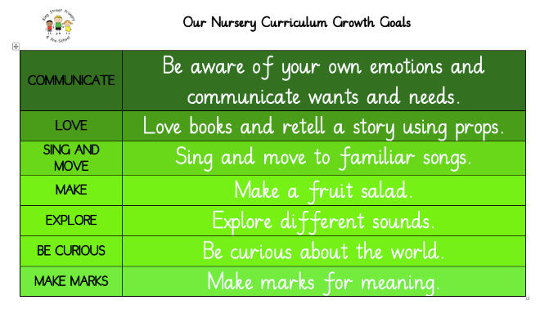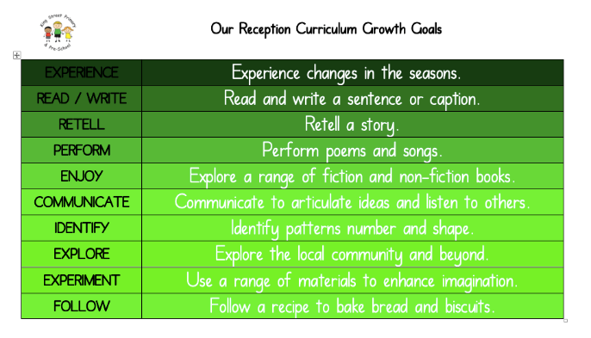
Characteristics of Effective Learning
Throughout all of these areas of learning and at the heart of the EYFS Curriculum are the “Characteristics of Effective Learning”. These help practitioners to identify a child’s attitude to learning and their ability to play, explore and think critically about the world around them. These are:
Playing and Exploring - children investigate and experience things, and ‘have a go’
“Children’s play reflects their wide ranging and varied interests and preoccupations. In their play children learn at their highest level. Play with peers is important for children’s development.”
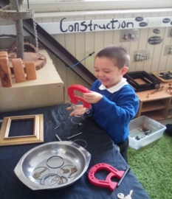
Learning through play underpins our approach to teaching and learning in the foundation stage. We embrace the fact the children learn best from activities and experiences that interest them and inspire them to learn. Our children access continuous provision throughout the day which provides them with stimulating, active play to encourage creative and critical thinking alongside other children, as well as on their own. Children are able to practise skills, build upon and revisit prior learning and experiences at their own level and pace. Play gives the children the opportunity to pursue their own interests, inspire those around them and consolidate their understanding and skills. The children learn to adapt, negotiate, communicate, discuss, investigate and ask questions. The adults in our setting take an active role in child-initiated play through observing, modelling and questioning. They teach and extend play while developing skills and communication and language. At King Street Primary School outdoor play is of equal importance therefore access to our outdoor area is available throughout much of the day.
Active Learning - children concentrate and keep on trying if they encounter difficulties and enjoy achievements.
“Children learn best through physical and mental challenges. Active learning involves other people, objects, ideas and events that engage and involve children for sustained periods.”
Active learning occurs when children are motivated and interested. Children need to have some independence and control over their learning. As children develop their confidence, they learn to make decisions. It provides children with a sense of satisfaction as they take ownership of their learning.
Creativity and Critical Thinking- children have and develop their own ideas, make links between ideas, and develop strategies for doing things.
“When children have opportunities to play with ideas in different situations and with a variety of resources, they discover connections and come to new and better understanding and ways of doing things. Adult support in this process enhances their ability to think critically and ask questions.”
Our children are given opportunities to be creative through all areas of learning, not just through the arts. Adults in our setting support children’s thinking and help them make connections by showing genuine interest, offering encouragement, clarifying ideas and asking open ended questions. Our children can access resources freely and are allowed to move them around the classroom to extend their learning.
A Unique Child
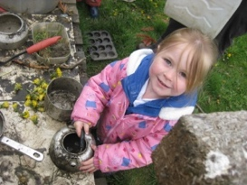
At King Street Primary and Pre-School EYFS Unit School we recognise that every child is a competent learner who can be resilient, capable, confident, and self-assured. We recognise that children develop in individual ways and at varying rates. Children’s attitudes and dispositions to learning are influenced by feedback from others; we use praise and encouragement, with our focus being on the process rather than the product, as well as celebration/ sharing assemblies and rewards linked to gem powers, to encourage children to develop a positive attitude to learning.
Inclusion
The EYFS seeks to provide equality of opportunity and anti-discriminatory practice, ensuring that every child is included and supported.
We value the diversity of individuals within the school and do not discriminate. All children at King Street Primary and Pre-School are treated fairly, regardless of race, religion or abilities. All children and their families are valued within our school. In our school we believe that all of our children matter. We give our children every opportunity to achieve their best. We do this by taking account of our children’s range of life experiences when planning for their learning. In the EYFS we set realistic and challenging expectations that meet the needs of our children. We achieve this by planning to meet the needs of boys and girls, children with special educational needs, children who are more able, children with disabilities and children from all social and cultural backgrounds.
We meet the needs of all our children through:
- planning opportunities that build upon and extend children’s knowledge, experience and interests, and develop their self-esteem and confidence;
- using a wide range of teaching strategies based on children’s learning needs; providing a wide range of opportunities to motivate and support children and to help them to learn effectively;
- providing a safe and supportive learning environment in which the contribution of all children is valued;
- using resources which reflect diversity and are free from discrimination and stereotyping;
- planning challenging activities for children whose ability and understanding are in advance of their language and communication skills;
- monitoring children’s progress and taking action to provide support as necessary.
Welfare
“3.1 Children learn best when they are healthy, safe and secure, when their individual needs are met, and when they have positive relationships with the adults caring for them.” – EYFS Statutory Framework (September 2025)
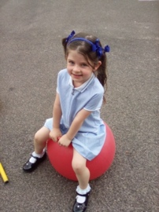
The EYFS specifies requirements for safeguarding children and promoting their welfare. It is important to us that all children in our school are safe. We aim to educate children on boundaries, rules and limits and to help them understand why they exist. We provide children with choices to help them develop this important life skill. Children should be allowed to take risks, but need to be taught how to recognise and avoid hazards. We aim to protect the physical and psychological well-being of all children.
At King Street Primary and Pre-School EYFS Unit School we understand that we are legally required to comply with certain welfare requirements as stated in the Statutory Framework for Early Years Foundation Stage 2025. We understand that we are required to:
- Promote the welfare of children.
- Promote good health, preventing the spread of infection and taking appropriate action when children are ill.
- Safeguard all our children.
- Manage behaviour effectively in a manner appropriate for the children’s stage of development and individual needs.
- Ensure all adults who look after the children or who have unsupervised access to them are suitable to do so.
- Ensure that the premises, furniture, and equipment is safe and suitable for purpose.
- Ensure that every child receives enjoyable and challenging learning and development experiences tailored to meet their needs.
- Maintain records, policies and procedures required for safe efficient management of the setting and to meet the needs of the children.
- Ensure staff are aware of the setting’s whistleblowing procedures and must ensure all staff feel able to raise concerns about poor or unsafe practice and know that such concerns will be taken seriously by the senior leadership team.
- Ensure that children attend Nursery/School regularly and any absences are checked if school has not been notified with patterns or trends identified to ensure that all children are safe.
- Ensure that food has been prepared safely and correctly in accordance to Government guidelines to ensure that risks to choking and allergies has been minimised with staff ensuring correct supervision of children.
We take all necessary steps to meet all these requirements and keep our children safe and well.
Positive Relationships
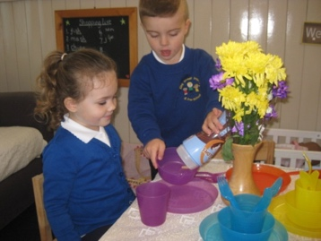
At King Street Primary and Pre-School EYFS Unit we recognise that children learn to be strong and independent from a base of loving and secure relationships. We aim to develop caring, respectful, professional relationships with the children and their families. We want to carry this out by inviting parents to share with us the children’s online learning journeys via Tapestry and show examples of their work every term through Stay and Play sessions where parents are invited into our setting to spend time with their child and speak to the practitioners who work together as the EYFS team within the setting.
Parents as Partners
We recognise that parents are children’s first and most enduring educators and we value the contribution they make. We recognise the role that parents have played, and their future role, in educating the children. We do this by:
- Asking parents to complete an ‘All About Me’ questionnaire on the Tapestry app showing their interests prior to starting school;
- The Key Person writing to each child and their parent prior to them starting school to introduce themselves;
- Inviting all parents to an induction meeting during the Summer term before their child starts school, allowing them to spend some time in the Reception class with their child;
- Induction sessions when children spend time in our setting prior to starting full days.
- Staff from school spending some time in the children’s own setting prior to them starting Reception in September;
- Asking parents to let us know of any ‘WOW’ moments for any area that they feel their child has improved in: these are then added to their learning Journals.
- Holding a specific Phonics introductory meeting to ensure that parents know how to support their child in their early reding/writing skills;
- Sending parents a termly EYFS Newsletter sharing information and showing the objectives the children will be working towards over each half term;
- Regular memos sent to parents via Tapestry that link to different areas of learning covered throughout the week and ideas for possible opportunities to be developed further at home;
- Providing ‘Reading Diary’ books to encourage dialogue between parents and teachers about their child’s progress in reading;
- Offering an ‘open door policy’ whereby parents are welcome to talk to the child’s teacher if there are any concerns or anything they would like to share;
- Stay and Play sessions for each term where parents can enter school and spend time with their child in the setting and look at progress in floorbooks and speak to staff.
- Arranging formal meetings for parents (if requested) during the Autumn, Spring and Summer terms at which the teacher and the parent discuss the child’s progress in private either in person or on the phone;
- Parents receive a report on their child’s attainment and progress at the end of each school year;
- Asking parents to complete observation records of their children learning at home via Tapestry;
- Arranging opportunities throughout the year that encourage collaboration between child, school and parents: Early Bird activities, Reading Cafe, Class assemblies, Stay and Play sessions, Sports Day etc;
- Policies and procedures are available to parents on request.
- Staff have good links with our other feeder nurseries. The EYFS team meets with Nursery staff to discuss new intake children.

All staff involved with the EYFS aim to develop good relationships with all children, interacting positively with them and taking time to listen to them.

At our school each member of the EYFS team class acts as a key person for a specific group of children. They are responsible for ensuring that journals are kept up to date and they are the first point of contact for the parent. It is the class teacher’s responsibility to ensure that each child is planned for appropriately through regular observations and discussions with the team. It is the responsibility of the EYFS Lead to ensure that the EYFS Unit runs well. Along with the Headteacher, they must ensure that the area is appropriately resourced, that staff receive necessary professional development and that children are well cared for and challenged to reach their full potential.

Teaching
Play
“Play is essential for children’s development, building their confidence as they learn to explore, relate to others, set their own goals, and solve problems. Children learn by leading their own play, and by taking part in play and learning that is guided by adults. Practitioners need to decide what they want children in their setting to learn, and the most effective ways to teach it. Practitioners must stimulate children’s interests, responding to each child’s emerging needs and guiding their development through warm, positive interactions coupled with secure routines for play and learning. As children grow older and move into the reception year, there should be a greater focus on teaching the essential skills and knowledge in the specific areas of learning. This will help children to prepare for Key Stage 1.- EYFS Statutory Framework (September, 2025)

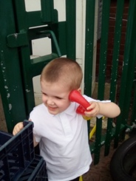
At King Street we value play and recognise the play-based learning opportunities that are present when children are at play. Through play our children explore and develop learning experiences, which help them make sense of the world. They practise and build up ideas, and learn how to develop self-regulation and understand the need for rules. They have the opportunity to think creatively alongside other children as well as on their own. They communicate with others as they investigate and solve problems. They express fears or re-live anxious experiences in controlled and safe situations.
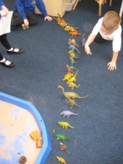
At King Street Primary and Pre-School EYFS Unit School we recognise that children learn and develop in different ways and at different rates. We value all areas of learning and development equally and understand that they are inter-connected.
The features outlined below ensure effective teaching and learning in our school:
- the partnership between teachers and parents, so that our children feel secure at school and develop a sense of well-being and achievement;
- the understanding that teachers have of how children develop and learn, and how this affects their teaching;
- the range of approaches used that provide first-hand experiences, give clear explanations, make appropriate interventions and extend and develop play and talk or other means of communication;
- the provision for children to take part in activities that build on and extend their interests and develop their intellectual, physical, social and emotional abilities;
- the encouragement for children to communicate and talk about their learning and to develop independence and self-management;
- the support for learning with appropriate and accessible indoor and outdoor space, facilities and equipment;
- the identification of the progress and future learning needs of children through observations which are shared with parents;
- the good relationship between our school and the feeder nurseries that our children attend prior to joining our school.
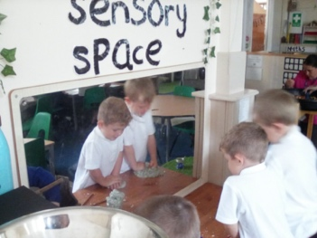
We ensure there is a balance of child-initiated learning through continuous provision, and adult led activities, across the school day. Although much of the time is spent with the children self-selecting tasks, the interaction between adult and child is essential. The adults respond to each child’s emerging needs and interests, guiding their development through warm, positive interaction. The adult’s role is to continually model, demonstrate and question what the child is doing. At times throughout the day an adult will ask a child to complete a task with them; at other times they will participate in the child’s play, extending it where possible.
There are set routines that we follow each day. There are designated times when the children come together to be taught. We teach a daily maths and phonics session, as well as stories, music time and Family Group time which introduces various topics as well as extends communication and language. All these sessions provide the opportunity for the children to develop their ability to work as a group to listen, take turns, to further develop vocabulary, to answer questions and to concentrate.
Phonics and Reading
At King Street Primary and Pre-School we recognise reading as a key life skill, which underpins access to the rest of the curriculum. We teach phonics using Bug Club Phonics, which is a synthetic, systematic phonics programme where children are taught the essential skills for reading through daily phonics lessons. These are delivered in whole classes (and in small groups where appropriate) once the children are settled into our unit.

We follow the Bug Club planning and our children are taught a cumulative progression of GPC’s (see phonics policy) that they practise through oral blending, reading and spelling words and sentences using Bug Club resources. It is our intention that children are able to read words and simple sentences by the end of Reception.
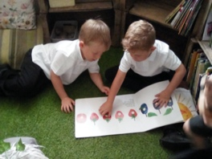
The children have daily reading sessions with teachers/trained adults to ensure that they are regularly applying and practising their phonic knowledge. Reading books are allocated to the children after assessments have been carried out, and the children read decodable ‘Bug Club’ books matched to the phase in which they are working.

Our children also take home a weekly Reading for Pleasure book and are encouraged to enjoy and share this at home in order to instil a love of reading.
We also encourage close links with our local library.
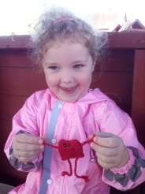
Story times are important parts of our day. We want the children to develop a life long love of reading. Children are exposed to a wide range of both fiction (traditional and modern) and non-fiction texts as well as rhymes and poetry to provide them with opportunities to hear and use new vocabulary. We end our day with a whole class story and create opportunities to enjoy books within the continuous provision.
Writing
Early writing is taught through early mark making. The children are encouraged to make marks and give meaning to their early transcriptions. Bug Club Systematic Synthetic phonics teaches the correct letter formation to match the phonemes they are learning and is enhanced with our Nelson handwriting programme. Children are then encouraged to use the sounds they have been taught to build phonetically regular CVC words and high frequency words. They are also encouraged to practise the skills they have learnt in phonics to build simple phrases and sentences. Children are also encouraged to write for a purpose linked to activities they are involved in during continuous provision.
Mathematics
In Reception, we teach daily maths lessons, loosely following the White Rose Maths scheme. Children are taught as a whole class so that specific learning objectives taken from the Statutory Framework for the Early Years Foundation Stage (Development Matters) guidance can be delivered. Throughout the year the scheme builds on maths skills and prepares our children for those required in Key Stage 1. An emphasis on developing and using mathematical vocabulary is important and the learning is encouraged and extended during continuous provision both indoors and outdoors.
Forest School – Into Nature Days
Welly Wednesday (Pre-School) Fresh Air Friday (Reception)

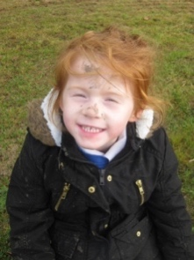
All children from the EYFS Unit have access to Forest School approach of outdoor learning led by a fully qualified member of staff.

Reception class go to the hub garden once a week to undertake a range of activities including focused maths and phonics learning with the class Teacher, supported by the EYFS Lead when needed.

Pre-School access the garden once a week with the Pre-School teacher who is a Level 3 Forest School leader,

Further information can be found in our Forest School Handbook.

Observation, Assessment and Planning

In Reception children are assessed within the first six weeks of their attendance using the RBA – Reception Baseline Assessment.
The Early Years Foundation Stage Curriculum provides the basis for planning in our Reception Unit. The planning objectives within the Foundation Stage are supported by the Development Matters Statements from the Statutory Framework for the Early Years Foundation Stage Document. Our planning is loosely based upon themes with an emphasis on introducing the skills required in preparation for learning in the National Curriculum in Key Stage 1.
The planning within the EYFS follows our long-term plan which is loosely based around half termly themed topic work linked to stories. Planned activities and experiences within the continuous provision are based on the children’s interests, skills and abilities and the learning may move away completely from the original topic. Our short-term weekly planning is flexible, based on our observations, challenges the children’s thinking and extends the children’s learning experiences.
Practitioners select themes according to the children’s interests, experiences and prior learning, as well on the specific needs of each cohort. Progress and curriculum coverage are monitored half termly. Staff reflect on the different ways in which the children learn and include these in their practice. The children’s social and emotional needs are responded to as well as their academic achievement.
Our Medium Term Planning is objectives based with clear end points defined, with themes and experiences clearly linked to our children’s prior knowledge and experiences and their next steps. These plans are used by the EYFS team during weekly meetings and daily observations as a guide for weekly planning; the plans may then be altered in response to the needs (achievements and interests) of the children. This will be indicated on weekly planning.
We monitor usage of the environment and detail any enhancements which could be made for the future weeks. Evaluations are also made during weekly planning meetings with the implications for future planning outlined.
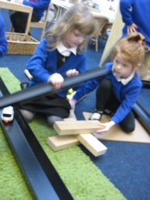
At King Street Primary and Pre-School ongoing assessment is an integral part of the learning and development processes. Practitioners observe pupils to identify their level of achievement, interests and learning styles. These observations are then used to inform future planning.
Assessment in the EYFS takes the form of observation, and this involves the teacher and other adults as appropriate. Planned, regular observations as well as spontaneous observations are made by staff to ensure that each child’s needs are being met and provided for. These observations may be recorded in a variety of ways through the use of notebooks, post it notes and photographic evidence. Emphasis is also placed on recording the children’s voice. Evidence for mathematics is recorded in floor books as well individual mathematics books and literacy in individual Physical Development and Phonics books. We also collect evidence in our large indoor and outdoor floorbooks and Tapestry where appropriate.
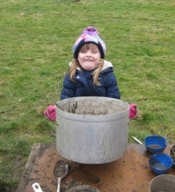
During the children’s journey with us they will develop, grow, learn and flourish in a number of different ways. In order for us to ensure they develop to their full potential it’s important to have an effective, meaningful and principled assessment of young children’s learning. This allows us to ensure we support the children in achieving significant milestones in their development. Observations made inform our everyday practice and curriculum. By gaining an insight into children’s thinking, feeling and needs we can plan our environment and actions to provide future possibilities for learning.
At King Street Primary and Pre-School EYFS Unit School, we record judgements against the 17 areas of learning, stating which level the children are working in and whether they are emerging, developing or secure in each area. For our Little Buds, we record judgements against the Prime Areas only.
At the end of the EYFS it is a statutory requirement for practitioners to complete the EYFS Profile for each child. Pupils are assessed against the early learning goals, which is the level of development children should be expected to have attained by the end of the EYFS, indicating whether they are;
- Expected - meeting expected levels of development
- Emerging – not yet reaching the expected levels of development
Children’s development levels are assessed as the year progresses.
Pupil progress meetings with the head teacher take place every term. If a child’s progress gives a cause for concern, practitioners will discuss this with the child’s parents/carers and agree how to support the child.
Monitoring and Review
It is the responsibility of the EYFS team to follow the principles stated in this policy. There is a named Governor responsible for the EYFS. This governor will discuss EYFS practice with the practitioners regularly and provide feedback to the whole governing body, raising any issues that require discussion. The Head teacher and EYFS Lead will carry out monitoring on the EYFS as part of the whole school monitoring schedule.
This EYFS Policy will be reviewed every two years.
EYFS Lead: Louise Whitfield
Headteacher: Joanne Bromley
EYFS Governor: Kate Luther
