King Street Primary & Pre - School
High Grange Road
Spennymoor
County Durham
DL166RA Telephone: (01388) 816078
Email: kingstreet@durhamlearning.net

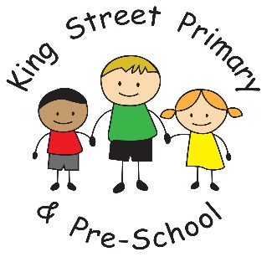

3rd October 2025
Dear Parents/Carers,

Thank you to all the families who were able to attend our Harvest Service yesterday. It was lovely to see you there and the church certainly seemed very full. On behalf of St Andrew’s Church and the local food bank, we would like to thank you for the generous donations. They are already packed and ready to support families in need. We hope you enjoyed our service, we are grateful to be able to share this with you and we enjoyed Father John’s reminder about being thankful for what we have and the support we have from those around us.

Year 3 and 4 parents
As the numbers of children and families in school continues to grow, we are going to change the exit door for children in Year 3 and 4. Children will now leave school from the Sports Yard door at the rear of the school building. This is to allow staff more space to dismiss the children and to ensure they can see all parents clearly. We appreciate this means that parents may now need to collect siblings from the main yard and then move onto the sports yard for older children. Year 3 and 4 staff will keep children until families have collected siblings. This also allows more space for children in Year 1 and 2 when dismissing onto the main yard and should also be a quicker system as the main door area can become quite clogged. All children will continue to enter the building through the main yard on a morning. The changes refer only to home time. Thank you.

Key ring sale
Our children have been asking us to host another key ring sale with the many new items we have created. We will, therefore, hold the event on Thursday 9th October. Children will be taken to the hall where they can browse the items and choose what they would like. Please do not send in any more than £10. Items start at £1 and there is plenty of choice. All funds raised are used to enrich the activities that we provide to the children. We already have a pantomime booked in for later this year.

Junk modelling
Miss Bell (Year 2) has asked parents for any donations of empty cardboard boxes, cardboard tubes, margarine tubs etc that can be used in a junk modelling project. Any items that you would generally recycle would be really useful for us. We just ask that these items are all clean. Thank you.

Healthy eating workshops
On Tuesday 14th and Thursday 16th October we are holding healthy eating workshops for families. We already have a number of families signed up for the event, which we believe will be brilliant at supporting with fresh food ideas, recipes and budget friendly tips on healthy eating. The sessions run 9-11am on 14th and 1-3pm on 16th. Every attendee is eligible for a £20 voucher. Please see the Microsoft form to sign up for a session. We look forward to seeing you there.

As always, if you have any questions or concerns, please email your child’s class teacher or speak to a member of staff on the yard. We can also sign post families to other support services you may need so please do ask.

Joanne Bromley
Head Teacher

Diary dates
Thursday 23rd October- Y5 reflection visit to church
Thursday 23rd October- Halloween disco in school
Friday 24th October- School Closes for Half Term Holiday

