King Street Primary & Pre - School
High Grange Road
Spennymoor
County Durham
DL166RA
Telephone: (01388) 816078
Email: Office@kingstreetprimary.org.uk

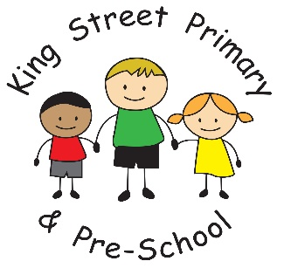

22nd May 2026

Dear Parent/carers,

We are at the end of another half term, with only one left to go. It will be a busy 7 weeks with lots of activities, some outdoor education for KS2, sports days and school fairs. The children have, as always, been a delight to have in school and I know they are going to enjoy a well earned rest. No matter who visits our school, or whether we take our children into the community, everyone always comments on their lovely manners and their super behaviour. We are really proud of them.

Bikes on the yard
I would like to remind families that when children bring bikes or scooters to school they must not ride them onto the school yard to ensure the safety of everyone. There was an incident today where a child was knocked to the floor and we want to prevent such incidents happening in the future. Please encourage your child to dismount and walk their bike to the bike store. Thank you.

Year 6 leavers hoodie
Mr Colling is reminding all families that any hoodies need to be ordered before tonight’s deadline. We will then raise an invoice on ParentPay after half term and full payment must be paid before 14th June for your child to receive their hoodie. This is an incredibly exciting time for the children and I know they will wear them for the rest of the school term.

Spennymoor Gala
You may already be aware that the Gala is on the 4th July this year and we will, once again, attend with our children. If your child would like to be part of the celebrations with us, please complete the form that was sent home. Please also be aware that parents must be able to attend the event alongside their children. Mrs Heightley will organise the group during school time and then everyone will meet at 12:30 on the day of the event.

I hope everyone has a brilliant half term break, the weather is looking glorious and hopefully this means everyone can be outside and enjoy the sunshine. Please also remember that the school is closed for training on Monday 1st June. It reopens on Tuesday 2nd June.

Joanne Bromley
Head Teacher

Upcoming diary dates:
Tuesday 2nd June- School reopens for teaching
Friday 5th June- Dress down day, bring a bottle donation for the summer fair.
Friday 12th June- Dress down day, bring chocolate donation for the summer fair.
Monday 8th June – Thursday 26th June - SEND support plan parents’ evening.
Thursday 18th June – Fathers’ Day breakfast event 9.15am.
Thursday 25th June – Summer Fair 3.15-5pm
Monday 6th -Friday 10th July – Sports activity week
Monday 6th July- KS2 (Year 3-6) Sports Day 1pm
Tuesday 7th July- KS1 (Reception- Year2) Sports Day
Wednesday 8th July – Wheels Day
Thursday 9th July- Silly sports activity day (children only)
Thursday 9th July – Leavers Performance Y6 families 6pm
Friday 10th July – Water Activity Day and park run activities
Friday 17th July - Y6 families celebration breakfast event.
Friday 17th July- School finishes for the summer break.
Wednesday 2nd September- school reopens for new academic year.

