Curriculum Area | Autumn 1 | Autumn 2 | Spring 1 |  | Spring 2 |  | Summer 1 |  | Summer 2
Theme | 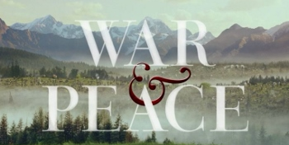 |  | 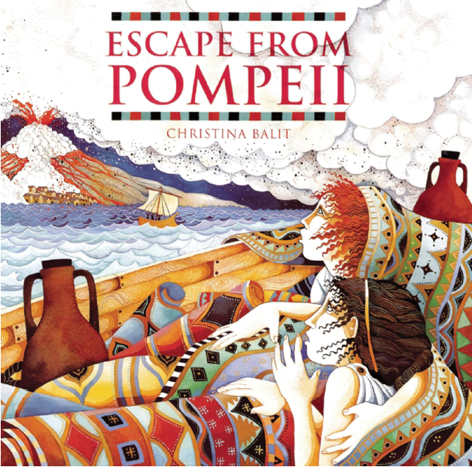 |  |  |  | 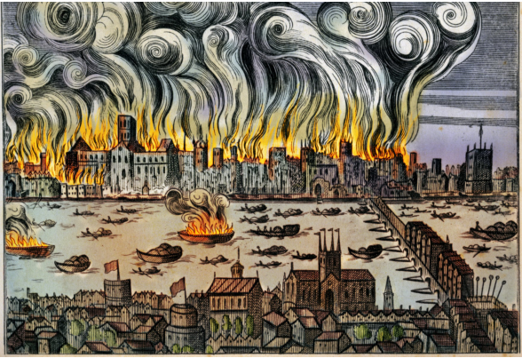
Trips and Visits | *Tudhoe Hall Livery  *What’s Wicked about Whitworth  *St Charles Primary School Trenches | *Safer Futures Safety Carousel |  |  |  |  |  |  | *London  *Durham Cathedral
Possible Class Texts | War Horse – Michael Morpurgo  Horses – Ted Hughes  Boy in the Striped Pyjamas – John Boyne |  | Floodland – Marcus Sedgwick  Escape from Pompeii – Christina Balit |  |  |  | London Eye Mystery
Possible English Writing outcomes | Poetry  *Free verse poetry inspired by Ted Hughes  *Emotive poem with Rhyme inspired by John McCrae’s Flanders Field  Instructional Writing  *How to make a WW1 Bi-Plane (Linked to DT)  Recounts  *Diary Event linked to War Horse | Persuasive Writing  *Propaganda posters  Narrative: Alternative Ending Stories  *Altering a key turning point of the war.  (Vague links with ‘The Man in the High Castle’)  Recounts  *Letters home from the front line/ trenches | Discussion  *Chernobyl - Who was to blame?  Poetry  *Free verse poetry - Springtime in Pripyat  Persuasive Texts  *Persuasive information leaflet advising citizens of Pripyar of the dangers posed by Chernobyl |  | Explanation texts  *How do volcanoes erupt?  Recounts  Newspaper article relating to Mount Vesuvius or Titanic  Non-Chronological Report  *Volcanoes and their features |  | Poetry  *Ring O’Roses and its association with the Black Death  Explanation text  *How to survive the Bubonic Plague.  Recounts  Doctor’s journal entry relating to plague victims. |  | Mystery Story  *Story based mystery inspired by Sherlock Holmes and the London Eye Mystery.
Possible English Spag outcomes | *Passive voice & subjunctive  *Relative clauses & adverbials  *Dashes & brackets  *Fronted adverbials  *Expanded noun phrases  *Verb tenses (including the progressive & perfect forms)  *Varied conjunctions  *Passive voice  *Modal verbs & adverbs |  | *Formal & informal structures (shifts)  *Synonyms & antonyms  *Colons & semi-colons  *Dashes & brackets  *Verb prefixes & nouns suffixes (word creation)  *Ellipsis  *Bullet points, colons and semi-colons for lists  *Verb tenses (including the progressive & perfect forms)  *Relative clauses & adverbials  *Varied conjunctions  *Subjunctive mood |  |  |  | *SATs Revision  *Formal & informal structures & language (shifts)  * Verb tenses including the progressive & perfect forms)  *Full range of sentence punctuation
Possible Whole Class guided reading texts | Extracts from:  *The mystery of the colour thief  EwaJozefkowicz  (Mystery)  *Aberrations – The beast awakens  Joseph Delaney  (Horror)  *William Wenton and the secret portal  Bobby Peers  (Adventure in the future)  *Spirit  Sally Christie  (Fantasy) |  | Extracts from:  *The black amulet  J R Wallis  (Fantasy)  *Mucking about  John Chambers  (Adventure in the present)  *You’ve got a friend  Judi Curtin  (Adventures from the past)  *Pages & Co. Tilly and the Bookwanders  Anna James  (Fantasy)  *We see everything  William Sutcliffe  (Spy Thriller) |  |  |  | Extracts from:  Extracts taken from previous SAT’s papers:  *Decoding - giving / explaining the meaning of words in context.  *Retrieval - Retrieve and record information / identify key details from fiction and non-fiction  *Summarisation - Summarise main ideas from more than one paragraph  *Inference - Make inferences from the text / explain and justify inferences with evidence from the text  *Prediction - Predict what might happen from details stated and implied.  *Comparison - Make comparisons within the text  *Language use - Identify / explain how a meaning is enhanced through choice of words and phrases
Maths White Rose Suggested Units | Number: Place Value  *Number: Four Operations | *Fractions  *Geometry, position and direction | *Number: Decimals  *Number: Percentages  *Algebra | *Measurement: Converting Units  *Measurements: Perimeter, Area and Volume  *Number: Ratio |  |  | *Geometry: Properties of shape  *Statistics |  | *Problem Solving  *Investigative work
Possible Science progression of knowledge | Electricity  *Timeline the changing ideas of electricity over time  *Consolidation of prior learning of electrical circuits (Yr4) and carry out a simple investigation relating to the brightness of a lamp or the volume of a buzzer  *Research and use recognised symbols when representing a simple circuit in a diagram  *Discuss a concept, gather evidence to support or refute it. | Animals including Humans  (Circulation)  *Consolidation of prior learning relating to the circulatory system  *Measure and record a set of results relating to one’s pulse rate  *Carry out independent research, creating a report relating to the circulatory system.  *Investigate a lamb’s heart through dissection  *Role play the human circulatory system  *Create a non-chronological report related to the circulatory system for lower year groups  *Observe the heart rate over time  *Poster creation of how to keep a healthy heart | Evolution & Inheritance  *Create a mind map showing an understanding of the key vocabulary from the topic – inheritance, adaptation and evolution  *Researching the characteristics that make a plant suited to its environment  *Researching the characteristics that make an animal suited to its environment  *Identifying characteristics that make an animal suited to its environment  *Create an animals suited to an unusual environment  *Researching the evolution of the peppered moth  *Seek pattern through investigation relating to birds’ beaks  *discuss the features inherited from parent to child  *Look for evidence for evolution through comparisons of woolly mammoths and elephants | Light  *Consolidation of prior learning – investigate light and shadows through puppets  *Investigate how light travels in straight lines by using pipes and mirrors  *Explore how we see non-light using a black cylinder  *Consolidate and assess learning in a piece of writing linked to ICT  *Investigate how shadow size can be changed  *Explore the shape of shadows |  |  | Living things and their Habitat  *Consolidation of prior learning – compare and classify leaves and identify similarities and differences  *Classify tulips and daffodils  *Identify the differences between groups in the plant kingdom: mosses, ferns, conifers, flowering plants  *Research the main characteristics of a vertebrate group  *Research the main characteristics of some invertebrate groups  *Classify unusual animals  *Classify an imaginary animal  *Research microorganisms
Science - progression of skills | - use recognised symbols when representing a simple circuit in a diagram  - associate the brightness of a lamp or the volume of a buzzer with the number and voltage of cells used in the circuit  - compare and give reasons for variations in how components function, including the brightness of bulbs, the loudness of buzzers and the on/off position of switches | - identify and name the main parts of the human circulatory system, and describe the functions of the heart, blood vessels and blood  - recognise the impact of diet, exercise, drugs and lifestyle on the way their bodies function describe the ways in which nutrients and water are transported within animals, including humans | - recognise that living things produce offspring of the same kind, but normally offspring vary and are not identical to their parents  - identify how animals and plants are adapted to suit their environment in different ways and that adaptation may lead to evolution  - recognise that living things have changed over time and that fossils provide information about living things that inhabited the Earth millions of years ago | - recognise that light appears to travel in straight lines  - explain that we see things because light travels from light sources to our eyes or from light sources to objects and then to our eyes  - use the idea that light travels in straight lines to explain that objects are seen because they give out or reflect light into the eye  - use the idea that light travels in straight lines to explain why shadows have the same shape as the objects that cast them |  |  | - describe how living things are classified into broad groups according to common observable characteristics and based on similarities and differences, including micro-organisms, plants and animals  - give reasons for classifying plants and animals based on specific characteristics
Science Key Vocabulary | Circuit, complete circuit, circuit diagram, circuit symbol, cell, battery, bulb, buzzer, motor, switch, voltage | Heart, pulse, rate, pumps, blood, blood vessels, transported, lungs, oxygen, carbon dioxide, nutrients, water, muscles, cycle, circulatory system, diet, exercise, drugs and lifestyle | Offspring, sexual reproduction, vary, characteristics, suited, adapted, environment, inherited, species, fossils | Reflection, transparent, translucent, opaque, periscope, luminous, non-luminous, absorb, direction |  |  | Vertebrates, fish, amphibians, reptiles, birds, mammals, invertebrates, insects, spiders, snails, worms, flowering and non-flowering
Possible Science Working Scientifically Tasks | - Does adding another battery make any difference?  - Does the thickness of the wire affect the brightness of the bulb?  - Does the length of wire affect the brightness of the bulb? | - How does your heart rate change for different activities?  - How would different types of stomach juices affect break down of food?  - Is lung capacity linked to height, age, fitness? | - How are local animals/insects different from those in other locations/countries  - Explore advantages and disadvantages of adaptations e.g. long fur | - What happens to the size of a shadow when you move the object nearer the light?  - How can we see round corners? – link to periscopes  - Which materials are the best for reflecting light?  - What colour of writing can be seen best in the dark?  - How many reflections can you create using mirrors?  - Which light makes the best shadows? |  |  | - To investigate the respiration of yeast
Possible History Progression of Knowledge | The War to End all Wars They Said (WW1)  - Identify and debate the four main cause of WWI.  - Investigate how the assassination of Arch-duke Franz Ferdinand set aflame the tinderbox that was Europe!  - Develop an understanding around the why and how Britain entered the war.  - Debate and discuss the implication of war on the common man and woman  - Research propaganda & conscription and their shared importance  - What was life really like in the trenches?  - Develop an understanding of the importance of woman during WW2 and understand the roles they carried out.  Local area study  * |  | Disaster Stations!  Titanic  - Titanic Timeline  - Titanic Sources  - Inside the Titanic and artefacts  - Who were the passengers of the Titanic?  - Who was to blame?  - Titanic’s legacy  Pompeii  What was life like in Pompeii the day before it was destroyed?  How was Pompeii first excavated?  How have archaeologists  found out about Pompeii and Herculaneum?  Chernobyl  - Who was at blame?  - What changed because of Chernobyl? (Linked to geography for map work) |  |  |  | Plague & Fire! London 1666  - Examine art as a historical source to see what we can learn about the plague and this time in history  - Investigate the symptoms of the Black Death.  - understand what medieval people thought would cure the black death.  - find out how the black death came to infect Britain  - understand the factors that led to the spread of the black death  - understand medieval and modern beliefs about the cause of the black death.  - understand how society was organised in the 14th century  - know facts about medieval knight  - know about the peasants revolt of 1381.  - understand what would happen if the black death returned today.  - know about the bacteria Yersinia Pestis.
History - Progression of Skills | Historical Enquiry  *recognise primary and secondary sources independently  *use a range of sources to find out about aspects of period studied  *identify omissions in their knowledge and suggest means of finding out  * gather knowledge from several sources to create a fluent account  Chronology  *sequence up to ten events on a timeline  *use relevant dates and times accurately  Range & Depth of Historical Knowledge  *find out about beliefs, behaviour and characteristics of people, recognising that not everyone shares the same views and feelings  *write an alternative explanation of a past event in terms of cause and effect, using evidence to support and illustrate their explanation – linked to English
Possible Geography Progression of Knowledge | Africa! Asia! Oceania! Continents Not Countries  - Locate Africa, Asia and Oceania on a map and identify that that it is a continent, not a country.  - Locate countries of Africa, Asia and Oceania & their capital cities.  - Compare & contrast region in Africa, Asia and Oceania with a region in the UK – geographical features. |  |  |  |  |  | Raging Rivers From Around the World  - Where Does Our Water Come From? The Water cycle!  - Rivers of the World including the River Wear  - Features of a River  - Erosion and Deposition  - How Do We Use Rivers?  - Holding Back the Flood  Local Area Study  - River wear – mouth to sea
Geography - Progression of skills | - use maps, atlases, globes and digital/computer mapping to locate countries and describe features studied  - locate, on a world map, the main countries in Africa, Asia & Australasia/Oceania  - expand map skills to include non-UK countries  - compare a region in the UK with a region in Africa, Asia or Australasia with significant differences and similarities |  | - describe and understand key aspects of physical geography, including: volcanoes and natural disasters e.g. earthquakes, looking at plate tectonics and the ring of fire  - understand and discuss fair & unfair distribution of natural resources, focusing on energy |  |  |  | - describe and understand key aspects of physical geography, including: coasts, rivers and the water cycle (including transpiration)  - name and locate the topographical features including coast, features of erosion, hills, mountains and rivers  - extend into six-figure grid references, including longitude and latitude in greater depth  - use fieldwork to observe, measure and record the physical and human features in the local area using a range of methods, including sketch maps, plans and graphs, and digital technologies
Computing |  | Scheme  iSafe  eSafety | Scheme  IProgramme Unit 1  Designing and Developing programmes |  |  | Scheme  iApp  Designing and Developing apps | Scheme  iNetwork  Networks, data & HTML/CSS | Scheme  iProgramme Unit 2  Developing 3D Animations
Music | Charanga Unit  Happy  By Pharrell Willaims | Charanga Unit  Classroom Jazz 2 | Charanga Unit  A New Year Carol |  |  | Charanga Unit  You’ve got a friend | Glee Club
Possible Art projects | Sketching  *Seaham Tommy  *World War 1 Bi-Planes  Colour Mixing  *Battle scenes  Persuasive Drawings linked to topic  *Propaganda posters |  | Banksy & the history/evolution of graffiti  *Sketching – Banksy’s art work  *Oil Pastels – Graffiti art |  |  |  | Lost masterworks (Picasso & Monet)  *Collective artwork – Chuck Close  http://www.artyfactory.com/art_appreciation/portraits/chuck_close.html  *Detailed Sketching - Woman with a Parasol  *Clay Masks – sculpture of Plague Doctors mask
Art & Design skills | *Colour mixing, understanding tone, shade, hue, mood  select colour precisely for intended purpose  select colour to match intended mood/atmosphere | understand properties of different media
Possible Design and Technology projects | Machines of war  *World War 1  Bi-planes with electrical components | Make do and mend!  *Ration cook book food  *Patchwork quilts
Physical Education | Games  Wide Attack  Gymnastics  Group Dynamics | Games  *Grid Rugby  *Tag Rugby  Dance  WWII - Lindy Hop | Dance  Invasion  Gymnastics  Assessing level 1 Unit 6 Tasks 1 and 2 |  |  | Games  Zone Rounders  Gymnastics  Propped up | Games  *Long and Thin, Short and Fat  *Pairs Cricket  OAA  *Beat the Clock *Electric Fence  OUTDOOR ED |  | Athletics  Distance Challenge  SWIMMING  OUTDOOR ED
Religious Education | What can we find out about the 5 Pillars?  How do Muslims express their beliefs? |  | Why should people with a religious faith care about the environment?  Why are Good Friday and Easter Day the most important days for Christians? |  |  |  | What do we now know about Christianity? (exploration through the concepts)
PHSE / SMSC / Citizenship | Self-Confidence | Support | Positive relationships |  |  | Achievement and Success | Coping skills |  | Growing up
P4C | Amazon Fires: Is It the World’s Responsibility to Help? | Should animal testing for medicinal research be banned? | Should mobile phones be banned from schools? |  |  | Should women footballers earn as much as men? | Should new cars have speed limiters? |  | Should carrying a knife in public carry a long prison sentence?

