King Street Primary & Pre - School
High Grange Road
Spennymoor
County Durham
DL166RA Telephone: (01388) 8160781
Email: kingstreet@durhamlearning.net

10th November 2023

Dear Parents/Carers,

We have had a brilliant start to the second part of our Autumn term and today we judged our Autumn competition. There was definitely some tough competition and there have been lots of people out walking over the holidays as we had the most entries we have ever had! Our winners are:
Biggest conker: Sophie M
Biggest pine cone: Luna A and Macey P
Reddest leaf: Oscar J and Agata A
Yellowest leaf: Alayna W
Well done to all of our entries, hopefully it encouraged people to get out into the fresh air and explore the nature around us.

Reading in School
Reading is a fundamental part of education: it enables us to access any knowledge and learn any skill, for the rest of our lives. Through regular reading, we can all support the skills that children need, improve their reading confidence and inspire their love of reading. Reading enables children to engage in the world of literature which helps inspire ideas, broaden vocabulary and grow children's imaginations.

We use ‘Reading VIPERS’ to break down the key comprehension skills that we teach as part of the National Curriculum, and help children to understand all the different things skilled readers need to be able to do. We use the term ‘Reading VIPERS’ to encourage children to actively think about the comprehension skills they are using when they read. VIPERS stands for:
Vocabulary
Inference
Prediction
Explanation
Retrieval
Sequence in KS1 or Summarise in KS2.

The children are exposed to all of these terms regularly throughout their English work and other areas of the curriculum. The school day begins and end with reading as it is central to every child’s learning; as children come in to school, they are given time for independent reading, and every class has a ‘story time’ at the end of the day. Our children take part in regular reading skills sessions across the week. These texts are read to, or with, the children. Within these sessions, our staff model reading strategies during shared whole class reading activities. We use high quality, age-appropriate texts which are carefully selected by the staff to enrich the children’s vocabulary and broaden their familiarity with different genres.

All children work on VIPERS reading skills during class reading whether this is reading as a class, in a small group or one to one with an adult. We encourage children to orally talk through their answers before formally recording their answers. Children do this in a variety of ways such as discussing the answer first with their peers and/or an adult and then writing their best answer.

VIPERS Question Stems
It would be excellent if, as parents, you could also refer to these VIPERS regularly when you are listening to your child read at home. VIPERS questions can be applied to any text that a child is reading as well as with pictures, picture books and films! When any adult is listening to a child read, all they have to do is think of questions about the book, picture or film that cover some of the VIPERS. If you have any questions with your child’s reading, please contact your child’s class teacher. There are some examples of question stems for inspiration at the bottom of this week’s newsletter.

Attendance
We all know that children make more progress when they are in school regularly and they are ready to learn. Every week, classes hope to win the trophy in our Friday assembly for the best class attendance. It was wonderful this week to see a class with almost 100%. This time of year can be difficult with many illnesses circulating but where children have minor coughs and colds we do welcome them into school. Research makes it very clear that children with high levels of attainment have a much high success rate than those with poor attendance and when we look at the future of our children we want them to flourish. Please ensure that your child attends every day. We do monitor attendance (and lateness) on a weekly basis and we do send communication home to families where we can identify that attendance is falling. If you feel that you require any support with improving your child’s attendance, please speak to Mrs Livesley who will be happy to help.

Parents’ Evening
Thank you to everyone who has made an appointment for parents’ evening next week. We have lots of families booked in to speak to teachers and we look forward to seeing you. The appointment gives families an opportunity to find out how their child has settled into their new class and to ask any questions they may have. If you have missed out on booking an appointment online but would like to come for an appointment, please contact the class teacher to arrange a mutually convenient time.

Flu Nasal Vaccine
For those families who have signed up to their child receiving the vaccine, the NHS nurses will be in school on 14th November. There is still time to give consent if you have not done so already, please use the link that was provided.

Christmas Nativity
Although it is not yet even December, preparations have begun for the Christmas nativity performances. The school will soon be full of Christmas songs and children rehearsing their lines. We will soon send out ticket request forms so you can book your tickets. The children love to have an audience and it always helps them to perform really well.

Upcoming Diary Dates
Monday 13th to Friday 17th November – Parents’ evening Y1-6
Monday 13th November - Reception Class stay and play
Wednesday 15th November – Nursery Class stay and play
Friday 17th November – Children in Need, dress down day.
Friday 24th November – Dress down day- bring chocolate donation for the school fair.
Friday 1st December – Pantomime in school.
Friday 1st December- Dress down day- bring a bottle donation for the school fair.
Thursday 7th December- Movie night
Tuesday 12th December – Nativity performance
Wednesday 13th December- Nativity performance
Thursday 14th December- Christmas fair
Monday 18th December – Christmas parties across school
Tuesday 19th December – service at St Andrew’s Church
Tuesday 19th December – School closes for the festive break

As always if you have any queries or concerns please speak to, or email, the school office. Teachers can also be contacted directly by email. If you require a teacher’s email, please speak to the school office.

Yours Sincerely
J Bromley
Head Teacher

VIPERS Questions for Year 2 & Year 3

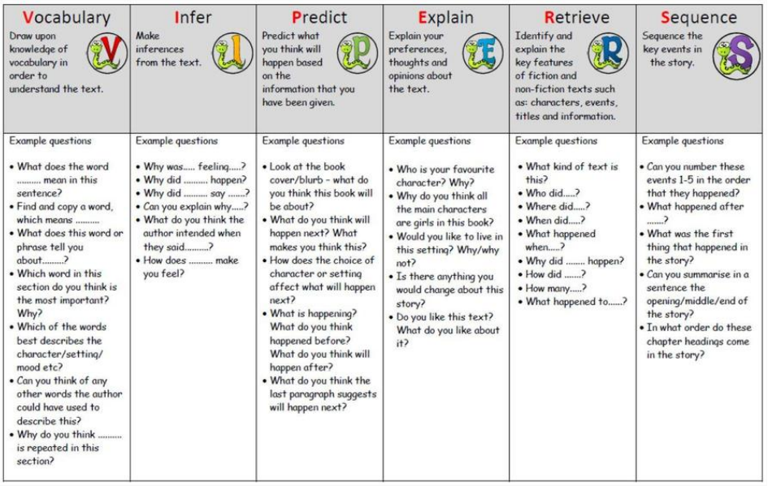

VIPERS Questions for Years 4-6