King Street Primary & Pre - School
High Grange Road
Spennymoor
County Durham
DL166RA Telephone: (01388) 816078
Email: kingstreet@durhamlearning.net

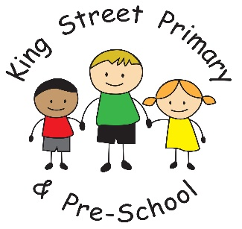

26th November 2021

Dear Parents/carers,
This week the school has been filled with the sound of children singing as they begin learning the songs for their Christmas performance. It is lovely to hear how excited they are and how much enthusiasm they have when they sing! It really will start to feel a lot like Christmas next week once our decorations go up and our tree arrives on Tuesday. They will finish their week with a lovely visit to the pantomime, so lots to look forward to.

Reminders - diary dates

Friday 3rd December- Pantomime

Tuesday 7th and 8th December -Christmas performances (Tickets must be pre-booked)

Thursday 9th December - Christmas Lunch and Christmas Jumper day.

Thursday 16th December -Christmas parties

Monday 13th December -Santa visits.

Friday 17th December - Church visit

The deadline for performance ticket requests was today and tickets will be allocated to Parentpay accounts next week and must be paid by Thursday 2nd December. The tickets will then be issued on Friday 3rd.

Y5 staffing
With Mrs Stiles leaving us later this term, we have been rearranging staffing to ensure that there is consistency for our children. Therefore, Ms Scott will now be working across both Year 4 and 5 as she knows the children very well from last year. She will be joined in both classrooms by Mr Murdoch who joined our team earlier term and already works across both classes.

Toy donation
The response to our toy donation was overwhelming and the children who organised the event are delighted with how much has been given. We will be having our final collection on Monday 28th, at the hub, and then they will be distributed to families in need and charities. Thank you for your donations as they do make a big difference.

Parentpay
We would like to give a gentle reminder to all families to clear their Parentpay accounts by the end of this term (Friday 17th Dec). This helps us to keep our school accounts in order but also ensures that debts do not become overwhelming. We do have procedures to follow where debts are not cleared and we always try and avoid this process with reminders where possible. Thank you in advance.

Tablets for home use.
During the period of home learning we had a number of tablet devices that we were able to loan to families to access home learning. Whilst this is no longer necessary we do still have a number of tablets in school which we are able to loan to families without a device. This could be to help with online homework or to help children further research topics covered in the curriculum. If you would be interested in loaning a device, please email the school office with your child’s details and we will arrange for a loan contract to be sent home to complete. Devices can then be issued.

As always, if you have any questions or queries about any of the above information or if you are struggling with ParentPay please speak to a member of staff on the yard or make an appointment at the school office. We are also happy to answer any queries by email on kingstreet@durhamlearning.net

Yours Sincerely
Joanne Bromley
Headteacher

