King Street Primary & Pre - School
High Grange Road
Spennymoor
County Durham
DL166RA Telephone: (01388) 8160781
Email: kingstreet@durhamlearning.net

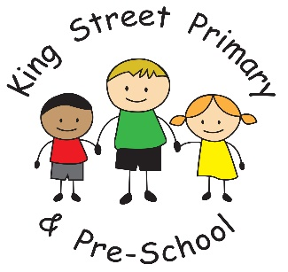

9th December 2022

Dear Parents /Carers

The Christmas spirit is definitely in full swing. The sound of Christmas songs and children practicing for nativities has echoed around school. Naughty elves and Santa cams have popped up around school and the sharing of Christmas cards has begun! It is lovely to hear how excited children are about visiting Santa next week and what games they want to play at their Christmas party. Our Christmas fair was a huge success and it was lovely to see everyone. The raffle has now been drawn and the winning numbers are as follows:
Rington’s tea and biscuit hamper- 85
Fox Cub voucher – 398
Hocking’s butchers voucher- 414
Mr B’s voucher-313
M&S biscuits- 437
Candle- 222
Guess the name of the bear was won by Jereme O’Keefe.
Congratulations to all of our winners. Prizes can be collected from the school office.

Nativity ticket requests
All requests have now been processed and tickets have been issued earlier this week. If you have requested tickets but have not received them, please check school bags and then contact the school office for them to be reissued. We were really pleased to be able to accommodate the request of every family and we are looking forward to seeing you next week. We have a mixture of both excited and nervous children but they always perform well on the day and they love to see you in the audience so we are pleased that we had so many requests for tickets. Please make your way onto the main school yard where doors will open at 9:15am for morning performances and 1:15pm for afternoon performances.

Community events
St Andrew’s Church are having informal Carol Singing at St. Andrew's this coming Saturday 10th at 2pm; tickets £3 for church funds, mince pies and other refreshments included; requests welcome.

Household Vouchers
We have been informed today by DCC that the household vouchers to support families eligible for Free School Meals will be issued to our school on Monday. As soon as these arrive we will be sending to families by email. Please ensure your email is up to date as they can not be redirected once they have been issued.

Community hub
Tuesday 13th December is the last day that our community hub will be open this term. We have had a fabulous response and lots of donations for it and I know these have been gratefully received by many families. If you require uniform, shoes, coats or hats/gloves for the start of the new year, please do come along between 9-11am as we have plenty to offer. It is a friendly place to stop for a chat and have warm refreshments too.

Diary dates
Tuesday 13th/Wednesday 14th - Christmas nativity performances
Thursday 15th December - Dress down day/Christmas jumper day
Thursday 15th December - Christmas Lunch
Friday 16th December – Santa visits for Nursery - Year 4
Monday 19th December – Christmas parties for all classes
Tuesday 20th December- St Andrew’s Church Service. 10.30am.

As always, if you have any questions, queries or concerns please contact class teachers or the school office. Kingstreet@durhamlearning.net . We are also looking for volunteers to help across school and also in our Community Hub. If you are interested, please speak to the school office for a volunteer pack.

Yours Sincerely

Joanne Bromley
Head Teacher

