King Street Primary & Pre - School
High Grange Road
Spennymoor
County Durham
DL16 6RA
Telephone: (01388) 816078
Email: kingstreet@durhamlearning.net

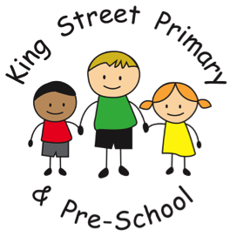

03/01/21

Dear Parent/Carer

I hope you all managed to enjoy some precious family time over the Christmas period and have been able to stay safe. Many of you will have heard that the return to school for primary aged children has been a great debate over the last 2 days. There has been a public announcement from our PM in favour of children returning this week but also many public discussions in regards to the safety of this.

At present, we still expect to reopen on Tuesday 5th January as planned. This is based on the information that we hold at present with regards to staffing levels and our risk assessment.
Please be aware that this is a very fast moving environment and if it is anything like the beginning of the pandemic, advice can change by the hour. It would be a sensible decision for families to have alternative childcare in place should school be advised we are to close. This decision would not be taken lightly and would be made strictly on the basis of safety for children, families and staff and based on the information we are given.

In the event of a school closure, we would only remain open to those families who have ‘Key Worker status’ or where children have previously been identified as vulnerable or with social workers. Many of you will already have been offered a place as a key worker during the last lockdown and this place will remain. As children in Reception only joined us in September, if the situation arises, we would issue the Key Worker questionnaire to those families to identify any eligible children. Please do be aware that we follow Government and Local Authority guidance on identifying these children.

When we do return on Tuesday 5th, please ensure you continue to follow our social distancing guidelines and do not meet up with other families. Tier 4 restrictions are in place for the whole county and this includes whilst on school premises. If you do need to contact the class teacher, this can still be done through your child’s eschools account or you can email the office at kingstreet@durhamlearning.net who will forward information for you. Please be aware that email continues to be the safest form of communication.

Please ensure that do check emails regularly as this is how we will communicate information regarding school closures. Email addresses can be updated by emailing the school office.

We look forward to seeing you on Tuesday.

Yours sincerely

Mrs J Bromley

