King Street Primary & Pre - School
High Grange Road
Spennymoor
County Durham
DL16 6RA Telephone: (01388) 8160781
Email: kingstreet@durhamlearning.net

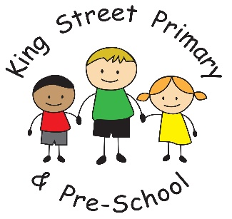

5th February 2021
Dear Parents/Carers
We have now successfully finished week 5 of lockdown and I am really hopeful that schools will return again on the 8th March and we can get back to having lots of happy, excited children in school. We also only have one more week until the half-term break, when we can all enjoy a thoroughly-deserved rest!

We have had a lovely week in school, celebrating both ‘Mental Health Awareness’ week and the ‘Love for Louis’ Muscular Dystrophy campaign. The Love for Louis JustGiving page has received over £800 of donations this week and we have the money raised in school to add to this. Hopefully, it will help fund vital research into the condition and give support to those who have been diagnosed. Thank you to everyone who has donated.

Our King Street Striders group has also had a very successful week with our latest challenge now complete. In total, at the time of writing, we achieved a massive 942 miles which more than covers the intended journey! Well done to everyone who took part- we are now going to be looking for the next challenge!

Safer Internet Day
Tuesday 9th February is Safer Internet Day and we feel that this is more important now than ever before. Children are spending significant amounts of time on line and we always want to keep them safe. Look out for activities set by teachers next week and chat to your children about only using recommended, age-appropriate websites and the importance of kindness when communicating with their peers.

Free School Meal vouchers after half term
Whilst we know that children will not be returning to school immediately after half term, the Government have not yet opened up the voucher system to issue vouchers for Free School meals to families. Please be patient with this as we do not have any control of when these are issued. Once we have been notified we will inform families.

As always, if you have anything that concerns you or have any queries please get in touch through Eschools or the school office. We are here to help.

Yours Sincerely
Joanne Bromley
Head Teacher

