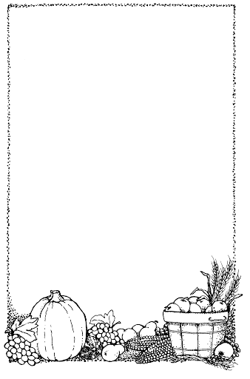
Cup of Tea

Here’s a cup,

And here’s a cup,

And there's a pot of tea.

Pour a cup,

And pour a cup,

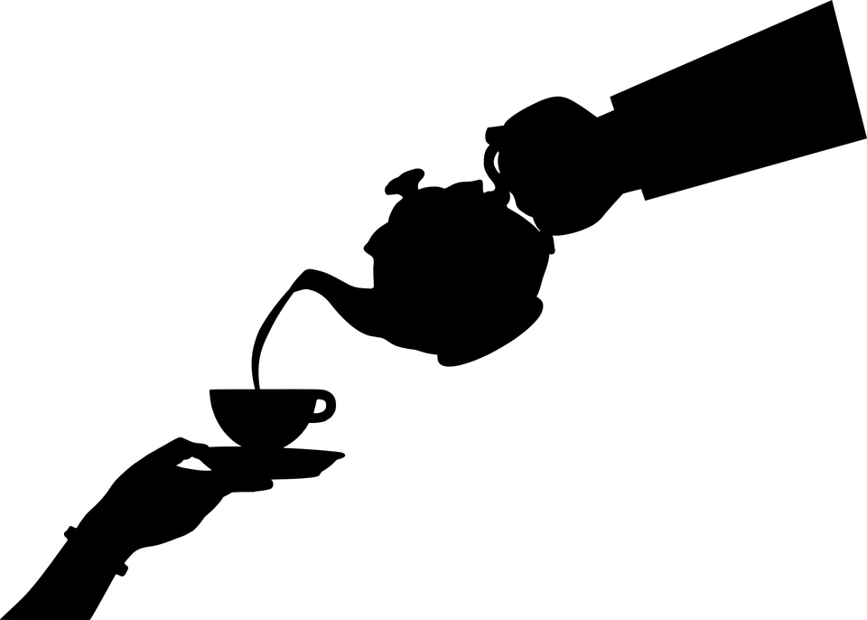
And have a drink with me.
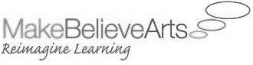
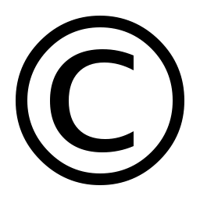
The Poetry Basket www.helicopterstories.co.uk

