School is closed again and I am so sorry that I won’t be seeing you all every day. However, we need to stay positive. Remember how good you all are at using the gem powers, I have put together some ways and ideas where you can use you gem powers at home – stay safe, Mrs Livesley
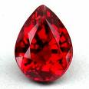
Ruby – being kind and caring, being positive. Using eye contact and speaking to people politely.
Think about ways that you can help out around the house. Could you tidy your bedroom? Draw a picture for your grown-ups? Write and post a letter to one of your friends?

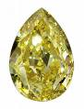
Diamond – being responsible.
Remember that your home learning is up to you. You have to keep at it and remember what you have already been taught. How can you use past learning to help you now? Can you show independence in your learning?

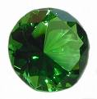
Emerald power – sticking with things even when it gets tough. (We are all having to use this one!)
This is the gem that is going to help you keep on trying even if you are struggling. Keep trying and giving it a go, mistakes are fine, you can bounce back!

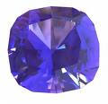
Sapphire - Managing your monster distractions.
Learning at home can be tricky, especially if there are other things you would rather be doing. You could always try using those other activities as a treat. “Once I’ve done this work I can have some time playing the game I like best.”

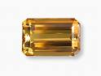
Topaz – Sharing learning with others.
Working at home means that there will be some times when you need help from your grown up or maybe a brother or sister. This is working together and can give you a chance to use topaz power. Can you listen to others’ advice? Can you share your ideas?

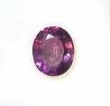
Amethyst – co operation
This one can be tricky with home learning, however, there are loads of board games, even playing noughts and crosses gives you a chance to work well with a partner.

You are all so good at using you gem powers at school, I would love to hear from your grown ups that you are doing the same at home.

