Year 5 Summer Term Newsletter
Miss Chazot and Mrs Scott would like to welcome everyone back after the Easter holidays! We hope you have all had a restful break and are ready for what this term has in store.
Reading and Homework
- As per last term, reading books and records will be sent out on a Monday and collected on a Friday. Please take the time to read with your child daily and focus on their understanding of the text by asking questions.
- We try to avoid changing books too often, as this ensures the children have time to read and fully understand the texts. Despite not being very long, the topics are often sophisticated, and children require time to discuss and fully understand the theme of their book.
- Reading books and records must still be brought to school each day so we can listen to children read 1:1.
- Spellings will also be set on a Monday. We have ‘Home Learning’ books set up for children to practise spellings and put them into sentences. These books will need to be brought back on Fridays so new spellings can be added for the following week.
- Spelling tests will continue to take place on a Friday.
- As many of you will know, we will now be sending a small amount of weekly maths homework, which will be set on eSchools, Purple Mash or other familiar platforms. It is therefore important that the children remain confident using these platforms to access work. If your child has forgotten their login details, please just ask and these can be re-issued.

Our topic this term is ‘The Marvellous Mayans’. We will be exploring and learning all about the Mayan civilisation and drawing comparisons between the other ancient civilisations which we have already studied.
PE
For the first half of the summer term, we will be taking part in swimming lessons on a Wednesday morning at Spennymoor Leisure Centre. As a result, we will have one PE lesson per week, on a Thursday morning. However, please ensure your child has appropriate kit all week, as we may spend more time outdoors, as the weather improves.
Pupils will need shorts/leggings, a plain t-shirt in their house colour and trainers. Long hair should be tied back and earrings taken out or covered for PE. PE kits should be sent with your child on a Monday and we will send them home on a Friday.

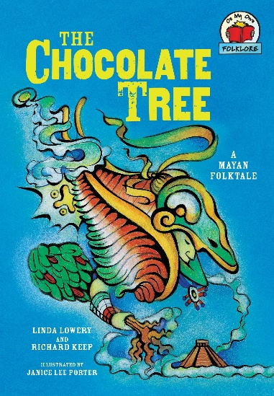
Many of our reading and writing sessions will be linked with our history topic. We will be reading the Mayan folk tale, ‘The Chocolate Tree’, as well as a wide range of other fiction and non-fiction texts, which we will use to inspire our writing. We will also be choosing our new class novel, which we will read for pleasure, at the end of each day.
In Geography, we will be investigating how the human and physical geography of countries in South America compare and contrast with the UK. This will fit in nicely with our study of the Mayans.
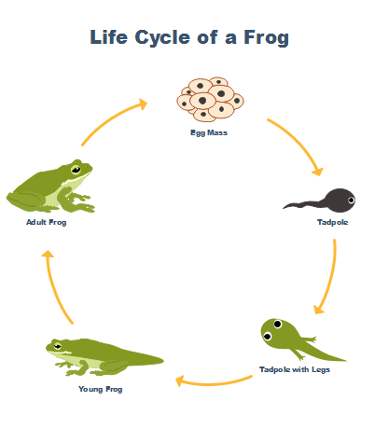
In Maths, we are moving on to decimals, percentages and geometry. In the second half of the summer term, we will focus on position and direction and measures. Please ensure your child knows and regularly practises their times tables. This can be the reason many children find these concepts tricky! Children still have access to Purple Mash and Times Table Rockstars and can use these at home to practise.
In Science, we will complete our work on Forces, which will be embedded through real-life applications in our Outdoor Ed sessions this term. You will receive information relating to these sessions shortly, as they do not begin until the end of May.
We will also be investigating life cycles of different plants and animals, before finishing the year by looking at how humans change, throughout our own life cycle.
After our successful soup-making in DT last term, we will be investigating structures this term. The children will be exploring different types of protective structure, before designing and creating their own animal shelter for birds or insects!
In Music, we will be investigating ‘Mars’ by Holst, through the BBC Ten Pieces, which introduces children to classical music. We will also be focusing on developing self-confidence in our PSHE lessons, whilst using our knowledge of Sikhism to draw comparisons to other religions we have studied.

It’s going to be a busy term! Thank you again for your continued support. If you need to get in contact with us, please do not hesitate to email, call the school office or see us directly and we will try our best to help!

Miss Chazot and Mrs Scott

Important dates:
Thursday 23rd June - KS2 Sports Day
Monday 11th July – Wednesday 13th July – Weardale residential

