King Street Primary & Pre - School
High Grange Road
Spennymoor
County Durham
DL16 6RA Telephone: (01388) 8160781
Email: kingstreet@durhamlearning.net

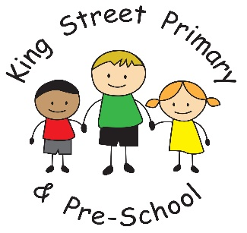

12th February, 2021
Dear Parents/Carers
Today is the last day of the first half of the spring term and marks another milestone to the hopeful return of all children on 8th March. The latest news we have is that the PM will make an announcement in the week of 22nd February with more details. Although this is likely to be delivered straight into the public domain anyway, we will update you as soon as we have the information.
Thank you to everyone for working so hard to continue the education of our children at home. It was never the Spring term that we had hoped for - we know that you are all not teachers, but you really have done a fabulous job. From speaking to many families, we know that children are desperate to be back in school and we are looking forward to welcoming our children back as soon as it is safe to do so. We have some lovely activities planned for the 2nd half of this term which we believe will really enthuse the children and will help rebuild lots of social connections that they have desperately missed.
Staff have been using the time in school over the past few weeks to redevelop some of the areas in school that our children use and we now have a lovely shared area with an emphasis on reading which we think the children will really enjoy. I will not reveal any parts of it and we will leave it as a surprise upon return. Our EYFS children also have some newly developed spaces, both inside and out, and we are hoping these developments can continue over the next few weeks to really give our children opportunities for exciting new adventures. These developments are, once again, thanks to the hard work and dedication of the staff who have spent many hours carefully planning and creating the beautiful spaces.
Our Facebook page has been a real success for us this term too and it has been lovely to see photos of all the additional activities that families undertake. From our snow days to Lego creations and the many, many miles that have been walked. Please continue to send us these over the next half term and we can share them on the Facebook community.
I hope you all have a lovely half term break and manage to get out into the fresh air for some much need space. We look forward to seeing our Key Worker families on Monday 22nd February. I think our caretaker is hoping that upon our return after half term the snow stays away- he said he has never been as fit as these last few weeks, from clearing all the snow!
As always, if you have anything that concerns you or have any queries please get in touch through Eschools or the school office. We are here to help.

Yours Sincerely
Joanne Bromley
Head Teacher

