King Street Primary & Pre - School
High Grange Road
Spennymoor
County Durham
DL166RA Telephone: (01388) 816078
Email: kingstreet@durhamlearning.net
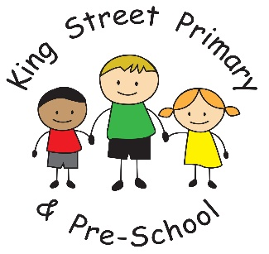

1st July 2022

Dear Parents/carers,
The weeks are flying by and I can’t believe we are now into July. There isn’t long until the end of term yet we still have so much to fit in. We are very excited that our children will get to meet their new teachers next week when we hold our transition morning on Wednesday. Children love the excitement of telling stories about themselves and asking their new teacher lots of questions too. They will learn a little bit about their new curriculum and also get to experience their new classroom. I am sure they will have lots to tell you.
Year 4 thoroughly enjoyed their visit to Tynemouth Aquarium this week and have already said they would love to visit again. Year 4 and 5 are also very excited as we approach their 3 day visit to Weardale. They will experience some wonderful outdoor activities and some very entertaining night time activities – they will most definitely sleep well! Next year we hope to add even more visits and continue our partnership with Weardale for the summer term residential.

Summer fair
Thank you to all our families for your generous donations of chocolate. The children love a Dress Down Day and families love a chocolate tombola stall, so it is a win- win situation! The organisation of the fair is well underway (and plans are growing by the day!). There will be lots of stalls and things to do, so please do come along after school on the 14th July. If you are cleaning your cupboards over the weekend and would like to donate any unwanted items, they will be gratefully received. We are setting up a ‘100 square stall’ and need a prize for every square! We would be grateful for toiletries, colouring books, jewellery, candles or other small gift items- they can all be used. You may even win them back! It promises to be a lovely occasion, we just hope this rain stays away.

Holiday Activities with Healthy Food
As we approach the holidays we are starting to get information from many different settings across the county with their offer of activities. Some are free, some paid for, so please check their information carefully before you sign up. This year, there appears to be a very wide range of activities so children will most definitely not be bored. Please look out for the flyers sent through eschools and you can also check the DCC website for further information.

Eschools App
All of our information is sent by Eschools and it is the best way to keep up to date with our newsletter, after school activities and community events. We advise that you download the Eschools app from your app store provider as this also gives you access to your child’s attendance information, parent’s evening bookings and direct access to text messages that we send. In addition, the school are able to save costs when parents sign up to it, meaning we have more money to spend on our children. If you ever need reminding of your log in details please contact the school office.

Debt on Parent Pay
A quick reminder for all families to clear their outstanding debts on Parent Pay. This may be for visits, childcare, breakfast club or school lunches.

As always, if there is anything we can help you with, or you have any questions please get in touch via the school office. Our email is kingstreet@durhamlearning.net. Phone number 01388 816078.

Yours Sincerely,

J Bromley
Head Teacher

