King Street Primary & Pre - School
High Grange Road
Spennymoor
County Durham
DL166RA Telephone: (01388) 8160781
Email: kingstreet@durhamlearning.net

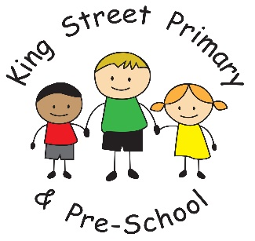

16th July 2021

Dear Parents/Carers,

I just wanted to end the term with a final goodbye and thank you. It has been a difficult year for everyone but we have made it and we hope to start the new term in September without restrictions and full of hope of the good things to come. We were devastated late last night when we found out our Y6 bubble could not spend their final day in school due to a positive Covid test. However, we know that they had a wonderful last week with us and Mr Colling has spoken to them all today to send them his best wishes.

Staff news
Miss Wigham is delighted to announce that her wedding can now go ahead later this month and I am sure you will join us in offering congratulations. She will return in September as Mrs Heightley. We hope she has a lovely day.

Free swimming sessions
For anyone that maybe interested, there are free swimming sessions in Durham during the holidays
https://www.durham.gov.uk/article/25838/Free-summer-swimming-sessions-launch-for-school-holidays
We hope many families get to enjoy this.

Holiday activities
We really hope that families take advantage of the many activities that the Local authority are offering over the summer. The website is being updated regularly as new activities are added so please check regularly. It will be a great way to get children out and about. The link can be found here:
http://www.durham.gov.uk/funandfood

Finally, we hope you all have a well-earned summer break - whatever you do. We had some very excited children in school so we know there are bound to be lots of wonderful adventures! We look forward to seeing you back in school on Thursday 2nd September.

Yours Sincerely
Joanne Bromley
Head Teacher

