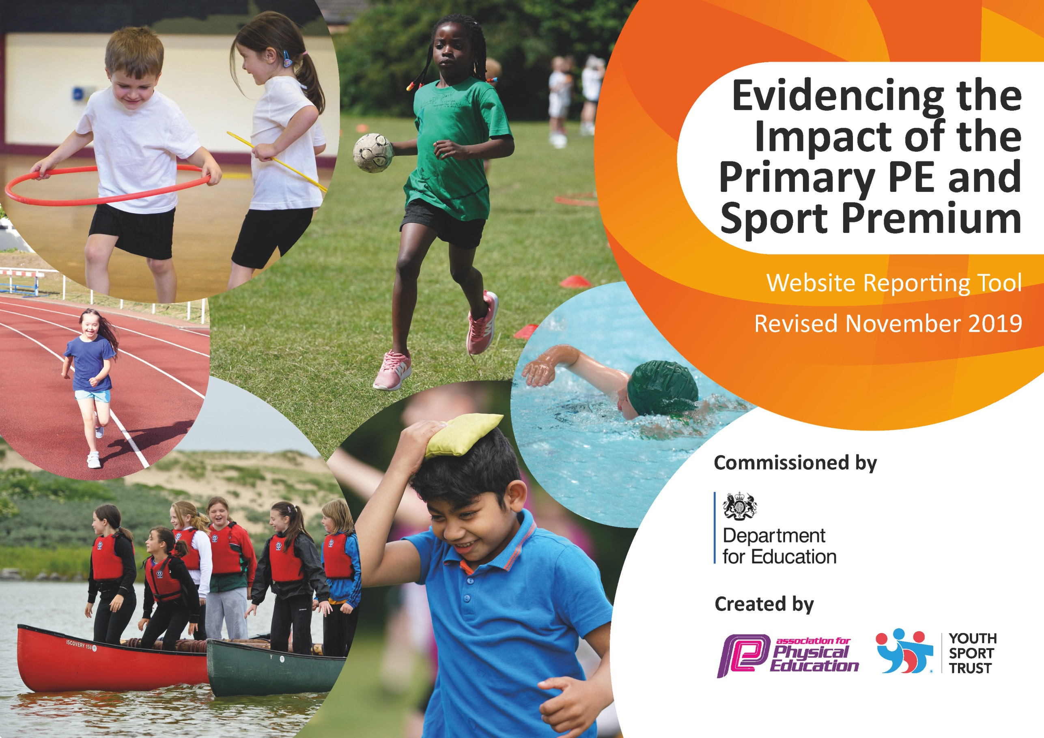

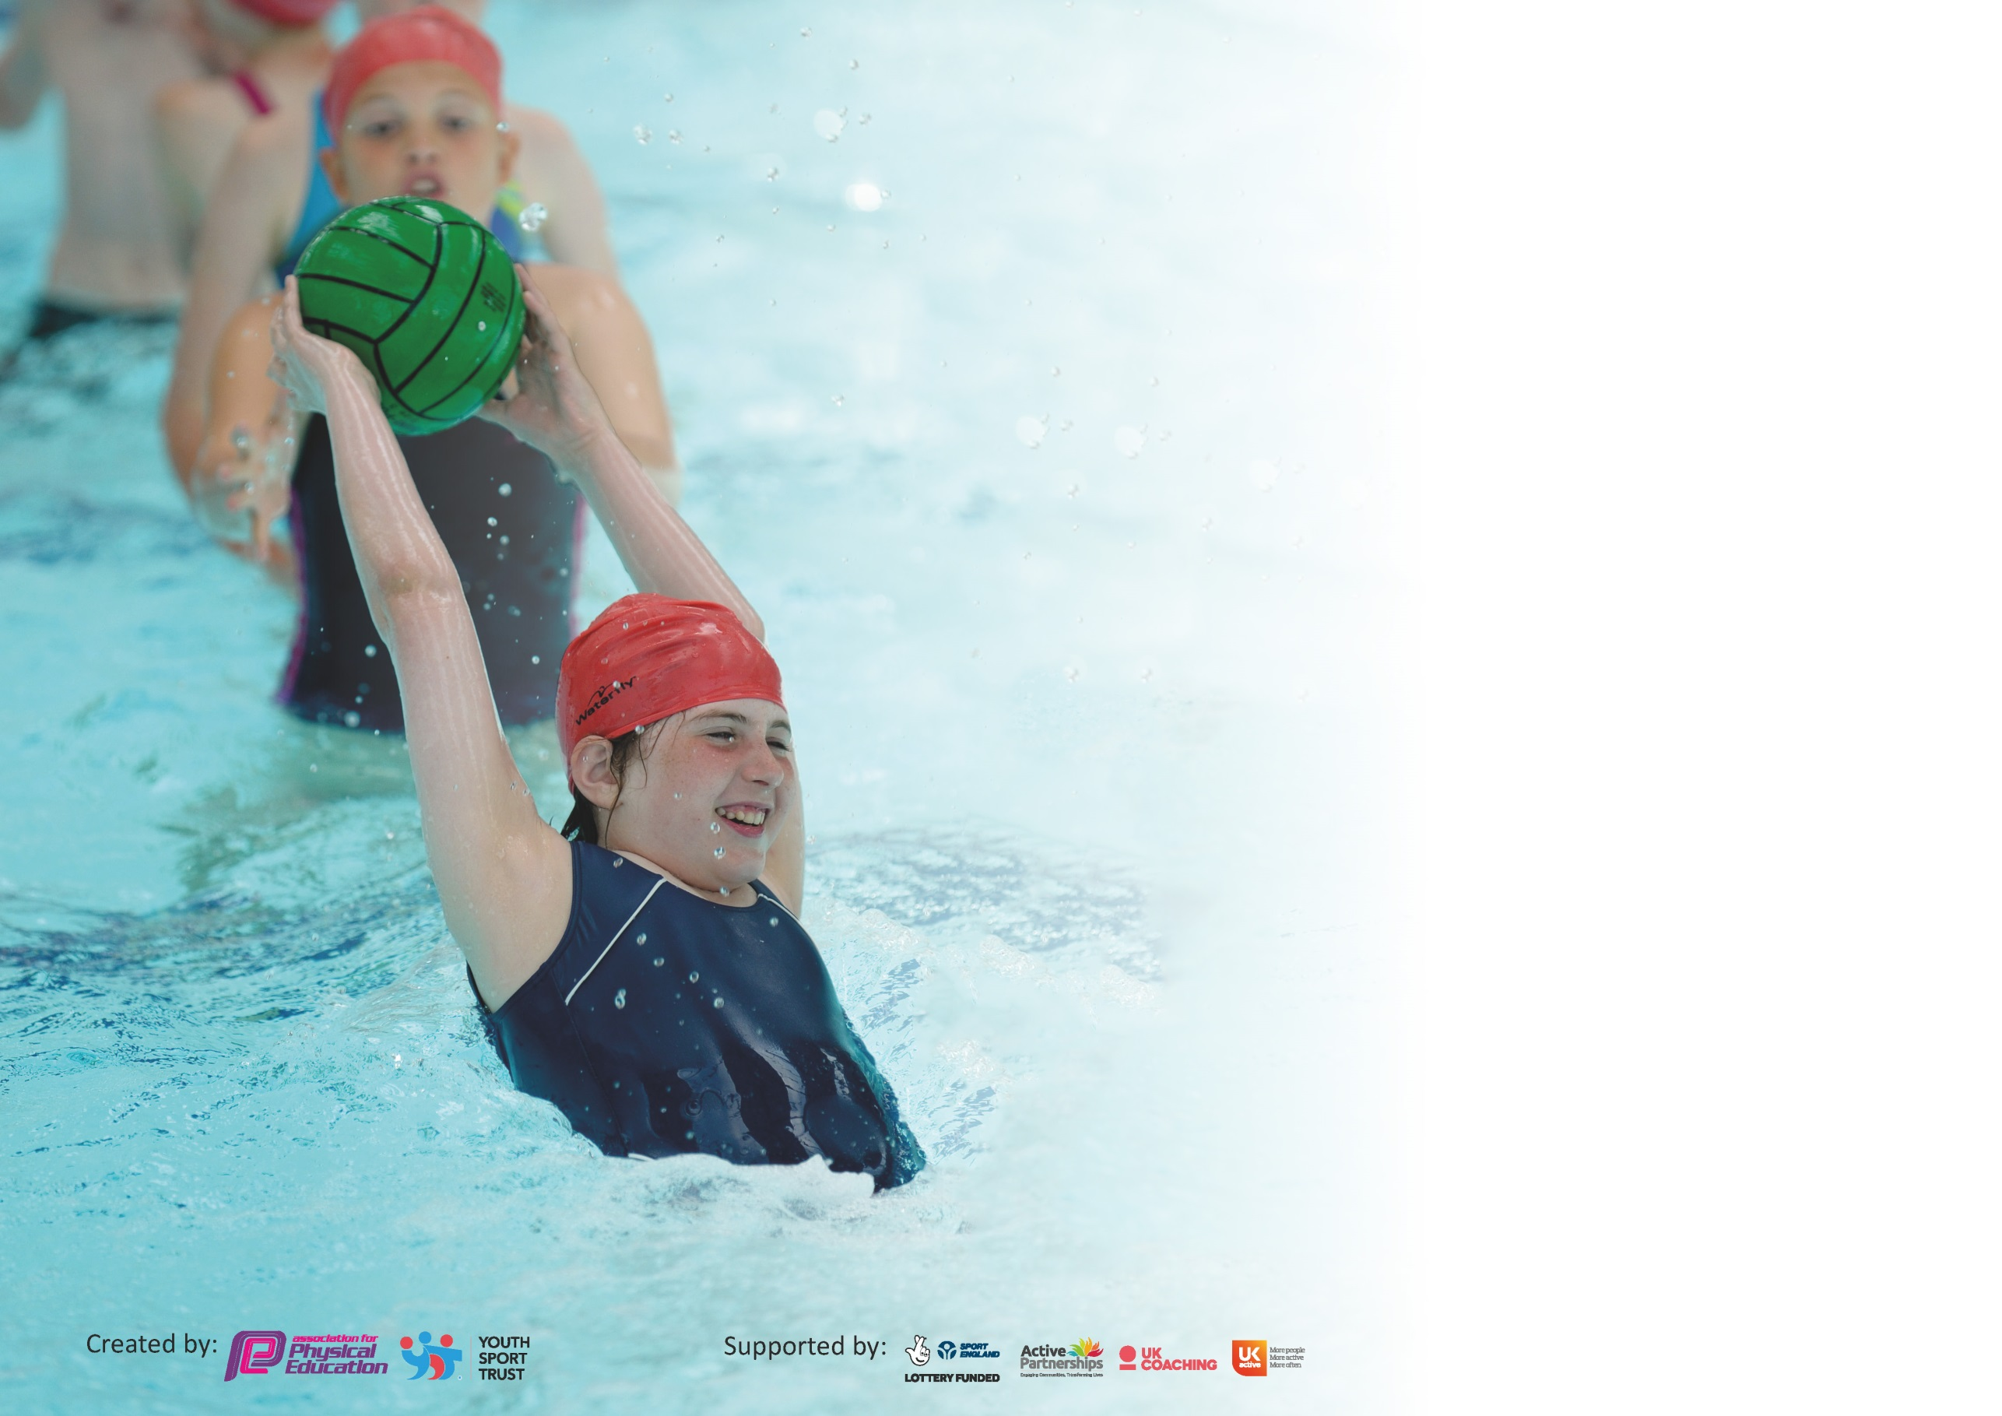

It is important that your grant is used effectively and based on school need. The Education Inspection Framework (Ofsted 2019 p64) makes clear there will be a focus on ‘whether leaders and those responsible for governors all understand their respective roles and perform these in a way that enhances the effectiveness of the school’.

Under the Quality of Education criteria (p41) inspectors consider the extent to which schools can articulate their curriculum (INTENT), construct their curriculum (IMPLEMENTATION) and demonstrate the outcomes which result (IMPACT).

To assist schools with common transferable language this template has been developed to utilise the same three headings which should make your plans easily transferable between working documents.

Schools must use the funding to make additional and sustainable improvements to the quality of Physical Education, School Sport and Physical Activity (PESSPA) they offer. This means that you should
use the Primary PE and Sport Premium to:

- Develop or add to the PESSPA activities that your school already offer
- Build capacity and capability within the school to ensure that improvements made now will benefit pupils joining the school in future years

Please visit gov.uk for the revised DfE guidance including the 5 key indicators across which schools should demonstrate an improvement. This document will help you to review your provision and to report your spend. DfE encourages schools to use this template as an effective way of meeting the reporting requirements of the Primary PE and Sport Premium.

We recommend you start by reflecting on the impact of current provision and reviewing the previous spend.

Schools are required to publish details of how they spend this funding as well as on the impact it has on pupils’ PE and sport participation and attainment by the end of the summer term or by 31st July 2020 at the latest.

We recommend regularly updating the table and publishing it on your website throughout the year. This evidences your ongoing self-evaluation of how you are using the funding to secure maximum, sustainable impact. Final copy must be posted on your website by the end of the academic year and no later than the 31st July 2020. To see an example of how to complete the table please click HERE.

Support for review and reflection - considering the 5 key indicators from DfE, what development needs are a priority for your setting and your pupils now and why? Use the space below to reflect on previous spend and key achievements and areas for development.

Key achievements to date until July 2020: | Areas for further improvement and baseline evidence of need:
- Pupil participation in sporting activity remains high. All classes receive a minimum of 2 hours PE per week  - Swimming attendance figures for the academic year 2018/2019 evidence 68% of school leavers swimming the national standard of 25m.  - Afterschool club attendance figures equated to 79%. Of this, 65% of Pupil Premium children attended an afterschool club, while 69% of SEN children attended an afterschool club.  - Outdoor education provision, pre lockdown, promoted independence, resilience, problem solving and teamwork skills throughout the cohorts.  - Incorporation of the scheme Team Up Kids 1 for Years 2 and 6 provided children with an opportunity to develop both mental, physical and emotional wellbeing. The introduction of the Brainy Bunch promoted the positive and the negative effect of chemicals within the brain and has given pupils appropriate coping strategies/techniques.  - Most classes are actively taking more time to complete Active30 brain breaks such as GoNoodle/Supermovers  - Sedgefield Sport Partnership competition event attendance continues to rise with 25+ events attended last academic year.  - In the previous academic year, King Street Primary School qualified for the two School Games Finals, basketball & netball. Each team placed 4th regionally.  - Incorporation of County Durham and QCA schemes of work have had positive feedback from teachers. Progression of skills within lessons and units are now established across the year groups. | Objectives of spending:  - Children will be healthier and more engaged in their learning.  - Children will recognise the value and importance of not only school sport, but sport as a tool to access a wider range of opportunities both in school and out of school; whilst understanding the cognitive processes behind their own emotional health and the positive impact of fitness on their mental health.  - Staff will have greater confidence in their ability to deliver sport throughout the school and recognise the value of physical development.  - Children will have access to a wider range of outdoor education activities to focus on: team building, resilience, problem solving and contextualised topic curriculum exercises and experiences.  - Children will have access to a range of differentiated sporting opportunities, both competitively and non-competitively.

Meeting national curriculum requirements for swimming and water safety.
What percentage of your current Year 6 cohort swim competently, confidently and proficiently over a distance of at least 25 metres?  N.B. Even though your pupils may swim in another year please report on their attainment on leaving  primary school at the end of the summer term 2020. | %
What percentage of your current Year 6 cohort use a range of strokes effectively [for example, front crawl, backstroke and breaststroke]? | %
What percentage of your current Year 6 cohort perform safe self-rescue in different water-based situations? | %
Schools can choose to use the Primary PE and Sport Premium to provide additional provision for swimming but this must be for activity over and above the national curriculum requirements. Have you used it in this way? | Yes/No

Action Plan and Budget Tracking
Capture your intended annual spend against the 5 key indicators. Clarify the success criteria and evidence of impact that you intend to measure to evaluate for pupils today and for the future.

Academic Year: 2020/21 | Total fund allocated: £18,020 | Date Updated: September 2020
Key indicator 1: The engagement of all pupils in regular physical activity – Chief Medical Officer guidelines recommend that primary school pupils undertake at least 30 minutes of physical activity a day in school |  |  |  | Percentage of total allocation:
 |  |  |  | %
Intent | Implementation |  | Impact
Your school focus should be clear what you want the pupils to know and be able to do and about  what they need to learn and to  consolidate through practice: | Make sure your actions to achieve are linked to your intentions: | Funding allocated: | Evidence of impact: what do pupils now know and what can they now do? What has changed?: | Sustainability and suggested next steps:
Considering new and everchanging Covid measures, King Street Primary School intend to:  Children will be healthier and more engaged in their learning by:  - Offering more active brain breaks or physical activity throughout the school day which coincides with the Chief Medical Officers recommended guidelines of at least 30 minutes of physical activity per day.  - Creating year group break time/lunch time boxes of equipment to promote active play  - Trialling Marathon Kids with Year 6 and rolling out to other classes/key stages if successful.  - Promoting gross motor development/activities in the Early Years Setting. | - Whole school to introduce active breaks in classrooms over 2020/2021 to avoid inactive playtimes due to wet weather.  - Investigate benefits of full subscription of GoNoodle or other providers who offer a similar service.  - Subject Leader to purchase new playground equipment after checking current equipment is no longer fit for purpose plus additional equipment for each Year Groups PE.  - Year 6 teacher to incorporate trial period of Marathon Kids once a week (second PE slot) with current Year 6 cohort and any other opportunities to do so.  - Incorporate Move with Max scheme into the Early Years setting | £2000
Key indicator 2: The profile of PESSPA being raised across the school as a tool for whole school improvement |  |  |  | Percentage of total allocation:
 |  |  |  | %
Intent | Implementation |  | Impact
Your school focus should be clear what you want the pupils to know and be able to do and about  what they need to learn and to  consolidate through practice: | Make sure your actions to achieve are linked to your intentions: | Funding allocated: | Evidence of impact: what do pupils now know and what can they now do? What has changed?: | Sustainability and suggested next steps:
Considering new and everchanging Covid measures, King Street Primary School intend to:  Continue to raise the profile of school sport and physical activity throughout the year. Children will recognise the value and importance of not only school sport, but sport as a tool to access a wider range of opportunities both in school and out of school; whilst understanding the cognitive processes behind their own emotional health and the positive impact of fitness on their mental health. We will achieve this by:  - Ensuring the teaching and learning of PE is consistent throughout the school and is engaging and enjoyable for all children.  - Incorporating the Team Up Kids programme throughout the school following a successful trial period last academic year.  - Purchasing branded staff physical education kit to promote physical education throughout the school and wider community.  - Purchasing branded children’s physical education team kit to promote physical education throughout the school and wider community. | - Subject leader to signpost children towards local clubs.  - PE lead to collate a bank of information about local clubs and activities which link to the clubs being offered.  - HT to include a sport focused weekly slot in celebration assembly to celebrate school sport as well as sport taking place outside of school.  - Teacher throughout school to trial Twinkl Move to support them with their planning of PE sessions.  - Subject leader to complete a staff survey to ensure staff are getting support that they need and provide them with extra resources that they need if needed.  - King Street’s Positive Futures Worker to work with each class weekly supporting children’s mental health and wellbeing providing lessons based around positive powers of physical activity and mental wellbeing techniques.  - Subject Leader to contact current school apparel provider to purchase staff PE kit (branded King Street Physical Education hoodies) for use during PE sessions and sporting competitions in the wider community | £700

Key indicator 3: Increased confidence, knowledge and skills of all staff in teaching PE and sport |  |  |  | Percentage of total allocation:
 |  |  |  | %
Intent | Implementation |  | Impact
Your school focus should be clear | Make sure your actions to | Funding | Evidence of impact: what do | Sustainability and suggested
what you want the pupils to know | achieve are linked to your | allocated: | pupils now know and what | next steps:
and be able to do and about | intentions: |  | can they now do? What has
what they need to learn and to |  |  | changed?:
consolidate through practice:
Considering new and everchanging Covid measures, King Street Primary School intend to:  To continue to improve the provision of PE and sport at King Street Primary School through staff development. Staff will have greater confidence in their ability to deliver sport throughout the school and recognise the value of physical development. We aim to achieve this by:  - Incorporating staff CPD within the academic calendar to upskill staff’s knowledge and understanding of physical education within the national curriculum.  - Incorporating staff CPD for the Early Years practitioners to develop staff’s knowledge of early physical development and strategies for improving it within continuous provision. | - Subject lead to attend virtual PE meetings held by Go Well and County Durham Primary PE Subject Leaders  - Subject lead to research and organise training opportunities which are relevant to the needs of staff. | £1000
Key indicator 4: Broader experience of a range of sports and activities offered to all pupils |  |  |  | Percentage of total allocation:
 |  |  |  | %
Intent | Implementation |  | Impact
Your school focus should be clear | Make sure your actions to | Funding | Evidence of impact: what do | Sustainability and suggested
what you want the pupils to know | achieve are linked to your | allocated: | pupils now know and what | next steps:
and be able to do and about | intentions: |  | can they now do? What has
what they need to learn and to |  |  | changed?:
consolidate through practice:
Considering new and everchanging Covid measures, King Street Primary School intend to:  Provide children with access to a wider range of outdoor education activities to focus on: team building, resilience, problem solving and contextualised topic curriculum exercises and experiences. We aim to achieve this by:  - Reserve funding for outdoor education provision to commence in the Spring Term.  - Purchase novel equipment with the intention to provide access to new and unfamiliar opportunities to widen prospects and perspectives of other sports | - Subject lead and HT to contact current provider (Real Adventure Through Sport) and organise provision for the Spring Term post Covid.  - Subject Leader and HT to investigate other providers in the local area who offer a similar package.  - Subject Leader to liaise with staff relating to their Spring and Summer term curriculum so potential opportunities for active learning can be exploited  - Subject leader to research and invest in appropriate equipment such as: static climbing wall holds, archery, fencing and kurling. | £10,000  £2,000

Key indicator 5: Increased participation in competitive sport |  |  |  | Percentage of total allocation:
 |  |  |  | %
Intent | Implementation |  | Impact
Your school focus should be clear | Make sure your actions to | Funding | Evidence of impact: what do | Sustainability and suggested
what you want the pupils to know | achieve are linked to your | allocated: | pupils now know and what | next steps:
and be able to do and about | intentions: |  | can they now do? What has
what they need to learn and to |  |  | changed?:
consolidate through practice:
Considering new and everchanging Covid measures, King Street Primary School intend to:  Increase participation in both competitive and non-competitive sport. All children will have access to a range of differentiated sporting opportunities, both competitively and non-competitively. We aim to achieve this by:  - Agreeing an SLA with Go Well, formally Sedgefield Sports Partnership, for competitive events package. | - Subject Lead to liaise with representatives from Go Well regarding competitions and events and distribute information to staff.  - Subject lead to arrange transportation to and from events, liaising | £1,800  £500

Signed off by
Head Teacher:
Date:
Subject Leader: | Steven Colling
Date: | August 2020
Governor:
Date:

