King Street Primary & Pre - School
High Grange Road
Spennymoor
County Durham
DL166RA Telephone: (01388) 816078
Email: kingstreet@durhamlearning.net
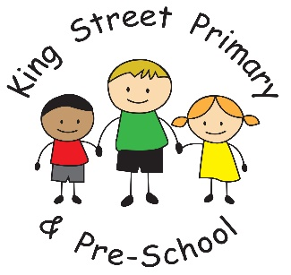

6th May 2022

Dear Parents/carers,

I can’t believe we are already into May! The weeks are flying by and we still have so much to do.
This week was the deadline for booking a place for the Royal High Tea. These responses will be collated and you will receive an email next week with your allocated time slot. Please remember that, due to the demand for places and limited space, only one adult from each family can attend. We have lots of lovely activities planned to celebrate the jubilee and it promises to be a wonderful event- we just hope the weather is kind to us.

Next week, our Year 6 children will undertake their SAT’s test and I would like to express how proud we all are of their achievements to date. We always explain to children that testing is only ever a snapshot of what a child’s academic achievement is and there are so many other valuable skills and attributes that account for future success. All of our children are hardworking, thoughtful, kind and considerate to others and these qualities will take them far in life. At this point in time, many people will be wishing them luck but we believe they do not need luck. They have worked incredibly hard throughout their whole education we know how brilliant they all are. If you have children in Year 6, this weekend, please remind them of this. We do not want them to spend their free time worried. We look forward to seeing them for breakfast next week.

Our Year 3 children also deserve high praise this week for their conduct when on outdoor education. We received an email from a member of the public last night who met them at Causey Arch. This lady was amazed at how the children presented, their behaviour and politeness and she was keen to have this recognised. She was delighted to see children were given the opportunities to explore the outdoors and observed the excitement in our children. We are, once again, incredibly proud of our children they are a credit to both our families and the school.

Year 2 visit
Our Year 2 children are also very excitable at the thoughts of their upcoming visit to the Captain Cook Museum on Thursday 26th May. If you have not already returned the consent form, please do so as soon as possible.

Diary dates
Just a reminder of some upcoming dates:
Thursday 26th May- Movie night (info to follow)
Friday 27th May- Royal High Tea
Wednesday 22nd June (PM) - Y1/2 sports day
Thursday 23rd June (PM) – KS2 Sports Day.

As always, if you have any questions or concerns please speak to class teachers or contact the school office.

Yours Sincerely
J Bromley
Head Teacher

