King Street Primary & Pre - School
High Grange Road
Spennymoor
County Durham
DL16 6RA Telephone: (01388) 8160781
Email: kingstreet@durhamlearning.net

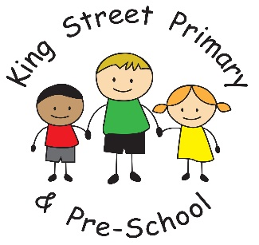

7th May 2021

Dear Parents/Carers,

We are delighted that the Local Authority have finally managed to undertake some of our planned maintenance, which was delayed due to the current situation. We still have lots more to do but by cutting down some hedges and some general maintenance has really opened up the area. We look forward to more being done over the summer term. We have also finally have a delivery date for all of our climbing wall equipment and flooring so we really hope that can start our yard developments very soon. We have plans for messy kitchens, reading areas, gardening spaces and play-based fitness equipment.

Fun and fitness
Next week we are participating in ‘skip into spring’ where children will enjoy skipping activities with their class, a daily challenge and opportunities to practice different types of skipping. I expect they will have a thoroughly enjoyable time – probably also feel a little tired so should sleep well!

Class visits
Please do continue to check your child’s bag as more classes plan their visits. This is the first opportunity for our children to enjoy enrichment visits in a very long time and I know they are looking forward to it.

Community safety
You may have also noticed that our community PSCOs were around school this week, they are helping to keep our school community safe and ensuring that families are following the one-way system. However, we are aware that when the police or staff are not present on the lane, families are continuing to use this as a short cut. We have begun to identify families who mis-use the system and they will be contacted by the PCSOs directly. Please help us keep everyone safe and use the one-way system. I would also like to remind families that the car park is for staff use only. It has already very limited space due to the walkway and it is a risk to children and families using the lane if cars are pulling into the car park at the beginning and end of the school day.

School news
Traditionally, our Y6 children would be undertaking their SATs next week and they would have been invited in for breakfasts and had a lovely treat at the end of the week. Despite the SATs not going ahead, our children will not miss out and Mr Colling and I have been busy planning some lovely activities and treats for later in the term.

At the opposite end of school, for all of our families with children who will be starting Reception in September, you will shortly receive a pack with all of the information you need and inviting you to a new starter event later in the term. We look forward to seeing you there.

Family support
We have been notified by the local Authority that they will be issuing Covid Local Support Grants to all families who are eligible for Free School Meals to support with household bills. This replaces the Covid winter grant payment and the holiday support fund paid over previous holiday periods. Please look out for the vouchers arriving by email over the next few weeks. We do not yet have a fixed date on when they will arrive so please regularly check your inbox.

As always, please do not hesitate to get in touch if you have any concerns or questions. If you would like to volunteer with us in school, we would love to have you. Our volunteers add an extra dimension to the children’s education and are a real asset. We would love to hear from you.

Yours Sincerely
Joanne Bromley
Head Teacher

