King Street Primary & Pre - School
High Grange Road
Spennymoor
County Durham
DL166RA Telephone: (01388) 8160781
Email: kingstreet@durhamlearning.net

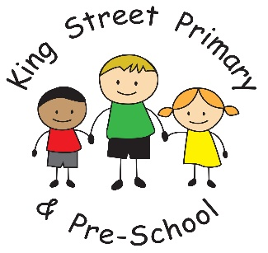

11th November 2022

Dear Parents/Carers,

Wow! What a busy week. The children have had the most amazing time this week creating all sorts of fabulous sweet treats for our ‘Bake Off’. There were some very technical creations and we have some very talented bakers. Prue Leith and Paul Hollywood took great consideration to decide on the winners from each class. We ended the week with a presentation assembly where the winners were awarded with prizes.

We also presented the winners for our Autumn competition this week too. Children have clearly been out in nature and looking very hard for pinecones, leaves and conkers. We had the biggest pine cone we’ve ever seen! Thank you to everyone who entered, we hope you had fun exploring the outdoors.

Thank you also to everyone who made an appointment for parents’ evening or Stay and Play this week. Staff have enjoyed talking about the children and explaining how they are getting on. We were however, disappointed with the number of families who made appointments but did not attend. This was the highest it has ever been and we had over 25 families across school who did not attend when expected. Although we appreciate that emergencies do happen, we do hope that next term families can let us know if they are unable to attend and staff can offer the appointments to other families.

Community Hub
Our community Hub is looking fantastic and we are fully stocked with all kinds of items. We now need lots of you to come and take what you need. We have beds, small appliances, electrical items, clothing, uniform, car seats and food items. These are all free to take and we want to share them with you. What we have created shows what can be done when a community comes together and the space is designed to benefit everyone in the community. There is no criteria, no checks carried out and no names taken! Please pop along on a Tuesday morning for a cuppa and a chat and browse what we have available. We look forward to seeing you there.

Parking
Many of you will have noticed that we have had a police presence around school this week. Since enforcement teams have been present the standard of parking has improved and the area has become safer. There are still some incidents of abuse aimed at our Crossing Patrol, which we are disgusted at. There were 5 incidents on Thursday where he was driven at or shouted at and this is totally unacceptable. We are in the process of discussing these incidents with the police, who will be issuing fines for dangerous driving. There will be cameras fitted to the area and more patrols will be visible. It is shocking that we have to resort to this but we must keep our families safe. We know the majority of our families drive and park sensibly but appeal to others to have more consideration. Thank you.

As always, if you have any questions, queries or concerns please contact class teachers or the school office. Kingstreet@durhamlearning.net . We are also looking for volunteers to help across school and also in our Community Hub. If you are interested. Please speak to the school office for a volunteer pack.

Yours Sincerely

Joanne Bromley
Head Teacher

