King Street Primary & Pre - School
High Grange Road
Spennymoor
County Durham
DL166RA Telephone: (01388) 816078
Email: kingstreet@durhamlearning.net
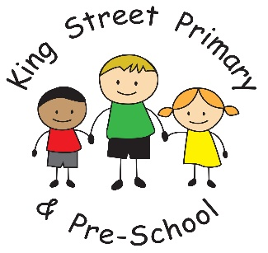

Dear Parents/Carers,

Next week, we will see the return of our annual KS1 and KS2 Sports Days. As a school, we are incredibly excited to welcome you all back after such a long time away from this prestigious event in the school calendar!
To celebrate these key dates, we will be holding a Sports Week. Please find below details of significant events taking place throughout the week.

Monday 20th June – Wheels Day

Each child, including EYFS, is invited to bring along a scooter or bike to participate in a ‘wheelie’ fun day! Every class will be allocated a time slot of 40 minutes to play on the main school yard. Please note, all children participating MUST bring a safety helmet to be allowed to ride. Any children who do not wish to bring a wheeled accessory for the day will still participate in the 40 minutes allocated to their class.

Tuesday 21st June – Futsal Day

Our afterschool football coach, Craig Mcleod, will be running Futsal sessions throughout the day for all children in school, including EYFS.

Wednesday 22nd June - KS1 (Year 1 and Year 2) Sports Day
Thursday 23rd June - KS2 (Year 3, Year 4, Year 5 and Year 6) Sports Day

Please join us on the main school yard from 1pm (no ticket required) with events due to start at 1.25pm, finishing by 3.05pm on both days. Staff will dismiss children from their usual exits as normal. Please do not take your child/children early. Tea and coffee will be available to purchase for a small charge.

Friday 24th June – EYFS Fitness Funday Friday (Nursery and Reception)

Please note that this event is not for parents as our events will take place over the whole day! Information will be sent separately via Tapestry.

Our EYFS and KS1 children will be joined by an external professional for a morning of relaxing yoga after such a busy week!

We look forward to all of these events and can’t wait to once more have an audience for our Sports Days. Please note, children from Year 1 to Year 6 will require PE kits all week and will need a T-shirt in the house’s colour for Sports Day to distinguish the different teams – Auckland, Brancepeth, Durham and Raby. If you do not know your child’s house, please contact their class teacher.

Yours Sincerely

Mr Colling

