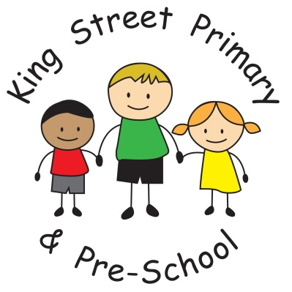

King Street Primary & Pre-School

Uniform Policy

Policy Review Date: November 2021

Introduction
At King Street we expect our children to wear school uniform. A uniform reinforces in children a pride in their appearance, instils recognition of themselves as an integral part of the school community and assists in developing pride in representing their school.
Issues of equality, health and safety and expense are also factors that contribute to the establishment of this policy.

Aims and Objectives
The school believes the following are the benefits derived from the wearing of school uniform by all children.

- Promotes a sense of identity and pride in our school
- Promotes equality amongst all children
- Eliminates peer pressure to wear less appropriate clothing
- Is practical and smart
- Reduces competition amongst children to wear fashionable items for daily wear
- School uniform is functional, durable and economical
- Helps identification and safety of children in public places

School uniform should consist of a blue sweatshirt, white polo shirt and black or grey trousers or skirt and appropriate black footwear. Samples of uniform are available to purchase on our school website (via the shop link) or by calling into Cre8ive Graphics (Peel Street, Bishop Auckland) throughout the year. We always seek ways to ensure that the cost of a school uniform is not restrictive to parents and therefore it is not a requirement for children to wear clothing branded with the school logo. Unbranded uniforms can also be purchased from most supermarkets. Please ensure all uniform is named.

Physical Education
It is essential that children change for PE. Key Stage 2 children will need trainers for physical activity. For Health and Safety it is important that trainers should not be worn to school, rather brought in a PE bag to get changed into. Children are encouraged to wear a t shirt in the colour of their ‘ school house team’ but these do not need to have the school logo on.

Jewellery
Stud earrings only can be worn during the school day but must be covered for times of physical activity such as PE or outdoor education. This is in the interests of your child’s safety.
Parents should note that if they intend to have a child’s ears pierced this needs to be carried out at the beginning of the summer holidays to allow time for ears to heal.

Extreme Haircuts
The school does not permit children to have haircuts that could serve as a distraction to other children, or heavily styled hair using excessive product which may vary depending on current fashionable styles.
The role of parents
We ask all parents who send their children to our school to support the school uniform policy. We believe that parents have a duty to send their children to school correctly dressed and ready for their daily schoolwork. Parents should ensure that their child has the correct uniform, and that it is clean and in good
The school welcomes children from all backgrounds and faith communities. If there are serious reasons, e.g. religious objections, why parents want their child to wear clothes that differ from the school uniform, the school will look sympathetically at such requests. Similarly, should an item of school uniform prove problematic for a pupil with disabilities, then parents are invited to draw this to the attention of the Head teacher. The school will not treat pupils with disabilities unfavourably.

The role of governors
The governing body supports the Head teacher in implementing the school uniform policy. It considers all representations from parents regarding this policy, and liaises with the Head teacher to ensure that the policy is implemented fairly and with sensitivity.
It is the governors' responsibility to ensure that the school uniform meets all national regulations concerning equal opportunities, and that our school uniform policy is consistent with our policy on equal opportunities.
Governors ensure that the school uniform policy helps children to dress sensibly, in clothing that is hardwearing, safe and practical.
Monitoring and review
When monitoring this policy, through its committee work, the governing body will:
- seek the views of parents, to be sure that they agree with the policy, and support it;
- consider with the Head teacher any requests from parents for individual children to have special dispensations;
- require the Head teacher to report to the governors on the way in which the policy is being implemented.

